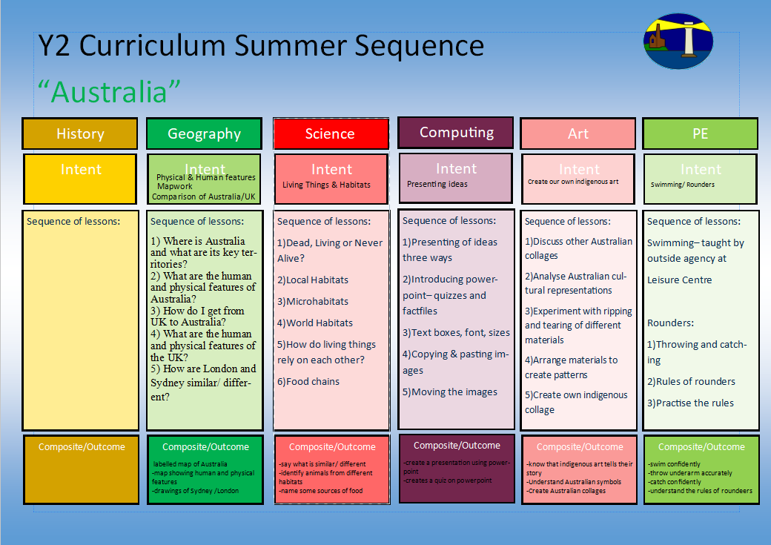
-labelled changes to a map
- analysis of old and new pictures of St Just
-predictons of causes
1.What can you see in St Just today?
2.How has St Just changed over time?
3.How has the landscape of St Just changed over the last 100 years?
4.How have our houses changed over time?
5.What do you think St Just will look like in the future?
How has St Just changed over time and why?
To identify materials
To classify materials and carry out simple experiments
-To be able to identify materials.
-To be able to identify the materials from which objects are made.
-To be able to investigate the physical properties of materials
-To investigate the properties of waterproof and absorbent
-To record the results simply in a table after investigating the properties of waterproof and absorbent
-To be able to design an underwater house and write about i
-understanding of pencil control
-understanding of representational drawing

1.I can look at other examples of portraits from a range of artistic styles (pop art/ contemporary/ classic)
2.I can look at mark making with sketch pencils, with a focus on shading and thickness of pencil and creating texture
3.I can practice the skills used in these examples
4.I can draw the key features of a face using youtube videos as support
5.I can draw myself using shading and texture and exploring my own style

Online Safety 2.2
Information Technology around us
-understand foot and arm position
-aiming and ball control
1)Chest push, underarm throw, over arm
2) Target throwing
3) Catching
4) Rolling and stopping
5) Bouncing and aiming
Multi-skills (ARENA Scheme)
Portrait of themselves
-log on and off
-confident with IT around us and why we have it
- how IT impacts on our world
1)What is IT?
2)IT in school
3)IT in the world
4)Benefits of IT
5)Using IT safely
6)Using IT in different ways
-sorting activities
--design and carry out scientific enquiries
Materials

Y1 Curriculum Autumn Term 2 Sequence

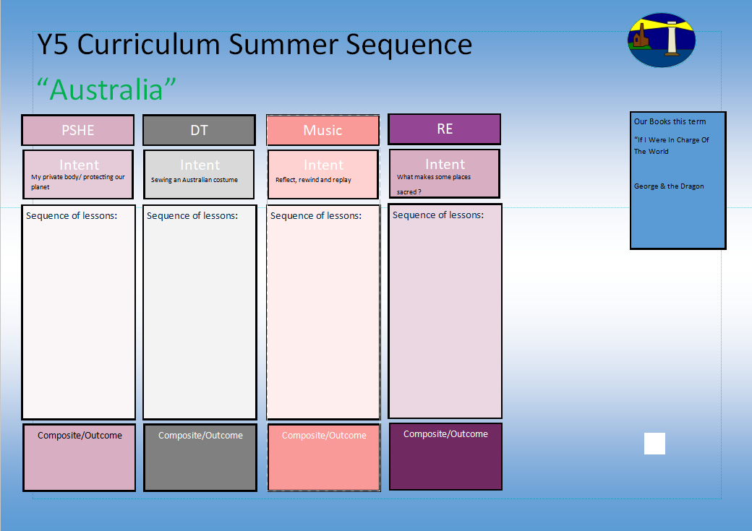
I know the stories that Jesus would tell and why they were important
1.I know who Jesus was and who his disciples were.
2.I know the importance of forgiveness in the Bible.
3.I know how Jesus spread the word of peace around the world.
4.I know the importance and power of prayer in Christianity.
5.I know why Jesus is ‘Good News’.
What is the good news that Christians say Jesus brings?
Understanding hygiene and sleep and their importance
Understanding why CPR can save lives

Our books this term for English:

The Twits

Persuasive letter
Our books this term for reading comprehension:

-The Twits

Ho Ho Ho

HYGIENE/ SLEEP/ CPR
Hygiene and Me- 1
Hygiene and Me- 2
Getting enough sleep-1
Getting enough sleep- 2
First Aid/ CPR- 1
First Aid/ CPR- 2

Y1 Curriculum Autumn Term 2 Sequence

Share and perform the learning that has taken place

1.Listen and Appraise Classical music
2.Understand about pulse and rhythm
3.Singing along to the pulse
4.Play instruments within the song and to create our own pulse
5.Improvisation using voices and instruments
6.Composition

-How to say no
-What can you remember?
-Private parts rap

-Why is the planet getting warmer?
-What can we do to help?

-Personal Goal Setting
-Adapting to Change

