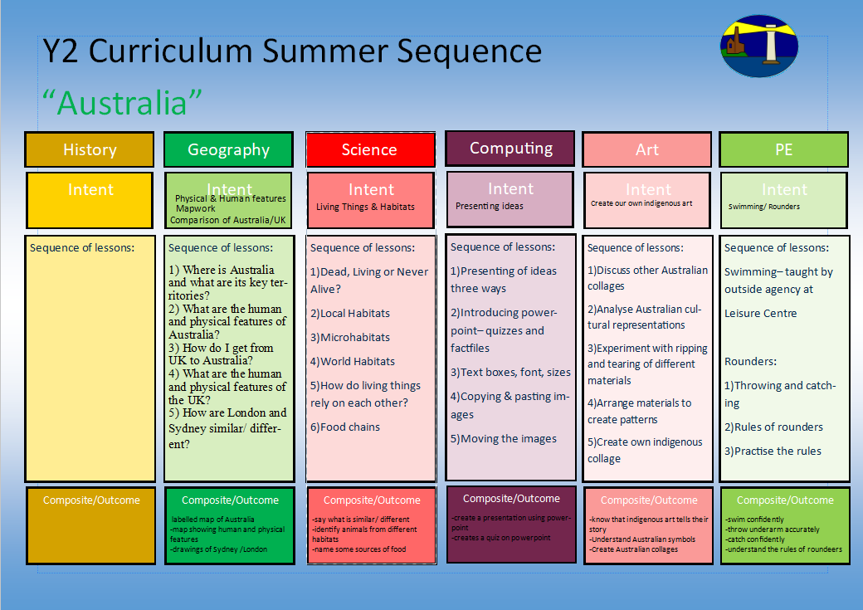
Monet
-family tree
- timeline
-analysis of representations of the Kings

1.Who was King Charles II?
2.Who were the Stuarts?
3.What were the causes of the Great Fire of London and what happened?
4.What were the consequences of the fire?
5. Who is King Charles III and how is he linked to Charles II?
6. How is life different for us today compared to King Charles II’s time?

The GFoL/ The 2 Kings
To understand and classify different animals including humans

How are different animals classified?
How can you identify vertebrates and invertebrates?
How can you identify crustacean, arachnids and insects?
How can you identify a fish, amphibian and reptile?
How can you identify birds and mammals?
Can you name different body parts?
How can you identify which part of the body helps us smell, taste, touch, see and hear?

1.I can look at other drawings of plants around us by selecting plants from my local area
2.I can analyse and describe other artists who have drawn plants (Monet; Van Gogh etc) and express my personal opinion
3.I can try out making different tones with pencils, chalk and charcoal.
4.I can create close up studies of Monet images
5.I can create my own observational plant drawing using inspiration and compare with their own with pencils, chalk and charcoal.

-use of water colours
-exploring brushes
-exploring using water and blending

Coding/Dance Mat Typing/ Powerpoints

-understanding balance and travelling
-using climbing frames
1)Using the equipment safely
2)Balancing effectively solo and with partner
3)Travelling from one balance to another
4)Exploring equipment in different ways
5)Creating sequences
Dance
-log on and off
-confident with Purple Mash
-understanding how to create a presentation using powerpoint
1)Using PowerPoint- Font style and size
2)Animating images on PowerPoint
3)Saving

4) What is coding?
5) Giving instructions
6) Maps and routes

Plants and living things?

Y1 Curriculum Spring Term 2 Sequence

Sowing and Growing
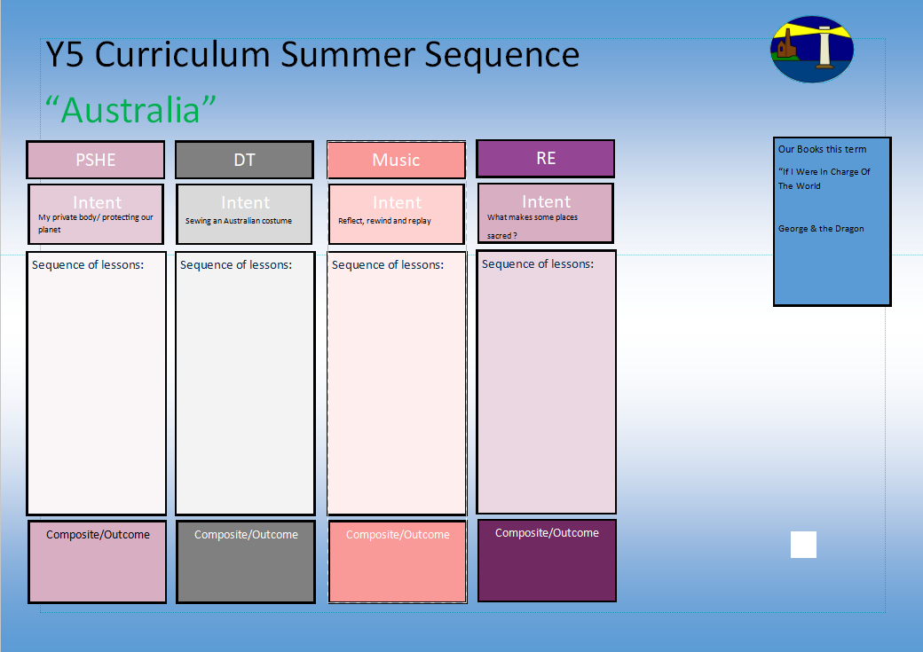
Our books this term for English:

The Great Fire of London

Instructional writing
1.I know why Easter is so important to Christians and can talk confidently about the Last Supper.
2.I know why symbolism is so important to Christians and the Easter story.
3.I know how Palm Sunday, Good Friday and Easter Sunday are important events in the Easter story.
4.I know the Easter story from start to finish and can talk about it in detail.
Our books this term for reading comprehension:

-The Boy who Grew Dragons
Why does Easter matter to Christians?
Zootime

Understanding the world around us
Emergency Services- 1
Emergency Services- 2
Braving the Weather- 1
Braving the Weather- 2
Weather Symbols- 1
Weather Symbols- 2
Y1 Curriculum Spring Term 2 Sequence

Sowing and Growing

I know the Easter story and why it is important to Christians
Share and perform the learning that has taken place

1.Listen and Appraise Classical music
2.Understand about pulse and rhythm
3.Singing along to the pulse
4.Play instruments within the song and to create our own pulse
5.Improvisation using voices and instruments
6.Composition

Understanding the environment
Understanding the weather

-How to say no
-What can you remember?
-Private parts rap

-Why is the planet getting warmer?
-What can we do to help?

-Personal Goal Setting
-Adapting to Change

