KEY INSTANT RECALL FACTS
Year 2 – Spring Term 1

Year 1 – Autumn Term 2

Key Vocabulary
What is double 9?
What is half 14?
What is double 7?
What is half of 18?

TARGET:
- I know my doubles and halves of numbers to 20
By the end of this term children should be able to:
- Recall instantly the double and halves of numbers to 20.

Top Tips…the secret to success is practising little and often. Use time wisely.
- Practise Key Facts while walking to school or during a car journey.
- Have a fact of the day – half of 18 is 9.
- Use what you already know – Encourage your child to find the connection between the 2 times table and double facts
- Pronunciation: Make sure that your child is pronouncing the numbers correctly and not getting confused between thirteen and thirty.
- Play games – to support your child in maths. Your child has access to Purple Mash, Times Tables Rock Stars and the White Rose 1 minute App (https://whiterosemaths.com/resources/1-minute-maths#download) is brilliant for building number confidence and fluency.
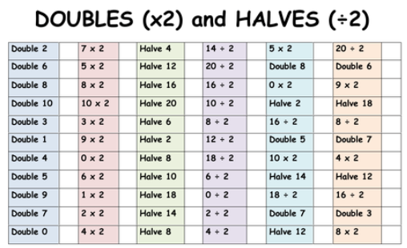
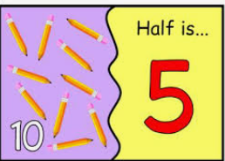

Remember – by the end of the term they should be able to recall these confidently and quickly.

