Rationale and Principles of Art and Design Technology
At St Just Primary School, Art and DT (Design Technology) is taught through a bespoke curriculum, tailored to the needs of our children and ensuring progression in skills and knowledge as they move up through the school. Decisions for the topics covered are based on the following reasons:
-skill progression
-links to topic
-links to local area
-needs of the children particularly in St Just

Through the sequencing of lessons, Art has been covered using ‘art concepts’ and ‘substantive concepts’ which ensures that it is taught thoroughly with depth.

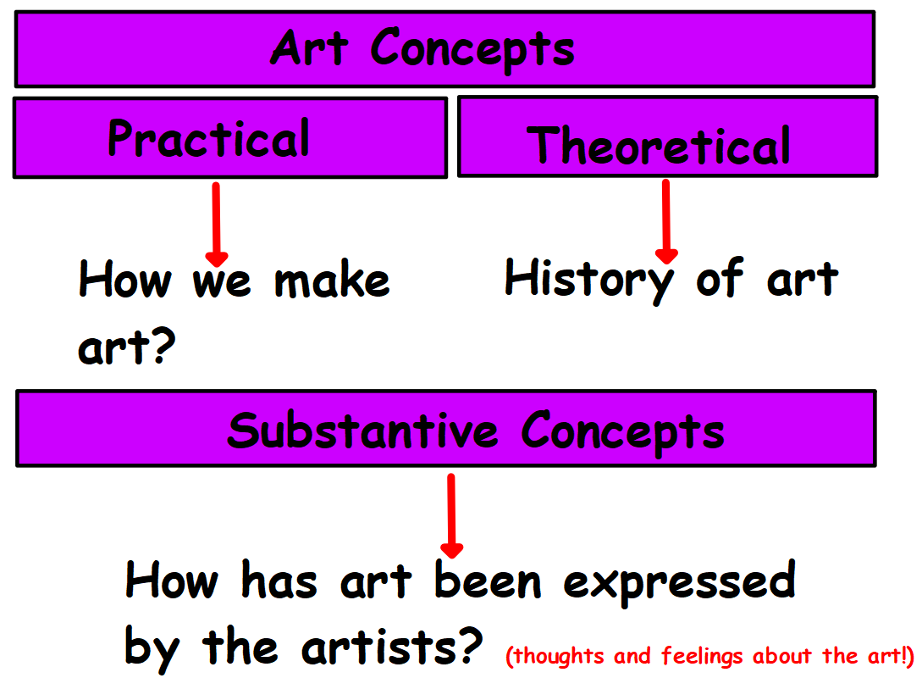

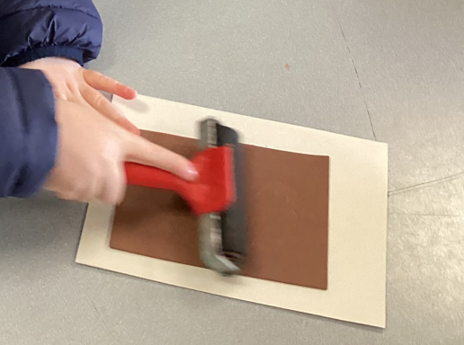

1
2
Investigating artist or object being made

Investigating and testing tools

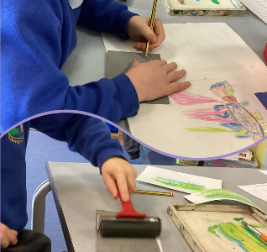
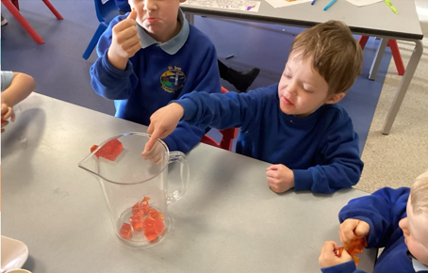
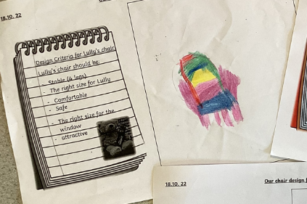

4
3
Practice of key skill using tools

Creating variety of images/ products

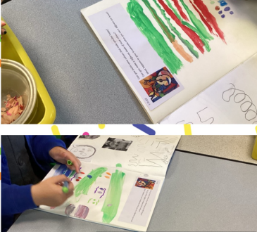
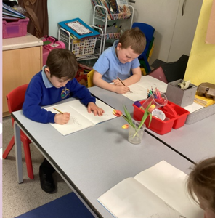
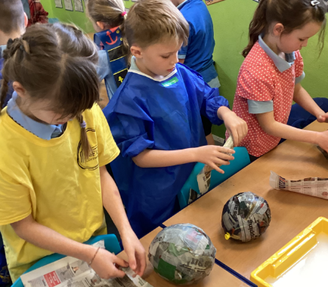

Evaluation

6
5
Creating final product

