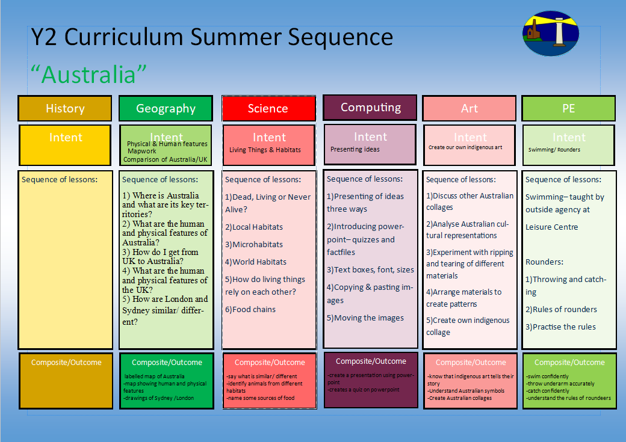
1.I can look at other drawings of plants around us by selecting plants from my local area
2.I can analyse and describe other artists who have drawn plants (Monet; Van Gogh etc) and express my personal opinion
3.I can try out making different tones with pencils, chalk and charcoal.
4.I can create close up studies of Monet images
5.I can create my own observational plant drawing using inspiration and compare with their own with pencils, chalk and charcoal.

Climate and Weather
-use of water colours
-exploring brushes
-exploring using water and blending

Coding/ Moving objects
1)What do plants need to grow healthily?
2)What is inside a seed?
3)What is the difference between a seed and a bulb?
4)What is the lifecycle of a plant?
5)How are seeds dispersed so they can germinate again into new plants?
6)How do plants grow in a dry, hot or cold climate?

-understanding balance and travelling
-using climbing frames
1)Using the equipment safely
2)Balancing effectively solo and with partner
3)Travelling from one balance to another
4)Exploring equipment in different ways
5)Creating sequences
Dance
Exploring colour, shade and tone
-log on and off
-confident with Purple Mash
-understanding how to create a presentation using powerpoint
1)Using PowerPoint- Font style and size
2)Animating images on PowerPoint
3)Saving

4) What is coding?
5) Giving instructions
6) Maps and routes

Understanding what can affect a plant’s growth
Difference between a seed and a bulb
Lifecyles with correct vocabulary

How do plants grow?
Understanding what can affect climate/ weather?
Mapwork indicating the Equator

1) What is the difference between weather and climate? (cross curricular with Science)
2) To explain where in the world I should go for hot/cold weather?
What makes a hot/ cold country? How does this compare to the UK?
3) What is the Equator? What countries does it go through?
Why is the globe not upright? What is this lines? - the Equator
What does this mean for these countries around the equator?
4) To locate and identify the North and South Poles.

Y2 Curriculum Spring Term 2 Sequence

Sowing and Growing
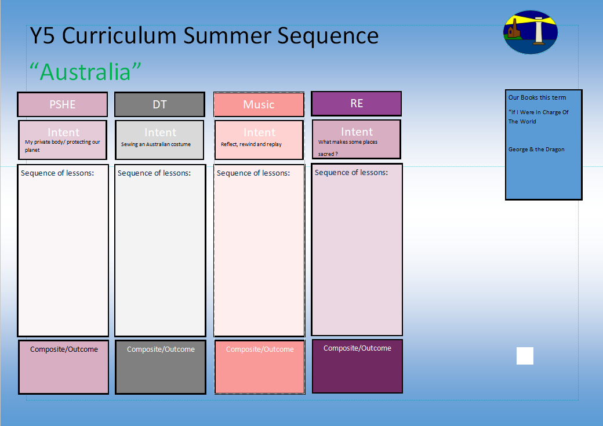
Our books this term for English:

The Owl Who is Afraid of the Dark

The Magic Paintbrush

1.I know why Easter is so important to Christians and can talk confidently about the Last Supper.
2.I know why symbolism is so important to Christians and the Easter story.
3.I know how Palm Sunday, Good Friday and Easter Sunday are important events in the Easter story.
4.I know the Easter story from start to finish and can talk about it in detail.
Our books this term for reading comprehension:

-The Owl Who is Afraid of the Dark
-The Boy who Grew Dragons
Why does Easter matter to Christians?
Zootime

Understanding our emotions
Personal Goal Setting
Environment
Understanding the art of failure
Y2 Curriculum Spring Term 2 Sequence

Sowing and Growing

I know the Easter story and why it is important to Christians
Share and perform the learning that has taken place

1.Listen and Appraise Classical music
2.Understand about pulse and rhythm
3.Singing along to the pulse
4.Play instruments within the song and to create our own pulse
5.Improvisation using voices and instruments
6.Composition

Understanding the environment and our impact of the earth
Navigating our emotions

-How to say no
-What can you remember?
-Private parts rap

-Why is the planet getting warmer?
-What can we do to help?

-Personal Goal Setting
-Adapting to Change

