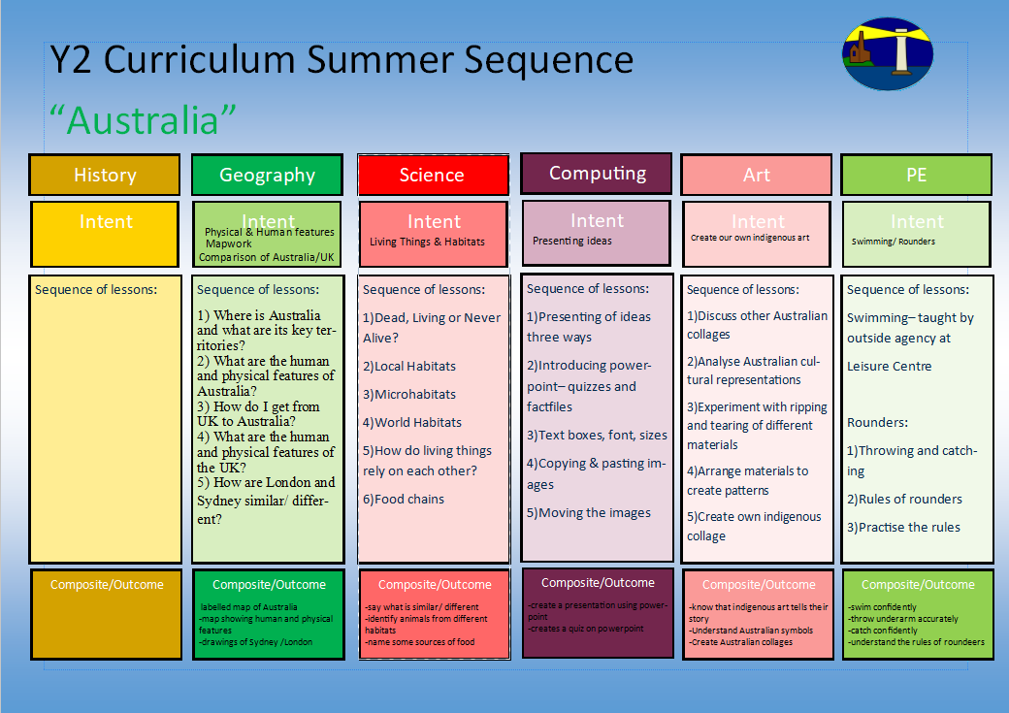
-understanding of pencil control
-understanding of representational drawing

1.I can look at other examples of portraits from a range of artistic styles (pop art/ contemporary/ classic)
2.I can look at mark making with sketch pencils, with a focus on shading and thickness of pencil and creating texture
3.I can practice the skills used in these examples
4.I can draw the key features of a face using youtube videos as support
5.I can draw myself using shading and texture and exploring my own style

Online Safety 2.2
Information Technology around us
1)How can we describe the properties of everyday materials?
2)What are materials around us used to make that we use every day?
3)Which material is the most waterproof and suitable for a rain coat?
4)How do we change the shape of certain materials?
5)What is the difference between natural and manmade materials?
-understand foot and arm position
-aiming and ball control
1)Chest push, underarm throw, over arm
2) Target throwing
3) Catching
4) Rolling and stopping
5) Bouncing and aiming
Multi-skills (ARENA Scheme)
Portrait of themselves
-log on and off
-confident with IT around us and why we have it
- how IT impacts on our world
1)What is IT?
2)IT in school
3)IT in the world
4)Benefits of IT
5)Using IT safely
6)Using IT in different ways
-sorting activities
--design and carry out scientific enquiries
Materials

Y2 Curriculum Autumn Term 2 Sequence

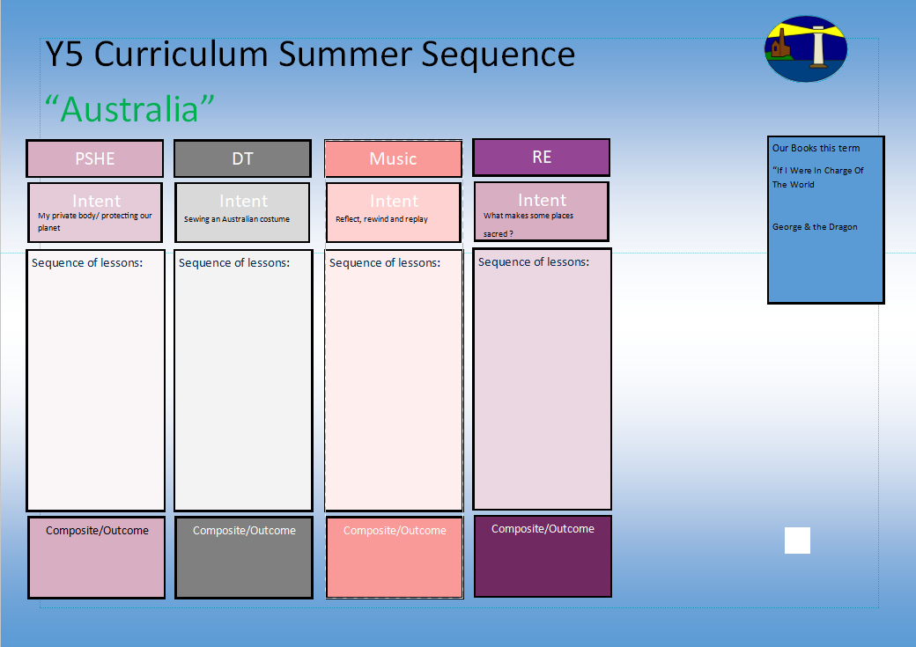
Understanding the use of screen time
Understanding about relaxation.
The dangers of certain drugs

1.I know the Nativity story and know why it is important to Christians.
2.I know how the Christmas story has been represented throughout history.
3.I know how Jesus’ story is told through the Gospels of Mathew and Luke.
4.I know how Advent is celebrated by Christians and why.

Our books this term for English:

The Great Fire of London
Diary
Newspaper Report

Malala’s Magic Pencil
Biography
Christmas Acrostic Poetry
Our books this term for reading comprehension:

-Squash & A Squeeze
-The Twits

Why does Christmas matter to Christians?
Ho Ho Ho

Internet Safety
What is screen time?
Too much screen time is bad.
Relaxing- what it is and how it helps us.
How relaxation and technology can work together.
Medicines and how they can help us.
Smoking and drinking.

Y2 Curriculum Autumn Term 2 Sequence

I know the Christmas story and why it is important to Christians
Share and perform the learning that has taken place

1.Listen and Appraise Classical music
2.Understand about pulse and rhythm
3.Singing along to the pulse
4.Play instruments within the song and to create our own pulse
5.Improvisation using voices and instruments
6.Composition

-How to say no
-What can you remember?
-Private parts rap

-Why is the planet getting warmer?
-What can we do to help?

-Personal Goal Setting
-Adapting to Change

