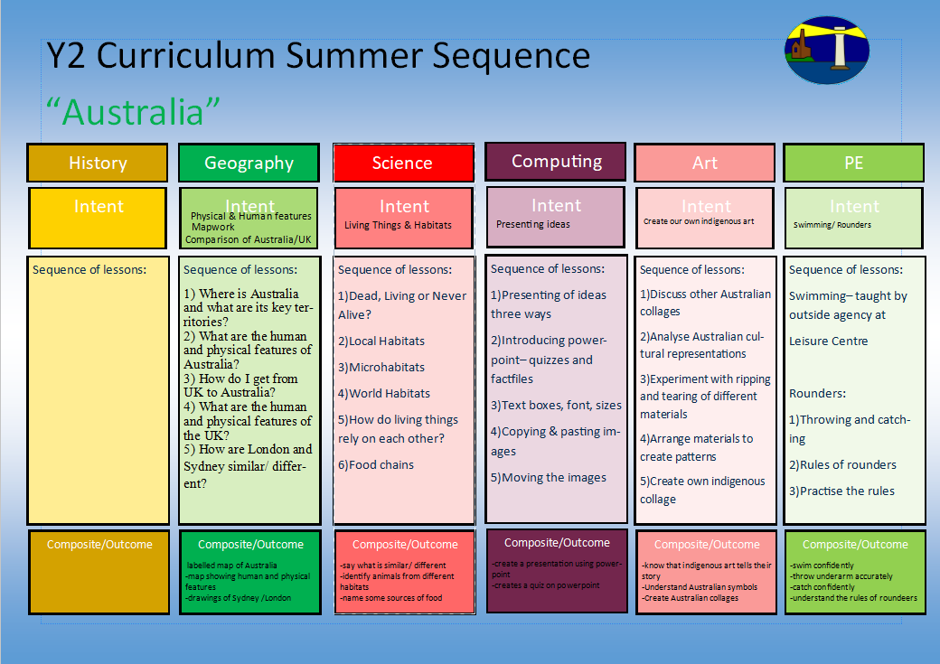
Dance Mat Typing
Open/ Save/ Copy/ Paste
1.Who was King Charles II?
2.Who were the Stuarts?
3.What were the causes of the Great Fire of London and what happened?
4.What were the consequences of the fire?
5. Who is King Charles III and how is he linked to Charles II?
6. How is life different for us today compared to King Charles II’s time?

1. I can use a paint brush with more control and explore other tools when mark making
2. I can identify the 3 primary colours
How do we make colour?
3.I can mix 2 primary colours together to make a secondary colour
4.I can experiment with black and white paint to alter tints and shades
5. I can analyse mood boards that explore primary and secondary colours as well as shades and say how they make me feel.
6. I can create my own moodboard inspired by Paul Klee work.

-understanding primary and secondary colours
-what happens when we add white/ black?

-understanding balance and travelling
-using climbing frames
1)Using the equipment safely
2)Balancing effectively solo and with partner
3)Travelling from one balance to another
4)Exploring equipment in different ways
5)Creating sequences
Gym
Exploring colour, shade and tone
-confident with the keys
-understand how to type efficiently
-how to copy and paste text
1) To be able to use the home row keys
2) to be able to use the home row keys
3) To be able to use the six keys above the home keys
4) To be able to use the six keys above the home keys
5) To learn the six keys below the home keys
6)To copy a piece of text written in class.

-family tree
- timeline
-analysis of representations of the Kings

The GFoL/ The 2 Kings
Y2 Curriculum Spring Term 1 Sequence

Great Fire of London/ Two Kings
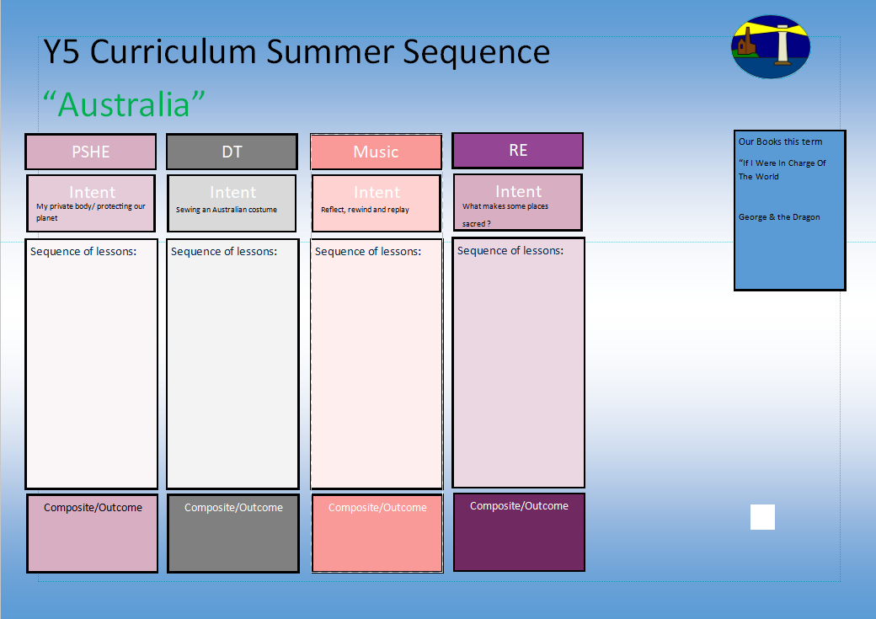
Our books this term for English:

Great Fire of London

The Crow

1.I know who the Prophet Mohammad was and why he is important to Muslims.
2.I know why the Prophet Mohammad was a good leader.
3.I know the man teachings of the prophet Mohammad and how they inspire Muslims.
4.I know how the Qu’ran informs Muslims’ faith.
5.I know how Muslim’s prayer and why.
Our books this term for reading comprehension:

-Owl Who is Afraid of the Dark
-The Twits
Who is Muslim and how do they live?
I wanna play in a band
-how to stabilize a structure
-joining techniques
-finishing techniques

1.I can look at examples of other 3d sculptures
2.I can look how different materials have been used for strength
3.I can look at and practice joining techniques
4.I can design my own 3d bird
5.I can make my own 3d bird
6.I can evaluate my structure against my initial criteria

3d bird
Understanding our emotions
Basic survival needs
Living in the wider world
Basic needs for forest survival
Checklist for forest survival
Preventing a fire
Making a fire escape plan
Y2 Curriculum Spring Term 1 Sequence

How do I get off the ground?

I know how Muslim’s live and can make comparisons to my own life.
Share and perform the learning that has taken place

1.Listen and Appraise Classical music
2.Understand about pulse and rhythm
3.Singing along to the pulse
4.Play instruments within the song and to create our own pulse
5.Improvisation using voices and instruments
6.Composition

Understanding family structure
How to cope with loss
How our body reacts

-How to say no
-What can you remember?
-Private parts rap

-Why is the planet getting warmer?
-What can we do to help?

-Personal Goal Setting
-Adapting to Change

