**Rationale and Principles of Art**

**At St Just Primary School, Art is taught through a bespoke curriculum, tailored to the needs of our children and ensuring progression in skills and knowledge as they move up through the school. Decisions for the topics covered are based on the following reasons:**

**-skill progression**

**-links to topic**

**-links to local area**

**-needs of the children particularly in St Just**

**Through the sequencing of lessons, Art has been covered using ‘art concepts’ and ‘substantive concepts’ which ensures that it is taught thoroughly with depth.**

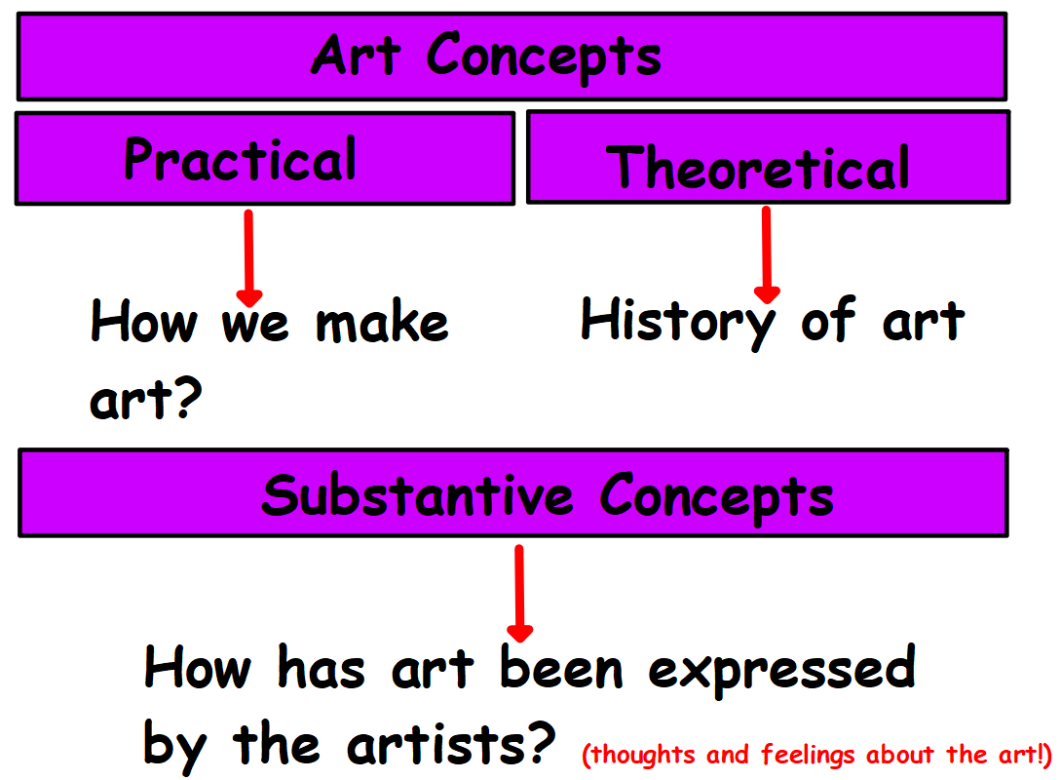

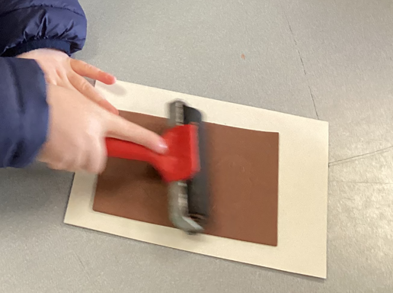

**1**

**2**

**Investigating artist or object being made**

**Investigating and testing tools**

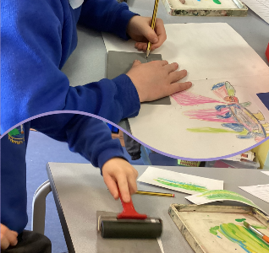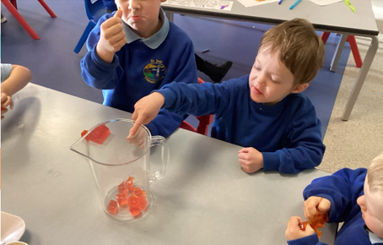

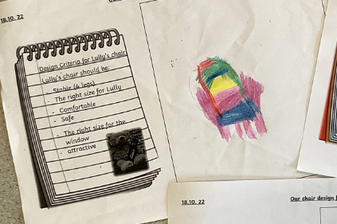

**4**

**3**

**Practice of key skill using tools**

**Creating variety of images/ products**

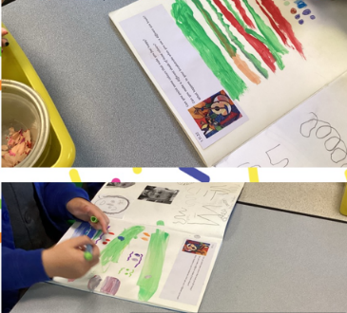

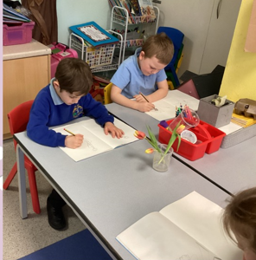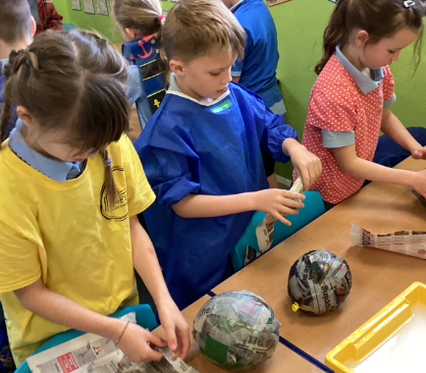

**Evaluation**

**6**

**5**

**Creating final product**

