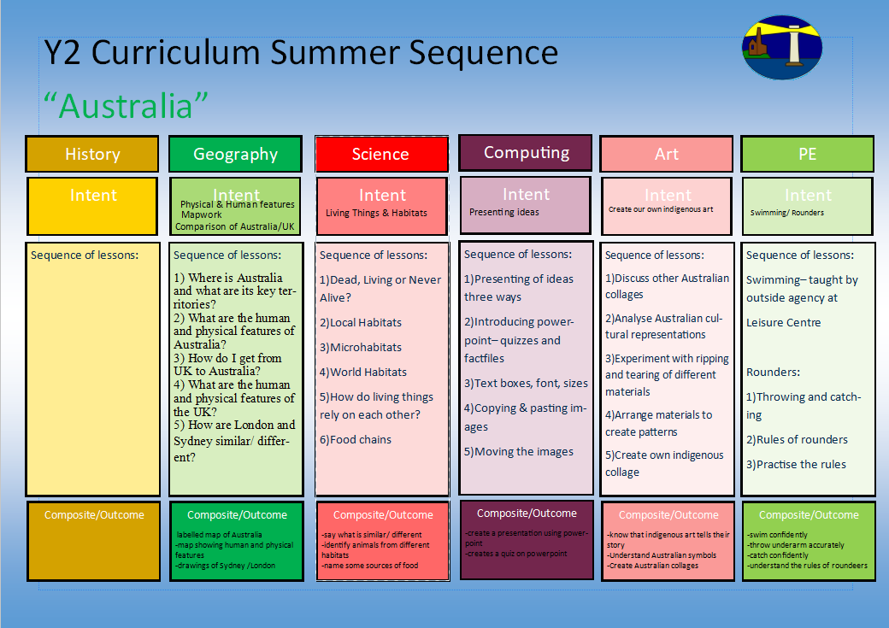

Getting around Australia
1) Where is Australia and what are its key cities?
2) Where Australia is located and what are some of its key human and physical features?
3)How do I get from UK to Australia?
4)What are the human and physical features of the UK?
5) How are the UK and Australia similar and different?

Y2 Curriculum Summer Term 2 Sequence

Australia
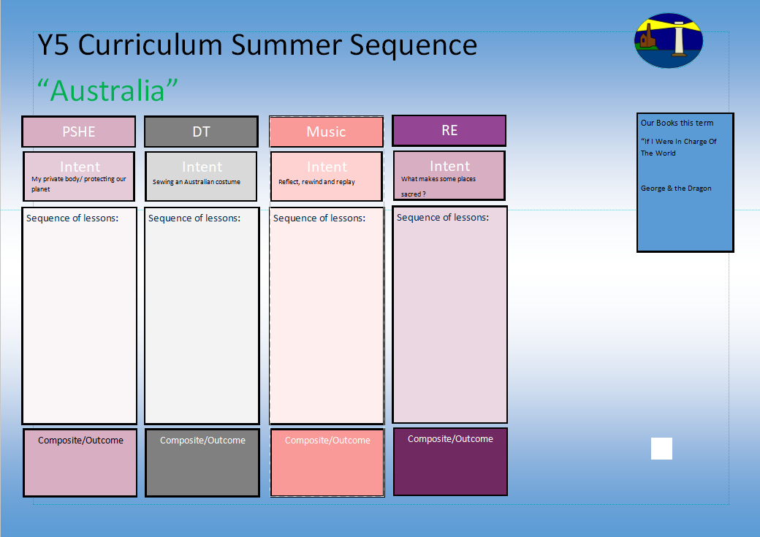
Sewing an Australian animal puppet
-My Private Body – Private parts and how to respond to unwanted touch
-It’s okay not to be okay What it’s like to not be okay
- It’s okay not to be okay What we can do when someone is not feeling ok
- Mental Health – Growing Together
-Adapting to change – What skills help you prepare for change?
- Adapting to change – Preparing to transition to KS2
Y2 Curriculum Summer Term 2 Sequence

Australia
Our books this term for reading comprehension:

-The Enormous Crocodile
-I Don’t Want to be a Frog
Our books this term for English:

If I Were In Charge Of The World
Free Verse poetry

George & the Dragon
Legend
Diary

Understand how all religions are similar and different?
-Where is safe and why?
-What ae the important symbols in all religions?
-What are the special places for Christians?
-What is important in the Jewish faith?
- What is important in the Islamic faith?
Share and perform the learning that has taken place

1.Listen and Appraise Classical music
2.Continue to embed the foundations of the interrelated dimensions of music using voices and instruments
3.Singing
4.Play instruments within the song
5.Improvisation using voices and instruments
6.Composition

Sewing different styles
Joining fabrics
1.1. I can look at examples of Australian animals.
2. I can design my own Australian animal.
3. I can practise a basic running stitch.
4. I can make my own Australian animal.
5. I can evaluate my own Australian animal.
-Adapting to change- resilience
-Understand the importance of respecting each other
-understanding your body

