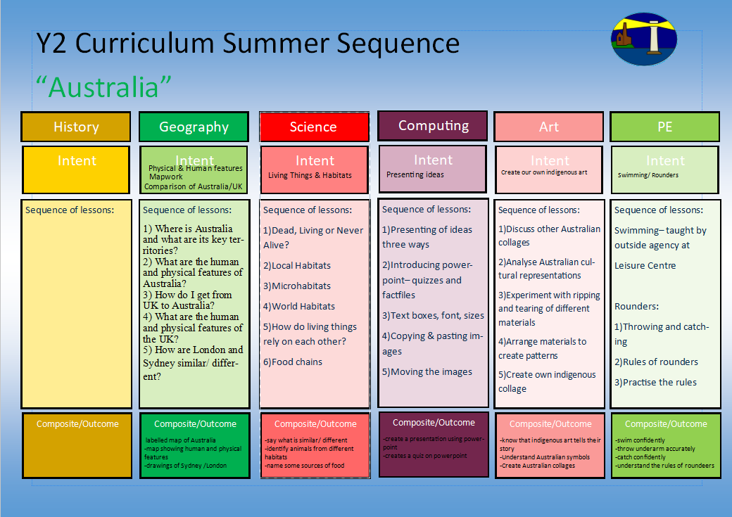
To name the seasons
To understand the different length of days
To explain the different weathers across the seasons

1.Can I name the different seasons
2.What are the different lengths of days across the seasons?
3.What are the different weathers in the Uk and across the world?
4.How do I make a rain gauge and record my findings?
5.How can I present my results in a simple chart or graph?
6.Can I write an instructional text on how to make a rain gauge
Seasonal Change
To work closely as a team and to build fitness
In this unit, the children will develop and apply their ball chasing and floor work balance through focused skill development sessions, thematic stories and games.
Unit 6 Health & Fitness Funs – 11 & 3

Getting around Australia
1) Where is Australia and what are its key cities?
2) Where Australia is located and what are some of its key human and physical features?
3)How do I get from UK to Australia?
4)What are the human and physical features of the UK?
5) How are the UK and Australia similar and different?

Y1 Curriculum Summer Term 2 Sequence

Australia
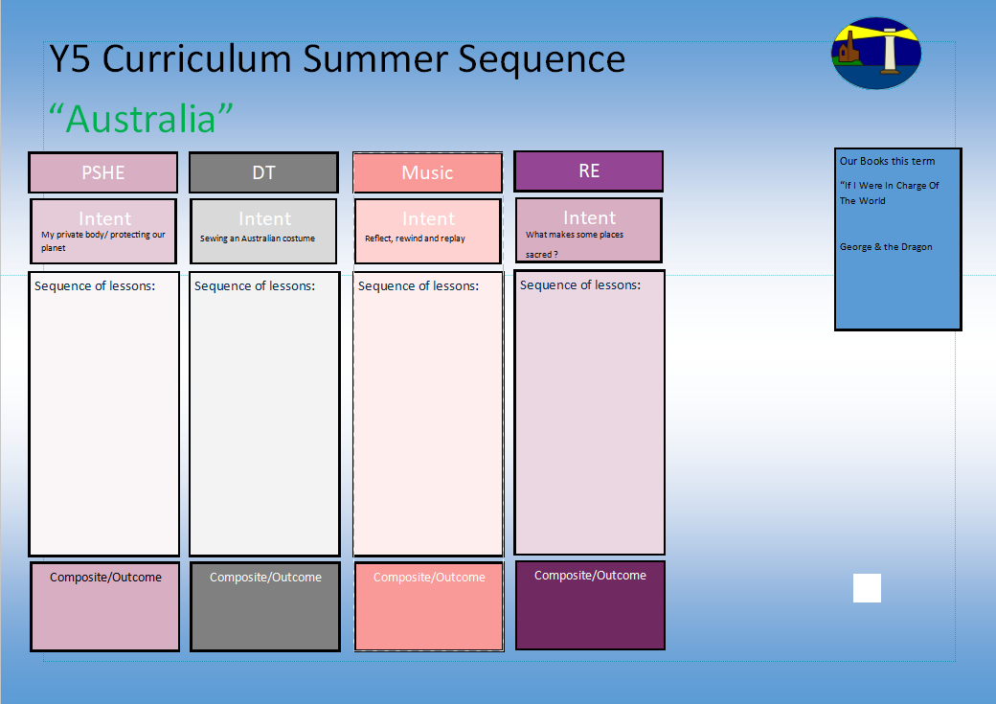
Feelings inside and out
Sewing an Australian animal puppet
My Growing Body
Trust 1
Trust 2
Understanding Difficult Feelings- 1
Understanding Difficult Feelings- 2
Sign Language
Y1 Curriculum Summer Term 2 Sequence

Australia
Our books this term for reading comprehension:

-The Enormous Crocodile

Our books this term for English:

-The Enormous Crocodile

Recount
Understand how all religions are similar and different?
-Where is safe and why?
-What ae the important symbols in all religions?
-What are the special places for Christians?
-What is important in the Jewish faith?
- What is important in the Islamic faith?
Share and perform the learning that has taken place

1.Listen and Appraise Classical music
2.Continue to embed the foundations of the interrelated dimensions of music using voices and instruments
3.Singing
4.Play instruments within the song
5.Improvisation using voices and instruments
6.Composition

Sewing different styles
Joining fabrics
1.1. I can look at examples of Australian animals.
2. I can design my own Australian animal.
3. I can practise a basic running stitch.
4. I can make my own Australian animal.
5. I can evaluate my own Australian animal.
-Adapting to change- resilience
-Understand the importance of respecting each other
-understanding your body

