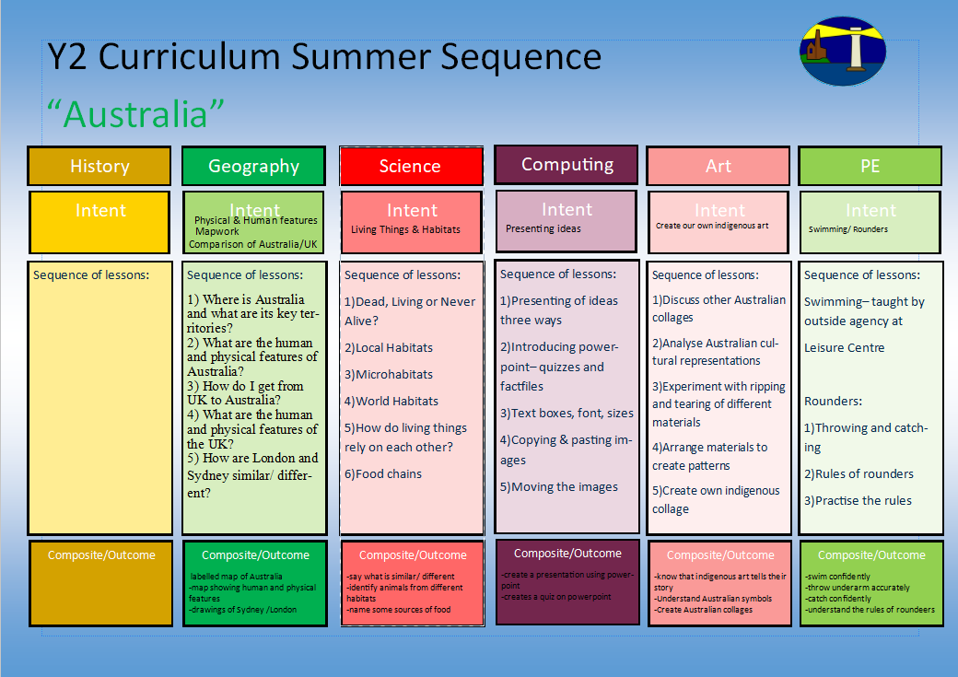
To be able to name the basic functions of a plant and to keep their bean alive.

Can I observe plants, trees and leaves in my local area?
Can I name the basic parts of a plant?
Can I name different species of trees?
Can I name common wild flowers?
Can I name common garden flowers?
Can I plant a range of vegetables, nurture them until ready to eat?

Where is St Just in the world?
-understand foot and arm position
-aiming and ball control
1)Chest push, underarm throw, over arm
2) Target throwing
3) Catching
4) Rolling and stopping
5) Bouncing and aiming
Multi-skills (ARENA Scheme)
-understanding of other artists
-printing

1.I can look at other animal prints from other artists and say what I like
2.I can experiment with mark making using rolling, pressing, stamping and rubbing with different materials
3.I can experiment with collage card to recreate some of my own animal markings
4. I can explore mark making on foam to create my print
5.I can make my own animal print

Create an animal print
-log on and off
-confident with the mouse
-Understand what we mean by IT
1)How do we log on and log off?
2) What programs have we got on the computer?
3) What is IT?
4)What are the benefits of IT?
5)What IT have we got around us?

Logging On & Off
-sorting activities
-life cycles
-animal brochures
-balanced meal wheel
-hygiene experiment
Animals- inc. Humans
-understanding of the world around us
-understanding of maps and keys
1.What does a map of St Just look like?
2.What does a map look like?
3.What countries make up the United Kingdom?
4.What are the capital cities of the United Kingdom?
5.What Continent is the UK in?
6. What are the 5 oceans and seas around the world called?
Y1 Curriculum Autumn Term 1 Sequence

Our Local Area-How has St Just changed over time?
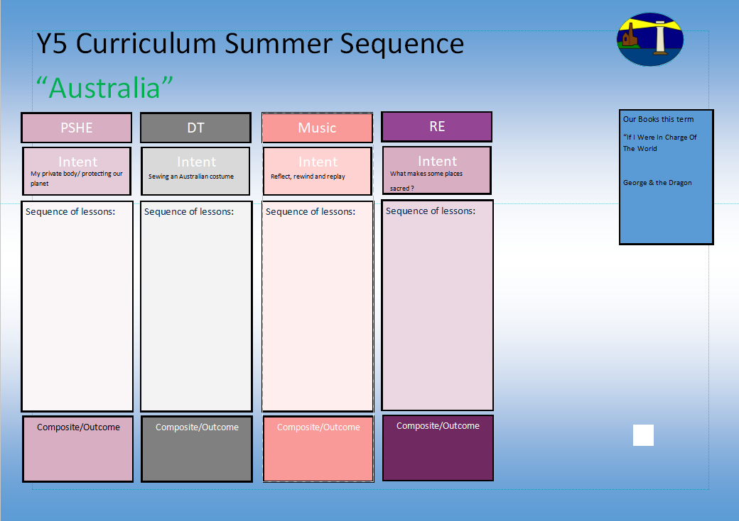
1.What do people/ Muslims think about God?
2. What do the 99 names for God mean?
3. What does the Shahadah say about Muslim beliefs?
4.Who was the Prophet Muhammed?
5.Why is he so important?
6.Why do they treat the Qu’ran with respect?

How to deal mindfulness, happiness and talking.
Our books this term for English:

-Zog & the Flying Doctors

Character Description
Our books this term for reading comprehension:

-Zog & the Flying Doctors

Who is Muslim and how do they live?
Hands, feet, heart
-understanding about food groups
-develop correct cutting technique
-understand about food design
1.I can look at examples of fruits
2.I can taste different fruits and explain which I like and why
3.I can design my own healthy fruit salad
4.I can make my own healthy fruit salad using correct cutting techniques
5.I can evaluate my own healthy fruit salad

Design/ Make a fruit salad
Being Happy- 1
Being Happy- 2
Being Mindful- 1
Being Mindful- 2
A Problem Shared- 1
A Problem Shared- 2
Y1 Curriculum Autumn Term 1 Sequence

Our Local Area-How has St Just changed over time?
I know what a Muslim believes in and how Muslim’s live
Share and perform the learning that has taken place

1.Listen and Appraise Classical music
2.Understand about pulse and rhythm
3.Singing along to the pulse
4.Play instruments within the song and to create our own pulse
5.Improvisation using voices and instruments
6.Composition

-Understanding our emotions.

-How to say no
-What can you remember?
-Private parts rap

-Why is the planet getting warmer?
-What can we do to help?

-Personal Goal Setting
-Adapting to Change

