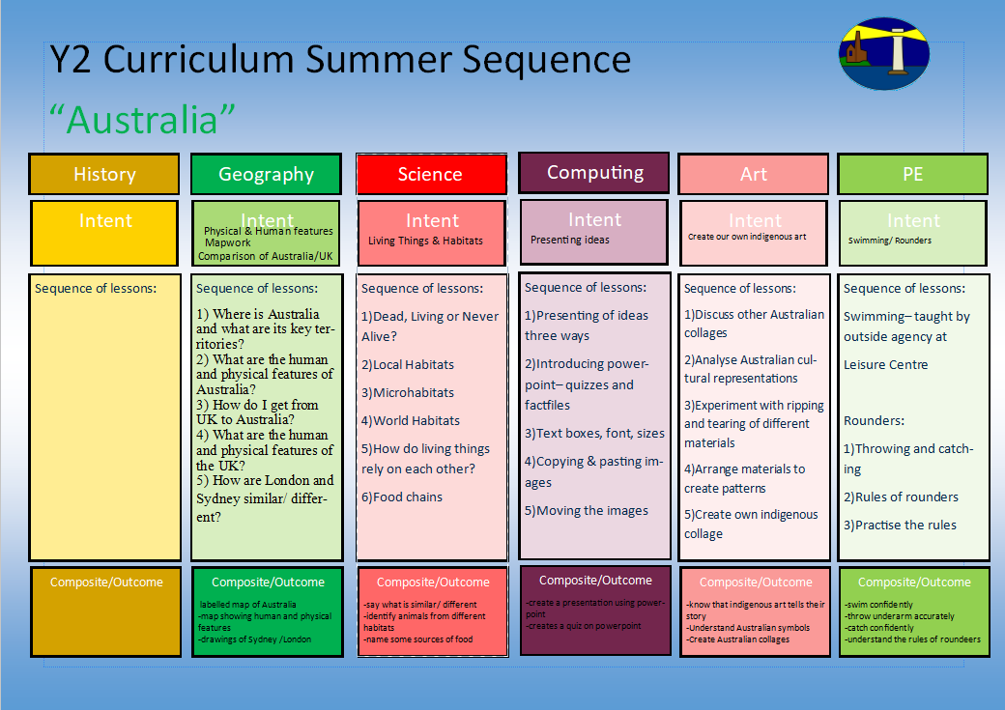
Where is St Just in the world?
-understand foot and arm position
-aiming and ball control
1)Chest push, underarm throw, over arm
2) Target throwing
3) Catching
4) Rolling and stopping
5) Bouncing and aiming
Multi-skills (ARENA Scheme)
-understanding of other artists
-printing

1.I can look at other animal prints from other artists and say what I like
2.I can experiment with mark making using rolling, pressing, stamping and rubbing with different materials
3.I can experiment with collage card to recreate some of my own animal markings
4. I can explore mark making on foam to create my print
5.I can make my own animal print

Create an animal print
-log on and off
-confident with Purple Mash
-Create a picture and save
1)How do we log on and log off?
2) What programs have we got on the computer?
3) How do we use purple mash?
4)How do we create pictures using Purple Mash?
5)How do we save on Purple Mash?

Logging On & Off
Creating Pictures 2.6
-sorting activities
-life cycles
-animal brochures
-balanced meal wheel
-hygiene experiment
1)How are offspring similar and different to their adults?
2)How do animals change as they grow into adults?
3)What can we do as we grow up?
4)What do living things need to survive?
5)How can exercise help us to stay healthy?
6)Why is eating a balanced diet so important?
7) Why is good hygiene so important?
Animals- inc. Humans
-understanding of the world around us
-understanding of maps and keys
-labelled changes to a map
- analysis of old and new pictures of St Just
-predictons of causes
1.What does a map of St Just look like?
2.What does a map look like?
3.What countries make up the United Kingdom?
4.What are the capital cities of the United Kingdom?
5.What Continent is the UK in?
6. What are the 5 oceans and seas around the world called?
How has St Just changed over time and why?
1.What can you see in St Just today?
2.How has St Just changed over time?
3.How has the landscape of St Just changed over the last 100 years?
4.How have our houses changed over time?
5.What do you think St Just will look like in the future?
Y2 Curriculum Autumn Term 1 Sequence

Our Local Area-How has St Just changed over time?
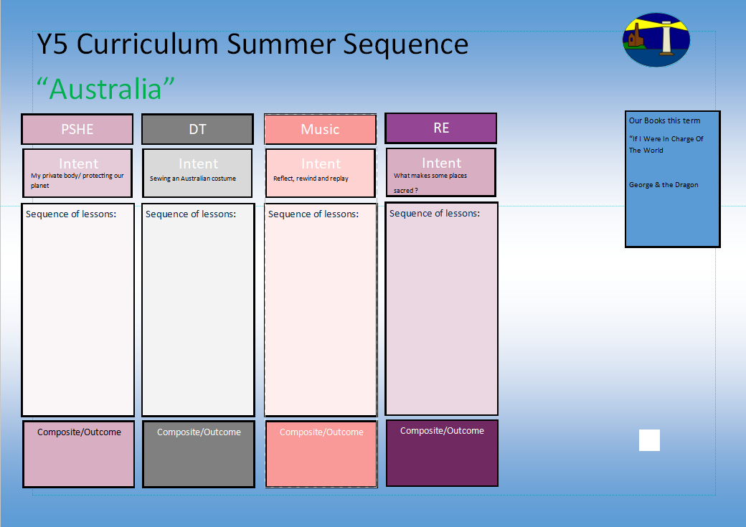
1.What do people/ Muslims think about God?
2. What do the 99 names for God mean?
3. What does the Shahadah say about Muslim beliefs?
4.Who was the Prophet Muhammed?
5.Why is he so important?
6.Why do they treat the Qu’ran with respect?

How to deal with sadness and happiness.
Our books this term for English:

How to make a bird feeder
-Character Description
-Instructions

Our trip to the woods
-Recount
Our books this term for reading comprehension:

-Zog & the Flying Doctors
-Monkey Puzzle

Who is Muslim and how do they live?
Hands, feet, heart
-understanding about food groups
-develop correct cutting technique
-understand about food design
1.I can look at examples of fruits
2.I can taste different fruits and explain which I like and why
3.I can design my own healthy fruit salad
4.I can make my own healthy fruit salad using correct cutting techniques
5.I can evaluate my own healthy fruit salad

Design/ Make a fruit salad
How sadness makes us feel
How sadness can help us help ourselves.
When I feel happy.
What to do when I am not feeling happy.
Coping with loss
Dealing with lost loved ones.
Y2 Curriculum Autumn Term 1 Sequence

Our Local Area-How has St Just changed over time?
I know what a Muslim believes in and how Muslim’s live
Share and perform the learning that has taken place

1.Listen and Appraise Classical music
2.Understand about pulse and rhythm
3.Singing along to the pulse
4.Play instruments within the song and to create our own pulse
5.Improvisation using voices and instruments
6.Composition

-Understanding our emotions.

-How to say no
-What can you remember?
-Private parts rap

-Why is the planet getting warmer?
-What can we do to help?

-Personal Goal Setting
-Adapting to Change

