**Godrevy Class**

**Earth and Space**

**Homework Menu**

As well as reading daily at home, practicing times tables (TTRock Stars) and spellings, we are continuing with our **homework menu** which has once again proved to be extremely popular.

The children will be able to choose a minimum of **two** activities from the selection of tasks below to complete by the end of the topic. At least one activity must be a Literacy (*) based task.

Choose a planet to research and write a ‘Planet Profile’ (*)

Write a newspaper report on the Moon landing. (*)

Observe the night sky and note any constellations you see.

Make a model/picture of our solar system using what you can find at home

Write a postcard from an astronaut in space. Tim Peake perhaps? (*)

Can you create your own simple sundial? Follow the link below, take pictures and talk us through the process: science-sparks.com/how-to-make-a-sundial

Create a solar system scene on Purple Mash.

Complete a labelled diagram showing the effects that space has on an astronaut’s body and what they need to be healthy (foods, workout).

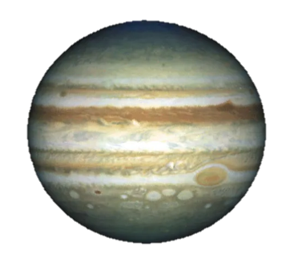

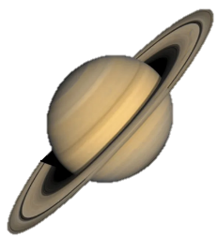

* Please can all homework be completed and brought

into school or uploaded to Seesaw by

Monday 20th October