St Just

Primary School

Art and Design Policy

Aspirations and Achievements; Together One and All

Perseverance - don't give up, perseverance - try your luck!

Enthusiastic in the things we do, enthusiastic me and you

Inspirational - be the best you can be, our inspirations set us free.

Updated July 2023

St Just Primary School

Art Policy

Reviewed July 2023

Purpose:  
The primary purpose of this art policy is to outline our school's approach toward delivering outstanding art education in accordance with the 2014 National Curriculum in England. This policy will guide the delivery of high-quality art provision, ensuring curriculum coverage, progression, and opportunities for creativity, imagination, and critical thinking.

Intent at St Just Primary School:  
  
1. Broad and Balanced Curriculum:  
   - Ensure that art is given its due importance as a foundation subject within a broad and balanced curriculum.  
   - Demonstrate provision for art education which is coherent, well-planned, and stimulates pupils' imagination, creativity, and critical thinking.  
   - Provide articulated links between art curriculum and other subjects across the curriculum to deepen pupils' understanding.  
  
2. Clear Curriculum Intent:  
   - Clearly articulate the school's vision, aims, and objectives for art education, ensuring they are ambitious and tailored to the pupils' needs.  
   - Show a bespoke, sequential, and progressive art curriculum that builds upon prior knowledge, skills, and understanding.  
  
3. High-Quality Teaching and Learning:  
   - Provide a range of effective teaching strategies to engage pupils and develop their artistic skills, techniques, and vocabulary.  
   - Demonstrate opportunities for pupils to explore a variety of media, materials, and techniques, both traditional and digital.  
   - Promote art as a practical subject to develop confidence, resilience, and positive attitudes towards learning.

Implementation at St Just Primary:

At St Just Primary, the implementation of our Art curriculum aims to foster an environment that encourages and celebrates pupils' creativity and imagination. We aim to facilitate opportunities for pupils to generate and communicate their own ideas, interpretations, and responses through art.

- at least one topic per term, which is usually linked to the topic covered in class

- skills and knowledge taught are progressive throughout the school to ensure development within year groups

- class teachers follow the 6 steps outlined to ensure not only are the skills explored but also knowledge of the artists and the materials available to them.

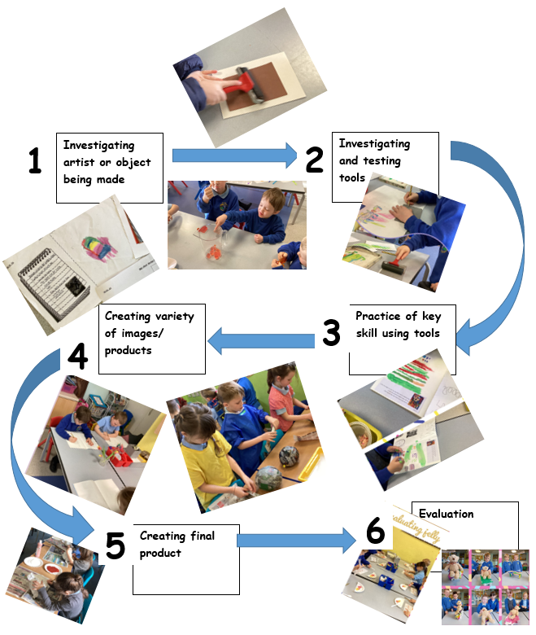

-Children do not just replicate or recreate the artist’s work but ‘reimagine’

- Engage with the local community and external organizations to enrich pupils' art experiences through workshops, trips, and collaborations.  
 - Display and celebrate pupils' artwork within the school and participate in local art events or competitions.

. Impact:  
  Through our art policy, St Just aim to ensure pupils have a clear understanding of important art concepts, including elements of art (line, shape, color, form, etc.), as well as art history, famous artists, and different art movements. We encourage pupils to discuss and evaluate their own artwork, as well as the work of others, using appropriate artistic language.

Assessment and Feedback:  
   - Use effective formative and summative assessment strategies to assess pupils' progression and inform planning.  
   - Provide timely and constructive feedback to pupils that supports their next steps in learning and celebrates their achievements.

-Use an assessment wheel that links to the curriculum expectations and suggests next steps.

Summary:  
In summary, our school's art policy ensures a broad and balanced art curriculum, clear curriculum intent, high-quality teaching and learning, opportunities for creativity and imagination, development of knowledge and understanding, effective assessment and feedback, and community and wider engagement. By implementing this policy, we will provide outstanding art education that meets the needs of our pupils and fulfills the requirements of the 2014 National Curriculum in England.