KEY INSTANT RECALL FACTS
Year 5 – Autumn Term 2

Year 1 – Autumn Term 2

TARGET:
Key Vocabulary
What is 9 multiplied by 12?
What is 11 times 11?
What is the product of 9 and 3?
What is 63 divided by 9?
How did you calculate 7 x 8 = 56?
How many 8’s equal 96?

- I can consolidate the learning of all the multiplication and division facts up to 12 x 12
By the end of this term children should be able to:
- Recall ALL times table facts up to 12 x 12
- Answer these questions in any order, including missing number questions e.g. 9 x ⃝ = 72 and ⃝ ÷ 3 = .8
Top Tips…the secret to success is practising little and often. Use time wisely.
- Practise Key Facts while walking to school or during a car journey.
- Have a fact of the day.
- Buy one get three free – If your child knows one fact (e.g. 9 × 5 = 45), can they tell you the other three facts in the same fact family?
- Songs and Chants: multiplication songs/chants/dances online. Check out … (https://www.bbc.co.uk/teach/supermovers) or www.timestables.co.uk
- If your child creates their own song, this can make the times tables even more memorable.
- Play games – to support your child in maths. Your child has access to Purple Mash, Times Tables Rock Stars and MTC - Multiplication Tables Check - URBrainy.com is brilliant for building number confidence and fluency.
- Hit the Button This game is an online app, free to use and great fun!
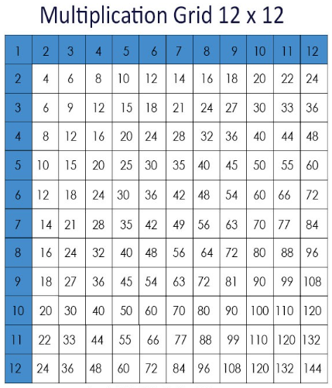
Remember – by the end of the term they should be able to recall these confidently and quickly. Building confidence in mathematics is crucial, so be pleased with their efforts and always encourage with praise. Make sure these practice sessions are enjoyable - if your child is really not in the mood it is the wrong time to be practising!

