St Just
Primary School

Design Technology Policy

Aspirations and Achievements; Together One and All

Perseverance - don't give up, perseverance - try your luck!
Enthusiastic in the things we do, enthusiastic me and you
Inspirational - be the best you can be, our inspirations set us free.

Updated July 2023

St Just Primary School
Design Technology Policy
Reviewed July 2023

Purpose:
This Design Technology Policy outlines the approach, expectations, and strategies for delivering outstanding design technology education in our Primary School, aligned with the 2014 National Curriculum in England.
Aims and Intent:
1.1. To develop students' creativity and imagination through designing, making, and evaluating products.
1.2. To foster problem-solving skills, critical thinking, and collaboration.
1.3. To promote an understanding of the impact of design and technology on society and the environment.
1.4. To put the development of the progression in knowledge and skills at the forefront of the planning.
Implementation
Health and Safety:
1. Appropriate risk assessments will be conducted for all design technology activities.
2. Teachers and support staff will receive regular training on health and safety procedures related to design technology.
3. Safety procedures and guidelines will be prominently displayed, and students will be educated about the safe use of equipment and tools.
Resources and Environment:
1. Sufficient resources, tools, and materials will be provided to support high-quality teaching and learning experiences.
2. Efforts will be made to source sustainable, recycled, and environmentally friendly materials whenever possible.
3. The design technology area will be organized, clean, and well-maintained, promoting a positive learning environment.
Staff Development:
1. Regular professional development opportunities, both internal and external, will be provided to enhance teachers' subject knowledge and pedagogy in design technology.
2. Collaborative planning and sharing of best practices will be encouraged, fostering a culture of continuous improvement.
Engagement with Parents and the Wider Community:
1. Regular communication will be maintained with parents to keep them informed about design technology activities and projects.
2. Opportunities will be created for parents to actively engage in their child's design technology learning, such as through workshops or exhibitions.
3. Links will be established with local industries, professionals, and organizations to showcase authentic applications of design technology.

- at least one topic per term, which is usually linked to the topic covered in class
- skills and knowledge taught are progressive throughout the school to ensure development within year groups
- class teachers follow the 6 steps outlined to ensure not only are the skills explored but also knowledge of the products and the materials available to them.
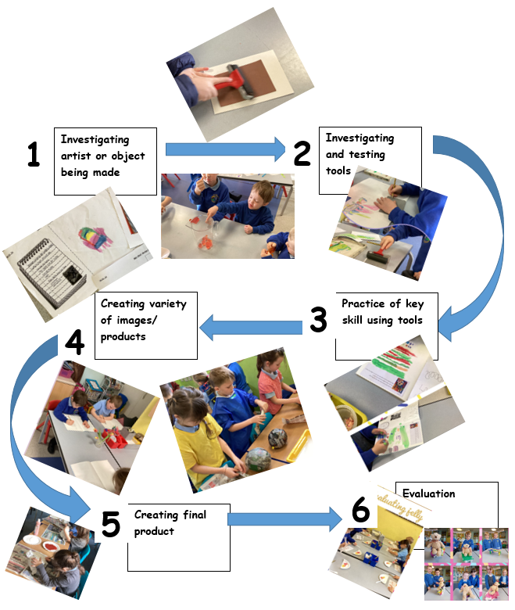

Impact of delivery:
1. The design technology curriculum will provide a balanced and progressive approach, encompassing elements such as structures, mechanisms, electrical control, textiles, cooking, and nutrition.
2. Lessons will be well-sequenced, building on prior knowledge, and planned with clear learning objectives and progression of skills.
3. Cross-curricular links will be established wherever appropriate to enhance students' understanding of design technology in real-world contexts.
4. Differentiation strategies will be used to ensure inclusive access and provision for all students.
5. Assessment and Feedback:
6. Formative and summative assessment approaches will be used to evaluate students' progress and understanding.
7. Constructive feedback will be provided to students, highlighting strengths and areas for improvement.
8. Assessment wheels will be used to inform future planning and ensure curriculum coverage.
This policy will provide a robust framework for the effective delivery of design technology in our Primary School, ensuring outstanding provision is aligned to the National Curriculum 2014.

