KEY INSTANT RECALL FACTS
Year 1 – Spring Term 1

Year 1 – Autumn Term 2

Key Vocabulary
What do I add to 5 to make 10?
What is 10 take away 6?
What is 3 less than 10?
How many more than 2 is 10?

TARGET:
- I know all my number bonds to 10.
- I can count in 10s to 100.
By the end of this term children should be able to:
- Count in 10s confidently to 100: 10, 20, 30, 40, 50, 60, 70, 80, 90, 100.

- Quickly recall number bonds to 10 (Number bonds are 2 numbers that go together to make a number)
Top Tips…the secret to success is practising little and often. Use time wisely.
- Practise Key Facts while walking to school or during a car journey.
- Have a fact of the day.
- Once your child is becoming more confident you could give them one number and ask them “how many more to make 10”.
- They could use cubes, pasta or teddies and ask… “you have 3 teddies in your bed, how many more make 10?”
- Play games – to support your child in maths your child has access to Numbots/Times Tables Rock Stars, Purple Mash and the White Rose 1 minute App (https://whiterosemaths.com/resources/1-minute-maths#download) is brilliant for building number confidence and fluency.
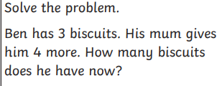
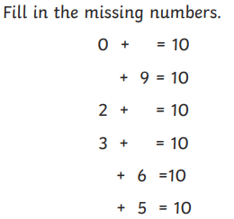
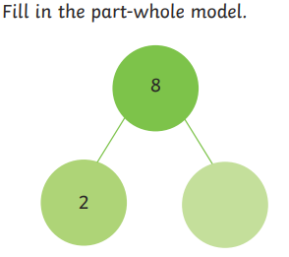
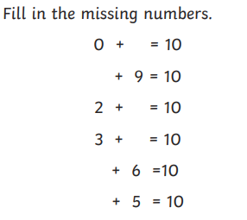

Remember – by the end of the term they should be able to recall these confidently and quickly without counting on their fingers.

