KEY INSTANT RECALL FACTS
Year 1 – Summer Term 2

Year 1 – Autumn Term 2

Key Vocabulary
What day comes after Monday?
What month comes before April?
What is the 9th month of the year?
What season is it after Autumn?

TARGET:
- To know the days of the week and the seasons and months of the year.
By the end of the Summer term children should be able to:
- Know the 7 days of the week in order
- Know the 4 seasons of the year
- Know the 12 months of the year
Top Tips…the secret to success is practising little and often. Use time wisely.
- Practise Key Facts while walking to school or during a car journey.
- Have a fact of the day.
- Sing songs, chant
- Play games – to support your child in maths your child has access to Numbots.
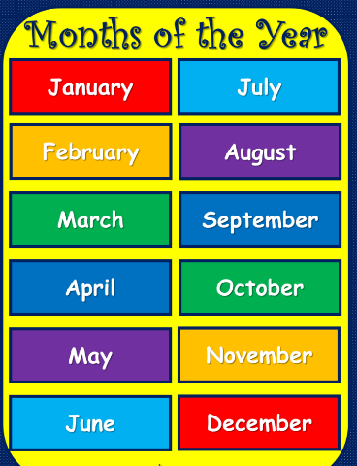
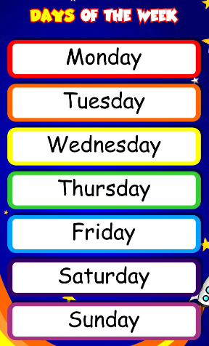
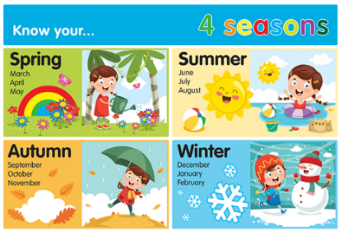

Remember – by the end of the term they should be able to recall these confidently and quickly.

