|  |  |  |
| --- | --- | --- |
| St Just Primary School  Curriculum Map  Design Technology | | |
| **What does Design Technology look like in EYFS?**  In planning and guiding what children learn, practitioners must reflect on the different rates at which children are developing and adjust their practice appropriately, referring to the Characteristics of Effective Teaching and Learning These are: playing and exploring – children investigate and experience things, and ‘have a go’; active learning – children concentrate and keep on trying if they encounter difficulties, and enjoy their achievements for their own sake; creating and thinking critically – children have and develop their own ideas, make links between ideas, and develop strategies for doing things. In addition, the Prime Areas of Learning (Personal, Social and Emotional Development, Communication and Language and Physical Development) underpin and are an integral part of children’s learning in all areas.  *Please see separate EYFS documents for further information on how our curriculum meets the needs of the children in the Tater Du cohort.* | | |
| St Just Primary School - Home**Expressive Design Technology (Exploring and Using Media and Materials)**  Children safely use and explore a variety of materials, tools and techniques, experimenting with colour, design, texture, form and function. | | |
| **Expressive Design Technology (Being Imaginative)**  Children use what they have learnt about media and materials in original ways, thinking about uses and purposes. They represent their own ideas, thoughts and feelings through design and technology, art, music, dance, role play and stories. | | |
| **Opportunties to promote skills.**   * Provide opportunities to work together to develop and realise creative ideas. Reflect with children on how they have achieved their aims.   • Provide a range of materials and tools and teach children to use them with care and precision.  • Promote independence, taking care not to introduce too many new things at once.  • Encourage children to notice features in the natural world and discuss their responses to what they see.  • Help them to define colours, shapes, texture and smells in their own words.  • Visit galleries and museums to generate inspiration and conversation about art and artists | | |
| **Possible vocabulary coverage.**  Mark-make, draw, lines, circles, colour, mix, primary, secondary, texture, form, sculpt, print, art, techniques | | |
| **Development Matters** | | |
| **3-4 years**   * Explore different materials freely, in order to develop their ideas about how to use them and what to make. * Develop their own ideas and then decide which materials to use to express them. * Join different materials and explore different textures. * Create closed shapes with continuous lines, and begin to use these shapes to represent objects. * Draw with increasing complexity and detail, such as representing a face with a circle and including details. * Use drawing to represent ideas like movement or loud noises. * Show different emotions in their drawings and paintings, like happiness, sadness, fear, etc. * Explore colour and colour mixing. | **Reception**   * Explore, use and refine a variety of artistic effects to express   their ideas and feelings.   * Return to and build on their previous learning, refining ideas   and developing their ability to represent them.   * Create collaboratively, sharing ideas, resources and skills. | **ELG – Creating with Materials**  To only be assessed against at the end of the Summer Term, using a ‘Best Fit’ judgement.   * Safely use and explore a variety of materials, tools and techniques, experimenting with colour, design, texture, form and function. * Share their creations, explaining the process they have used. |
| **Physical Development (Moving and Handling)**  Children handle equipment and tools effectively, including pencils for writing.  **Physical Development** is a Prime Area which underpins many of the skills needed to ensure progression within Expressive Arts and Design. The progression of Physical Development Skill are outlined below. | | |
| **3-4 Years**   * Use large-muscle movements to wave flags and streamers,   paint and make marks.   * Choose the right resources to carry out their own plan. * Use one-handed tools and equipment, for example, making snips in paper with scissors. * Use a comfortable grip with good control when holding pens and pencils. | **Reception**   * Develop their small motor skills so that they can use a range of   tools competently, safely and confidently.   * Use their core muscle strength to achieve a good posture   when sitting at a table or sitting on the floor.   * Develop overall body-strength, balance, coordination and agility. | **ELG – Fine Motor Skills**  To only be assessed against at the end of the Summer Term, using a ‘Best Fit’ judgement.   * Hold a pencil effectively in preparation for fluent writing - using   the tripod grip in almost all cases.   * Use a range of small tools, including scissors, paintbrushes and cutlery. * Begin to show accuracy and care when drawing. |
| **Summary of skills by end of year: developing small and gross motor skills; hold a paintbrush and pencil comfortably; hold a pair of scissors effectively; have explored materials for texture; used junk modelling to explore making something and talking about it; become aware of what is on their face** | | |

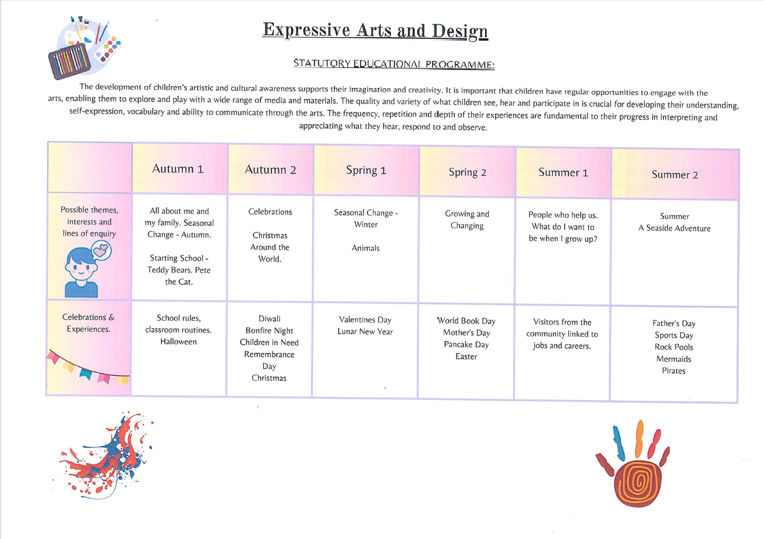

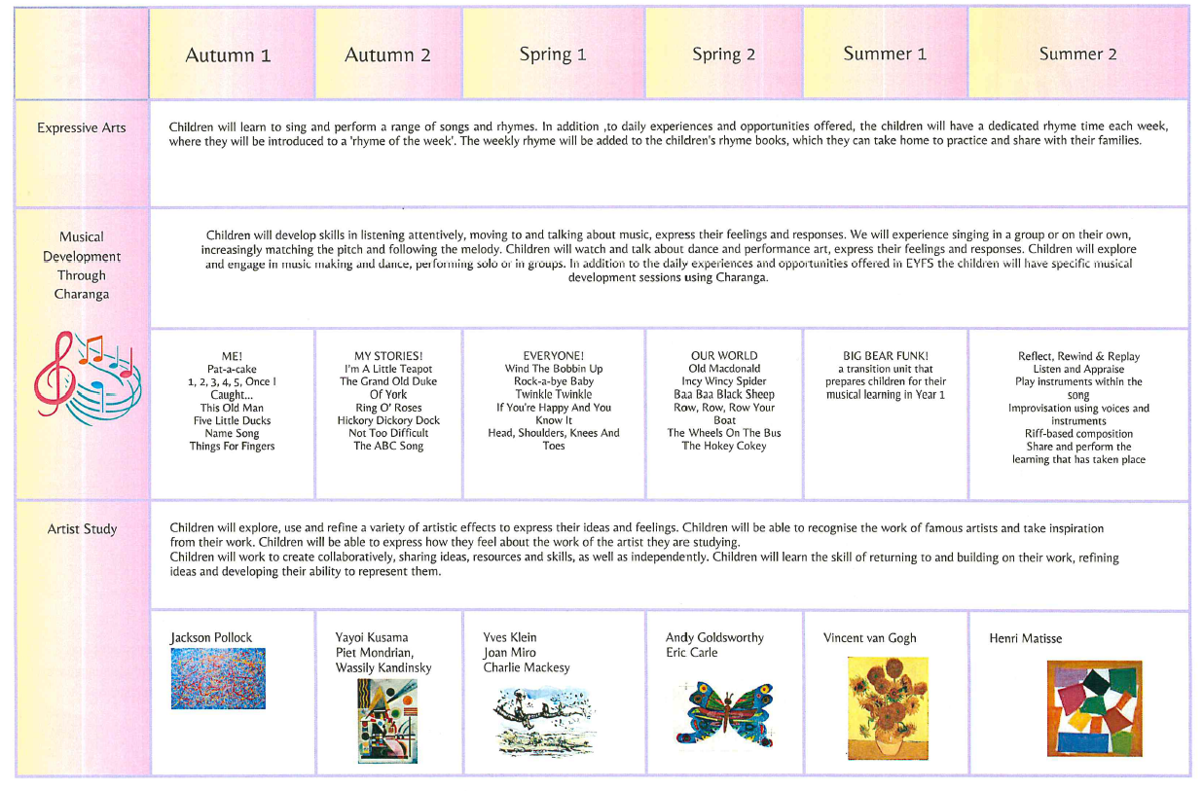

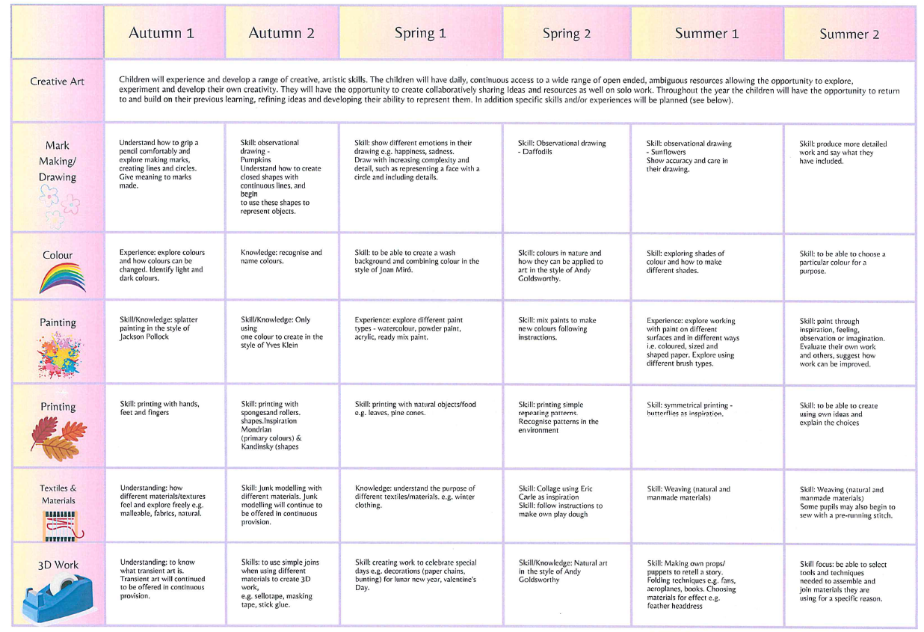

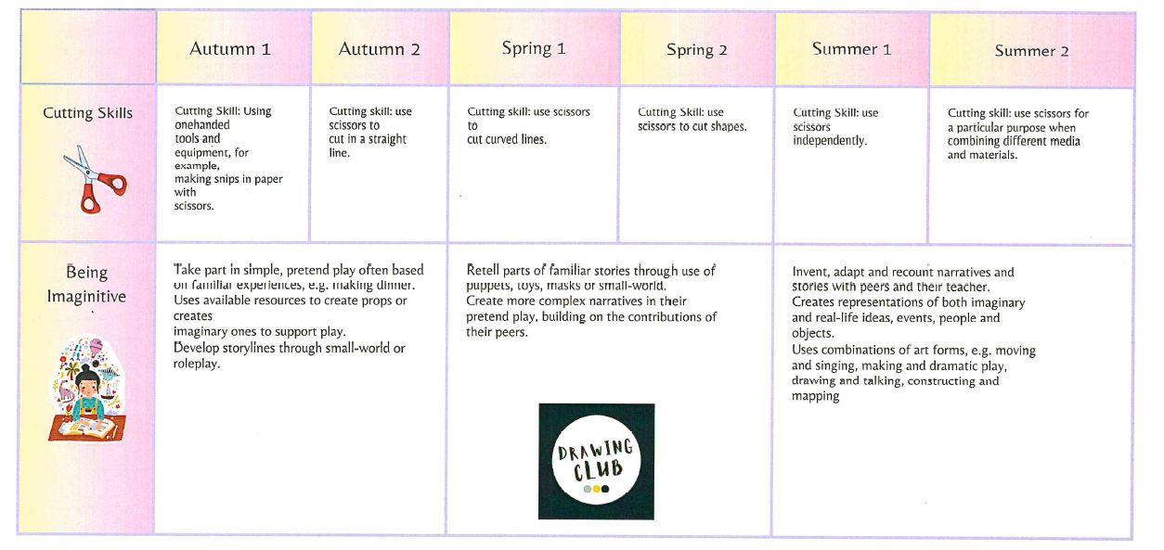

|  |  |
| --- | --- |
| **Key Stage 1 National Curriculum Expectations** | |
| **Design**  Pupils should be taught to:   * design purposeful, functional, appealing products for themselves and other users based on design criteria; * generate, develop, model and communicate their ideas through talking, drawing, templates, mock-ups and, where appropriate, information and communication technology.   **Make**  Pupils should be taught to:   * select from and use a range of tools and equipment to perform practical tasks [for example, cutting, shaping, joining and finishing]; * select from and use a wide range of materials and components, including construction materials, textiles and ingredients, according to their characteristics.   **Evaluate**  Pupils should be taught to:   * explore and evaluate a range of existing products; * evaluate their ideas and products against design criteria. | **Technical Knowledge**  Pupils should be taught to:   * build structures, exploring how they can be made stronger, stiffer and more stable; * explore and use mechanisms [for example, levers, sliders, wheels and axles], in their products.   **Cooking and Nutrition**  Pupils should be taught to:   * use the basic principles of a healthy and varied diet to prepare dishes; * understand where food comes from. |

|  |  |
| --- | --- |
| **Key Stage 2 National Curriculum Expectations** | |
| **Design**  Pupils should be taught to:   * use research and develop design criteria to inform the design of innovative, functional, appealing products that are fit for purpose, aimed at particular individuals or groups; * generate, develop, model and communicate their ideas through discussion, annotated sketches, cross-sectional and exploded diagrams, prototypes, pattern pieces and computer-aided design.   **Make**  Pupils should be taught to:   * select from and use a wider range of tools and equipment to perform practical tasks [for example, cutting, shaping, joining and finishing], accurately; * select from and use a wider range of materials and components, including construction materials, textiles and ingredients, according to their functional properties and aesthetic qualities.   **Evaluate**  Pupils should be taught to:   * investigate and analyse a range of existing products; * evaluate their ideas and products against their own design criteria and consider the views of others to improve their work; * understand how key events and individuals in design and technology have helped shape the world. | **Technical Knowledge**   * apply their understanding of how to strengthen, stiffen and reinforce more complex structures; * understand and use mechanical systems in their products [for example, gears, pulleys, cams, levers and linkages]; * understand and use electrical systems in their products [for example, series circuits incorporating switches, bulbs, buzzers and motors]; * apply their understanding of computing to program, monitor and control their products.   **Cooking and Nutrition**  Pupils should be taught to:   * understand and apply the principles of a healthy and varied diet; * prepare and cook a variety of predominantly savoury dishes using a range of cooking techniques; * understand seasonality, and know where and how a variety of ingredients are grown, reared, caught and processed. |

|  |  |  |  |  |  |  |  |  |  |  |  |  |
| --- | --- | --- | --- | --- | --- | --- | --- | --- | --- | --- | --- | --- |
| **Components**: content and skills that will be taught | | | | | | | | | | | | |
| **YEAR 1** | | | | | | | | | | | | |
| Autumn | | | | | Spring | | | | | Summer | | |
| Our School! | Let’s Celebrate! | | | |  | |  | | | Animal Allsorts | |  |
| STRUCTURES: Build a new classroom chair | COOKING/ NUTRITION: Design and make a jelly | | | |  | |  | | | TEXTILES: Animal puppets | |  |
| **Outcome** | | | | | | | | | | | | |
| To design and build a new classroom chair for the school | To design and make a celebratory jelly | | | |  | |  | | | To design and make an animal puppet | |  |
| **Sequencing** | | | | | | | | | | | | |
| **Summary of previous skills: developing small and gross motor skills; hold a paintbrush and pencil comfortably; hold a pair of scissors effectively; have explored materials for texture; used junk modelling to explore making something and talking about it; become aware of what is on their face** | | | | | | | | | | | | |
| **1.I can look at examples of chairs**  ***What makes it strong?***  ***How is it joined?***  ***What materials are used and why?***  **2.I can generate many ideas as a group**  **3.I can design my own classroom chair and say how I am going to join the different parts**  **4.I can explore different materials for strength, joining and flexibility**  **5.I can make my classroom chair**  **6.I can evaluate my classroom chair against the design criteria** | | **1.I can look at different jellies (unmade and made)**  ***What are their textures? Colour? Ingredients etc?***  **2.I can look at and discuss recipes to make jellies**  **3.I can design my own jelly and explain how I will make it with pictures and key words**  **4.I can make my jelly following hygiene rules**  **5.I can evaluate my jelly** | |  | | | |  | | **1.I can look at other animal puppets**  ***What materials are used? Why?***  ***What do you like? Why?***  ***What joins are being used? What stitches can you see?***  **2.I can design my own animal puppet**  **3.I can practice joining materials in different ways**  **4.I can add decoration to my puppet design**  **5.I can make my animal puppet**  **6.I can evaluate my animal puppet** | |  |
| **Vocabulary** | | | | | | | | | | | | |
| Tier 1: Classroom chair, Roll, Pinch, Flatten, Joining  Tier 2: Design, Stiffening, Flexible, Strength  Tier 3: Sculpture, Evaluate, Improve | Tier 1: Diet, Ingredients, Recipe  Tier 2: Hygiene, Instructions, Taste  Tier 3: Design, Evaluate, Improve, Texture, | | | |  | |  | | | Tier 1: Animals, Puppet, Join, Glue,  Tier 2: Stitches, Observe, Decoration  Tier 3: Design, Evaluate, Improve | |  |
| **Skills progression** | | | | | | | | | | | | |
| **Design** | | | **Make** | | | **Evaluate** | | | **Technical Knowledge** | | **Cooking & Nutrition** | |
| -use their knowledge of existing products and their own experience to help generate ideas as a group  -design products  -explain how their products look and talk through drawings  -design simple models  -understand and follow simple design criteria | | | -with support, follow a simple plan or recipe lead by the class teacher  -begin to select from a range of hand tools and equipment safely and hygienically  -select from materials, textiles and components according to characteristics  -with help, measure and mark out  -assemble, join and combine materials or ingredients  -manipulate fabrics in simple ways to create a desired effect  -use a basic running stitch  -cut, peel and grate ingredients; weighing and measuring ingredients  -begin to use simple finishing techniques, such as decorations | | | -explore existing products mainly through discussions, comparisons and simple written evaluations  -explain positives and things to improve for existing products  -explore what materials products are made from  -talk about their design ideas  -start to make changes and refine their existing design  -evaluate their products and ideas against their simple design criteria | | | -build simple structures, exploring how they can be made stronger, stiffer and more stable  -talk about and start to understand the simple working characteristics of materials  -explore and create products using levers and wheels | | -explain where in the world different foods originate from  -understand that all food comes from plants or animals  -name and sort foods into five groups  -everyone should eat at least 5 portions of fruit and vegetables every day and start to explain why  -design and prepare dishes | |

|  |  |  |  |  |  |  |  |
| --- | --- | --- | --- | --- | --- | --- | --- |
| **Design and Technology- Year 1**  **Key Stage 1 Objectives** | | 1 | 2 | 3 | 4 | 5 | 6 |
| Our School! | Let’s celebrate! | Posting and places | How does your garden grow? | Animal allsorts! | To the recue! |
| **Design** | |  |  |  |  |  |  |
| 1 | design purposeful, functional, appealing products for themselves and other users based on design criteria | **√** | **√** |  |  | **√** |  |
| 2 | generate, develop, model and communicate their ideas through talking, drawing, templates, mock-ups and, where appropriate, information and communication technology | **√** | **√** |  |  | **√** |  |
| **Make** | |  |  |  |  |  |  |
| 1 | select from and use a range of tools and equipment to perform practical tasks (for example, cutting, shaping, joining and finishing) | **√** | **√** |  |  | **√** |  |
| 2 | select from and use a wide range of materials and components, including construction materials, textiles and ingredients, according to their characteristics | **√** | **√** |  |  | **√** |  |
| **Evaluate** | |  |  |  |  |  |  |
| 1 | explore and evaluate a range of existing products | **√** | **√** |  |  | **√** |  |
| 2 | evaluate their ideas and products against design criteria | **√** | **√** |  |  | **√** |  |
| **Technical knowledge** | |  |  |  |  |  |  |
| 1 | build structures, exploring how they can be made stronger, stiffer and more stable. | **√** |  |  |  | **√** |  |
| 2 | explore and use mechanisms (for example, levers, sliders, wheels and axles), in their products | **√** |  |  |  | **√** |  |
| **Cooking and Nutrition** | |  |  |  |  |  |  |
| 1 | use the basic principles of a healthy and varied diet to prepare dishes |  | **√** |  |  |  |  |
| 2 | understand where food comes from |  | **√** |  |  |  |  |
| **Summary of skills by end of year: explore previous examples with guidance from teacher; group discussion on design criteria; independent exploration of materials to investigate stiffness; talk through their drawings with guidance; understand origin of food; simple constructions using joining of materials with support** | | | | | | | |

|  |  |  |  |  |  |
| --- | --- | --- | --- | --- | --- |
| **YEAR 2** | | | | | |
| Autumn | | Spring | | Summer | |
| How has St Just changed? |  | How do I get off the ground? |  | Around the world | Is Australia the place for me? |

|  |  |  |  |  |  |  |  |  |  |  |  |  |
| --- | --- | --- | --- | --- | --- | --- | --- | --- | --- | --- | --- | --- |
| COOKING/ NUTRITION: Design and make a fruit salad |  | | | | STRUCTURES: Sculpture of a 3d bird | |  | | | MECHANISMS: Moving toy | | TEXTILES: Stitching/ sowing- making an Australian animal |
| **Outcome** | | | | | | | | | | | | |
| To design and make healthy fruit salad |  | | | | To create a 3d bird sculpture | |  | | | To design and make a moving toy | | To design and make an Australian animal |
| **Sequencing & Skills Progression** | | | | | | | | | | | | |
| Prior skills:  Chn can talk about food they like and dislike  Chn can talk about what a piece of fruit smells/ tastes/ feels like  Chn to cut fruit with adult supervision | |  | | Prior skills:  Chn can explore materials linked to stiffness  Chn can test different materials suitable for the sculpture  Chn can cut materials with adult support  Chn can join some materials with masking tape | | | |  | | Prior skills:  Chn can design a toy using a large group idea  Chn can talk about how a toy moves in basic terms  Chn can say why they like a toy  Chn can discuss materials used for different toys | | Prior skills:  Chn can hold a needle and thread with 1:1 adult support  Chn can talk about what they like and what they do not like  Chn can explore sewing different materials in a straight line |
| **1.I can look at examples of fruits**  ***What good groups can you see?***  ***What does each food group do for your body?***  **2.I can taste different fruits and explain which I like and why**  **3.I can design my own healthy fruit salad**  **4.I can make my own healthy fruit salad using correct cutting techniques**  **5.I can evaluate my own healthy fruit salad** | |  | | **1.I can look at examples of other 3d sculptures**  **2.I can look how different materials have been used for strength**  **3.I can look at and practice joining techniques**  **4.I can design my own 3d bird**  **5.I can make my own 3d bird**  **6.I can evaluate my structure against my initial criteria** | | | |  | | **1.I can look at moving toys**  ***What makes them move?***  ***What materials are being used?***  ***What components can you see?***  ***Can you label these on a diagram?***  **2.I can design my own moving toy for a particular age group**  **3.I can practice joining different materials**  **4.I can explore different materials depending on strength, flexibility etc**  **5.I can make my own moving toy**  **6.I can decorate my moving toy**  **7.I can evaluate my moving toy** | | **1.1. I can look at examples of Australian animals.**  **2. I can design my own Australian animal.**  **3. I can practise a basic running stitch.**  **4. I can make my own Australian animal.**  **5. I can evaluate my own Australian animal.** |
| **Vocabulary** | | | | | | | | | | | | |
| Tier 1: Healthy, Balanced diet, Taste, Cut, Slice, Hygiene  Tier 2: Design, Texture,  Tier 3: Make,  Evaluate, Diagram |  | | | | Tier 1: Sculpture, 3d, Strength, Standing  Tier 2: Model, Shapes,  Materials, Rigid, Joining  Tier 3: Make,  Evaluate, Diagram | |  | | | Tier 1: Moving toy, Decoration, Strength, Flexibility, Stiffness, Joining  Tier 2: Lever, Diagram, Axle, Design, Experiment  Tier 3: Components, Evaluate, Make | | Tier 1: Colours, Materials, Joins, Flexible  Tier 2: Running stitch, Decoration, Design, Make  Tier 3: Culture, Evaluate, Improve |
| **Skills progression** | | | | | | | | | | | | |
| **Design** | | | **Make** | | | **Evaluate** | | | **Technical Knowledge** | | **Cooking & Nutrition** | |
| -use their knowledge of existing products and their own experience to help generate ideas  -design products that have purpose  -explain how their products look and talk through annotated drawings  -design simple models  -test ideas  -understand and follow simple design criteria | | | -with support, follow a simple plan or recipe  -begin to select from a range of hand tools and equipment safely and hygienically  -select from a range of materials, textiles and components according to characteristics  -with help, measure and mark out  -assemble, join and combine materials or ingredients  -manipulate fabrics in simple ways to create a desired effect  -use a basic running stitch  -cut, peel and grate ingredients; weighing and measuring ingredients  -begin to use simple finishing techniques, such as decorations | | | -explore and evaluate existing products mainly through discussions, comparisons and simple written evaluations  -explain positives and things to improve for existing products  -explore what materials products are made from  -talk about their design ideas  -start to make changes and refine their existing design  -evaluate their products and ideas against their simple design criteria | | | -build simple structures, exploring how they can be made stronger, stiffer and more stable  -talk about and start to understand the simple working characteristics of materials  -explore and create products using levers and wheels | | -explain where in the world different foods originate from  -understand that all food comes from plants or animals  -food has to be farmed, grown elsewhere or caught  -name and sort foods into five groups  -everyone should eat at least 5 portions of fruit and vegetables every day and start to explain why  -design and prepare dishes | |

|  |  |  |  |  |  |  |  |
| --- | --- | --- | --- | --- | --- | --- | --- |
| **Design and Technology- Year 2**  **Key Stage 1 Objectives** | | 1 | 2 | 3 | 4 | 5 | 6 |
| How has St Just changed? |  | How do I get off the ground? |  | Around the world | Is Australia the place for me? |
| **Design** | |  |  |  |  |  |  |
| 1 | design purposeful, functional, appealing products for themselves and other users based on design criteria | **√** |  | **√** |  | **√** | **√** |
| 2 | generate, develop, model and communicate their ideas through talking, drawing, templates, mock-ups and, where appropriate, information and communication technology | **√** |  | **√** |  | **√** | **√** |
| **Make** | |  |  |  |  |  |  |
| 1 | select from and use a range of tools and equipment to perform practical tasks (for example, cutting, shaping, joining and finishing) | **√** |  | **√** |  | **√** | **√** |
| 2 | select from and use a wide range of materials and components, including construction materials, textiles and ingredients, according to their characteristics | **√** |  | **√** |  | **√** | **√** |
| **Evaluate** | |  |  |  |  |  |  |
| 1 | explore and evaluate a range of existing products | **√** |  | **√** |  | **√** | **√** |
| 2 | evaluate their ideas and products against design criteria | **√** |  | **√** |  | **√** | **√** |
| **Technical knowledge** | |  |  |  |  |  |  |
| 1 | build structures, exploring how they can be made stronger, stiffer and more stable. |  |  | **√** |  | **√** |  |
| 2 | explore and use mechanisms (for example, levers, sliders, wheels and axles), in their products |  |  |  |  | **√** |  |
| **Cooking and Nutrition** | |  |  |  |  |  |  |
| 1 | use the basic principles of a healthy and varied diet to prepare dishes | **√** |  |  |  |  |  |
| 2 | understand where food comes from | **√** |  |  |  |  |  |
| **Summary of skills by end of year: explore previous examples with some guidance from teacher and developing small group design criteria with some support; independent exploration of materials to investigate stiffness, flexibility and qualities for various reasons; talk through their drawings with guidance and label resources needed; understand origin of food; prepare a simple dish with support; simple constructions using joining of materials with support with some knowledge of finishing qualities** | | | | | | | |

|  |  |  |  |  |  |
| --- | --- | --- | --- | --- | --- |
| **YEAR 3** | | | | | |
| Autumn | | Spring | | Summer | |
| Stone Age- Set in stone | Magnetism- What’s the Attraction? |  |  | Romans |  |

|  |  |  |  |  |  |  |  |  |  |  |  |  |
| --- | --- | --- | --- | --- | --- | --- | --- | --- | --- | --- | --- | --- |
| STRUCTURES: Simple shelter for a hunter | ENTERPRISE  Magnetic game | | | |  | |  | | | COOKING/ NUTRITION: Make bread for a Roman family  Vegetable soup | |  |
| **Outcome** | | | | | | | | | | | | |
| To design and make a simple shelter for a hunter | To design and make a magnetic game to sell | | | |  | |  | | | To design and make Roman vegetable soup and bread | |  |
| **Sequencing & Skills Progression** | | | | | | | | | | | | |
| Prior skills:  Chn can explore and experiment with materials linked with texture, colour and stiffness  Chn can finish a product with some final techniques  Chn can join materials with some finishing techniques within small groups | | Prior skills:  Use their knowledge of existing products and their own experience to help generate ideas  Design products that have purpose  Explain how their products look and talk through annotated drawings  Design simple models  Test ideas  Understand and follow simple design criteria | |  | | | |  | | Prior skills:  Chn can cut small fruit/ vegetables independently  Chn can talk about where food comes from  Chn can design a product through whole group discussions  Chn can say what they did well and what they would improve and why | |  |
| **1.I can look at examples of simple Stone Age shelters**  ***What do you notice?***  ***What materials are used and why?***  ***How are they joined?***  ***Which materials are best suited and why?***  **2.I can generate and design multiple ideas with labelled diagrams**  **3.I can practice joining materials**  **4.I can measure, mark and cut materials with some degree of accuracy**  **5.I can make my shelter**  **6.I can decorate my Stone Age shelter**  **7.I can evaluate my shelter** | | **1. I can look at examples of toys designed for children on sale now**  ***Why are they attractive?***  ***What is their unique selling point?***  **2. I can explore how magnets work and discuss how magnets are used in games**  **3. I can design and annotate 2 magnetic toys that fit our brief**  **4. I can select from my designs and make detailed notes on how it works**  **5. I can make my magnetic game**  **6. I can evaluate how my magnetic game works by allowing other children to play with it** | |  | | | |  | | **1.I can look at different ingredients used back in the Roman days**  ***Do we still get these ingredients? Why?***  ***How do our soup recipes differ to back then? Why?***  **2.I can taste different vegetables and breads and evaluate them on texture, colour, taste etc**  **3.I can design and write my own recipe guide for making a Roman soup**  **4.I can make my own Roman soup**  **5.I can evaluate my own Roman soup** | |  |
| **Vocabulary** | | | | | | | | | | | | |
| Tier 1: Shelter, Stone Age, Materials, Joining  Mark, Decorate, Design, Make, Cut  Tier 2: Suitability  Measure, Strengthen, Stiffen  Tier 3: Accurate, Safety, Evaluate, Reinforce | Tier 1: Game, Magnetic, Cut, Shape  Tier 2: Design, Make Stiffen, Product  Tier 3: Enterprise  Evaluate, Accuracy, Purpose | | | |  | |  | | | Tier 1: Romans, Ingredients, Recipe, Hygiene, Healthy, Balanced Diet, Cut, Temperature, Design  Tier 2: Taste, Texture, Appearance, Slice, Grate, Boil  Tier 3:Make, Evaluate, Improve, Purpose | |  |
| **Skills progression** | | | | | | | | | | | | |
| **Design** | | | **Make** | | | **Evaluate** | | | **Technical Knowledge** | | **Cooking & Nutrition** | |
| -identify the features of their products that will appeal  -look at a range of existing products to help generate ideas  -design appealing products with a purpose  -explain how particular parts of their products work  -use annotated sketches to communicate ideas  -explore different initial ideas as a group before coming up with final design  -test out ideas  -develop and follow a simple criteria | | | -select tools and equipment and explain choices with growing confidence  -select from a range of materials  -place main stages of making in a logical order  -learn to use a range of equipment safely and hygienically  -measure and mark with growing confidence  -cut, join and shape materials with some degree of accuracy  -join textiles using a sewing technique  -improve the final product | | | - evaluate existing products, explaining the purpose of the product and whether it has been designed to meet the purpose  -explore why materials might be selected  -alter plans depending on feed back and improvements needed  -evaluate their product against their original design | | | -strengthen, stiffen and reinforce complex structures  -explain how levers create movement | | -start to know when, where and how food in grown in the UK, Europe and the wider world  -understand how to prepare and cook a savoury dish safely and hygienically  -use a heat source to cook ingredients whilst controlling temperature  -mashing, whisking, crushing, grating, cutting, kneading and baking  -explain that a healthy diet is made up of a balance of foods  -prepare ingredients using appropriate utensils  -independently follow a recipe | |

|  |  |  |  |  |  |  |  |
| --- | --- | --- | --- | --- | --- | --- | --- |
| **Design and Technology- Year 3**  **Key Stage 2 Objectives** | | 1 | 2 | 3 | 4 | 5 | 6 |
| Set In Stone | What’s The Attraction | Shake Rattle And Roll | Are Humans animal Too? | What did The Romans Do For Us? | Source to Sea |
| **Design** | |  |  |  |  |  |  |
| 1 | use research and develop design criteria to inform the design of innovative, functional, appealing products that are fit for purpose, aimed at particular individuals or groups | **√** | **√** |  |  | **√** |  |
| 2 | generate, develop, model and communicate their ideas through discussion, annotated sketches, cross-sectional and exploded diagrams, prototypes, pattern pieces and computer-aided design | **√** | **√** |  |  | **√** |  |
| **Make** | |  |  |  |  |  |  |
| 1 | select from and use a wider range of tools and equipment to perform practical tasks (for example, cutting, shaping, joining and finishing), accurately | **√** | **√** |  |  | **√** |  |
| 2 | select from and use a wider range of materials and components, including construction materials, textiles and ingredients, according to their functional properties and aesthetic qualities | **√** |  |  |  | **√** |  |
| **Evaluate** | |  |  |  |  |  |  |
| 1 | investigate and analyse a range of existing products | **√** | **√** |  |  | **√** |  |
| 2 | evaluate their ideas and products against their own design criteria and consider the views of others to improve their work | **√** | **√** |  |  | **√** |  |
| 3 | understand how key events and individuals in design and technology have helped shape the world | **√** | **√** |  |  |  |  |
| **Technical knowledge** | |  |  |  |  |  |  |
| 1 | apply their understanding of how to strengthen, stiffen and reinforce more complex structures | **√** | **√** |  |  |  |  |
| 2 | understand and use mechanical systems in their products (for example, gears, pulleys, cams, levers and linkages) |  | **√** |  |  |  |  |
| 3 | understand and use electrical systems in their products (for example, series circuits incorporating switches, bulbs, buzzers and motors |  | **√** |  |  |  |  |
| 4 | apply their understanding of computing to programme, monitor and control their products. |  |  |  |  |  |  |
| **Cooking and Nutrition** | |  |  |  |  |  |  |
| 1 | understand and apply the principles of a healthy and varied diet |  |  |  |  | x |  |
| 2 | prepare and cook a variety of predominantly savoury dishes using a range of cooking techniques |  |  |  |  | x |  |
| 3 | understand seasonality, and know where and how a variety of ingredients are grown, reared, caught and processed |  |  |  |  | x |  |
| **Summary of skills by end of year: explore previous examples with some guidance from teacher and begin developing individual design criteria with some support; independent exploration of materials to investigate stiffness, flexibility and qualities for various reasons; talk through their drawings through exploded diagrams and label resources needed; understand origin of food and reasons for this; prepare a simple dish with some support; simple constructions using a range of joining of materials with support with some good knowledge of finishing qualities** | | | | | | | |

|  |  |  |  |  |  |
| --- | --- | --- | --- | --- | --- |
| **YEAR 4** | | | | | |
| Autumn | | Spring | | Summer | |
| Digestive System- Where does my food go? | Were the Anglo- Saxons good for Britain? |  | It’s Electric! | Rainforests |  |

|  |  |  |  |  |  |  |  |  |  |  |
| --- | --- | --- | --- | --- | --- | --- | --- | --- | --- | --- |
| COOKING/ NUTRITION: Create a fruit smoothie that is good for the digestive system | TEXTILES: Embroider a tapestry based on the Bayeux Tapestry | | |  | | ELECTRICAL SYSTEMS: Torches | | STRUCTURES: Wire sculpture of an Amazon animal | |  |
| **Composite/ Outcome** | | | | | | | | | | |
| To design and create a fruit smoothie | To design and make an embroidered tapestry using applique | | |  | | To design and make a torch. | | To design and make a wire sculpture of an Amazon animal | |  |
| **Sequencing & Skills Progression** | | | | | | | | | | |
| Prior skills:  Chn can discuss origin of food and reasons for this  Chn can slice, peel and crush food depending on need of recipe  Chn can discuss criteria and design own  Chn can evaluate their product and suggest next steps | Prior skills:  Chn can map out their basic design for sewing  Chn can thread a needle with support from an adult  Chn can make decisions about the colours needed  Chn can change direction when sewing | |  | | | Prior skills:  Chn can select tools and equipment and explain choices with growing confidence  Chn can select from a range of materials  Chn can use annotated sketches to communicate ideas  Chn can explore different initial ideas as a group before coming up with final design  Chn can test out ideas  Chn can develop and follow a simple criteria | | Prior skills:  Chn can design and evaluate with links to a specific design criteria  Chn can test different materials for stiffness, flexibility etc  Chn to can experiment with joining techniques  Chn can begin to develop their finishing techniques | |  |
| **1. I can understand that vegetables and fruit grow in certain seasons and is affected by climate**  **2. I can look at food items and which are good for the digestive system**  **3. I can look at examples of fruit and vegetables that provide nutritional benefits**  **4. I can design my own fruit smoothie with labelled diagrams**  **5. I can make my own fruit smoothie and know how to store and clean a knife safely.**  **6. I can evaluate my fruit smoothie** | **1. I can look at the layout and design of the Bayeaux Tapestry**  **2. I can practice a running stitch and other stitches for appearance**  **3. I can create a design inspired by the Bayeux Tapestry**  **4. I can use applique to attach fabric together**  **5. I can create a stitching plan**  **6. I can make my own tapestry**  **7. I can evaluate my tapestry based on the design criteria** | |  | | | **1. I can look at several torches and disassemble them to understand how they work.**  **2. I can label using exploded diagrams the different parts of a torch.**  **3. I can analyse and evaluate an electrical products (torch)**  **4. I can design a product to fit a set of specific user needs.**  **5. I can make and evaluate a torch against a design criteria.** | | **1. I can look at examples of wire sculptures**  ***How do they stand up?***  ***How are they supported?***  ***How are they made strong?***  ***How are they joined?***  **2. I can design multiple generate ideas with labelled diagrams and exploded diagrams**  **3. I can practice sculpting safely with wire**  **4. I can explore joining techniques**  **5. I can design and make my final sculpture**  **6. I can use finishing techniques to improve my sculpture**  **7. I can evaluate my sculpture** | |  |
| **Vocabulary** | | | | | | | | | | |
| Tier 1: Diagram, Design,  Make, Healthy, Slice, Grate, Measure, Balanced Diet  Tier 2: Digestive system, Blow Up Designs  Tier 3: Anatomy, Nutritional benefit, Evaluate, Refine | Tier 1: Tapestry, Sewing, Join, Needle, Thread, Eye, Design, Make  Tier 2: Running stitch, Cross stitch  Tier 3: Applique  Evaluate, Refine, Improve | | |  | | Tier 1: Design, Make, Electricity, Electrical circuit, Switch, Torch  Tier 2: Circuit, Components, Conductor, Lens, Battery, Wires, Contact, Bulb, Reflector  Tier 3: Disassemble,  Exploded diagrams  Target audience | | Tier 1: Sculpture, 3d, Wire, Joining, Flexible  Tier 2: Rigid, Strength, Safety, Design, Make  Tier 3: Exploded diagrams, Evaluate, Refine, Improve | |  |
| **Skills progression** | | | | | | | | | | |
| **Design** | | **Make** | | | **Evaluate** | | **Technical Knowledge** | | **Cooking & Nutrition** | |
| -identify the features of their products that will appeal  -broad range of existing products to help generate ideas  -design appealing products with a clear purpose  -explain how particular parts of their products work  -use annotated sketches to communicate ideas  -explore different initial ideas before coming up with final design  - explain choice of materials including functionality and aesthetic  -test out ideas  -develop and follow a simple criteria | | -carefully select a range of tools and equipment and explain choices with growing confidence  -select from a range of materials according to functionality and aesthetic  -place main stages of making in a systematic order  -learn to use a range of equipment safely and hygienically  -measure and mark with growing confidence  -cut, join, shape and score materials with some degree of accuracy  -join textiles using a sewing technique  -use a finishing technique to improve the final product | | | -explore and evaluate existing products, explaining the purpose of the product and whether it has been designed to meet the purpose  -explore why materials might be selected  -alter plans depending on feedback and improvements needed  -evaluate their product against their original design | | -understand that materials have both functional and aesthetic properties  -strengthen, stiffen and reinforce complex structures  -explain how levers create movement | | -start to know when, where and how food in grown in the UK, Europe and the wider world  -understand how to prepare and cook a variety of savoury dishes safely and hygienically  -use a heat source to cook ingredients whilst controlling temperature  -mashing, whisking, crushing, grating, cutting, kneading and baking  -explain that a healthy diet is made up of a balance of foods  -prepare ingredients using appropriate utensils  -measure and weigh ingredients  -independently follow a recipe | |

|  |  |  |  |  |  |  |  |
| --- | --- | --- | --- | --- | --- | --- | --- |
| **Design and Technology- Year 4**  **Key Stage 2 Objectives** | | 1 | 2 | 3 | 4 | 5 | 6 |
| Where does our food go? | Were the Anglo- Saxons good for Britain? |  | Crime and Punishment: Gangsta Granny | Rainforests |  |
| **Design** | |  |  |  |  |  |  |
| 1 | use research and develop design criteria to inform the design of innovative, functional, appealing products that are fit for purpose, aimed at particular individuals or groups |  | **√** |  | **√** | **√** |  |
| 2 | generate, develop, model and communicate their ideas through discussion, annotated sketches, cross-sectional and exploded diagrams, prototypes, pattern pieces and computer-aided design |  | **√** |  | **√** | **√** |  |
| **Make** | |  |  |  |  |  |  |
| 1 | select from and use a wider range of tools and equipment to perform practical tasks (for example, cutting, shaping, joining and finishing), accurately | **√** | **√** |  | **√** | **√** |  |
| 2 | select from and use a wider range of materials and components, including construction materials, textiles and ingredients, according to their functional properties and aesthetic qualities | **√** | **√** |  | **√** | **√** |  |
| **Evaluate** | |  |  |  |  |  |  |
| 1 | investigate and analyse a range of existing products | **√** | **√** |  | **√** | **√** |  |
| 2 | evaluate their ideas and products against their own design criteria and consider the views of others to improve their work | **√** | **√** |  | **√** | **√** |  |
| 3 | understand how key events and individuals in design and technology have helped shape the world |  |  |  | **√** |  |  |
| **Technical knowledge** | |  |  |  |  |  |  |
| 1 | apply their understanding of how to strengthen, stiffen and reinforce more complex structures |  | **√** |  | **√** | **√** |  |
| 2 | understand and use mechanical systems in their products (for example, gears, pulleys, cams, levers and linkages) |  |  |  |  |  |  |
| 3 | understand and use electrical systems in their products (for example, series circuits incorporating switches, bulbs, buzzers and motors |  |  |  | **√** |  |  |
| 4 | apply their understanding of computing to programme, monitor and control their products. |  |  |  |  |  |  |
| **Cooking and Nutrition** | |  |  |  |  |  |  |
| 1 | understand and apply the principles of a healthy and varied diet | **√** |  |  |  |  |  |
| 2 | prepare and cook a variety of predominantly savoury dishes using a range of cooking techniques | **√** |  |  |  |  |  |
| 3 | understand seasonality, and know where and how a variety of ingredients are grown, reared, caught and processed | **√** |  |  |  |  |  |
| **Summary of skills by end of year: explore previous examples with a little guidance from their teachers; developing individual design criteria with a little support; independent exploration of materials to investigate stiffness, flexibility and qualities for various reasons; talk through their drawings through exploded diagrams and label resources needed; understand how electricity is used in everyday appliances; understand origin of food and reasons for this and make selections based on this; prepare a simple dish with some independent skill; some complex constructions using a range of joining of materials with some good knowledge of finishing qualities** | | | | | | | |

|  |  |  |  |  |  |
| --- | --- | --- | --- | --- | --- |
| **YEAR 5** | | | | | |
| Autumn | | Spring | | Summer | |
| To the stars- Cosmic |  | Ancient Greeks |  | Indus Valley |  |

|  |  |  |  |  |  |  |  |  |  |  |  |  |
| --- | --- | --- | --- | --- | --- | --- | --- | --- | --- | --- | --- | --- |
| GEARS, LEVERS AND PULLEYS: To create a pop up book of the solar system |  | | | | COOKING/ NUTRITION: Design and make Greek food for a family | |  | | | STRUCTURE: Wire/ clay/ mod roc Indus Valley sculpture | |  |
| **Composite/ Outcome** | | | | | | | | | | | | |
| To design and make a pop up book of the solar system using gears, levers and pulleys |  | | | | To design and make Greek food | |  | | | To design and make an Indus Valley sculpture | |  |
| **Sequencing & Skills Progression** | | | | | | | | | | | | |
| Prior skills:  Chn can design a product linked to a general criteria  Chn can experiment with materials linked to its quality, flexibility and stiffness  Chn can create basic exploded diagrams to show plan  Chn can evaluate with suggestions of next steps | |  | | Prior skills:  Chn can make selections of ingredients based on their locality  Chn can use a range of preparation techniques and give reasons  Chn can design to a criteria  Chn can test and evaluate, beginning to make their own choices | | | |  | | Prior skills:  Chn can explore materials based on a set criteria  Chn can explore a range of joining techniques with some support  Chn can discuss their plan using an exploded diagram  Chn can hone their finishing techniques | |  |
| **1.I can analyse levers and pulleys**  **2.I can look at other examples of pop up books and discuss the authors choices**  **3.I can design individual solar system pop ups using pulleys and levers**  **4.I can experiment with different materials for strength and flexibility**  **5.I can design my own solar system pop up book with exploded and labelled diagrams**  **6.I can make my own solar system pop up book**  **7.I can evaluate my own solar system pop up book** | |  | | **1.I can look at examples of Greek food**  ***What ingredients are used?***  ***What do you like? Why?***  ***What do you think about the taste, texture, aroma etc?***  **2.I can look at Greek recipes**  **3.I can generate multiple designs for Greek recipes against a design criteria with exploded and labelled diagrams**  **4.I can safely and hygienically make a Greek recipe**  **5.I can evaluate my Greek food** | | | |  | | **1.I can look at other sculptures**  ***What do you like/ not like? Why?***  ***How is it stood up?***  ***What materials are strong, flexible, stiff? Etc***  **2.I can explore materials with joining and manipulation**  **3.I can generate multiple designs with exploded, detailed and labelled diagrams**  **4.I can design and make my final sculpture**  **5.I can use finishing techniques to improve and alter my designs**  **6.I can evaluate my sculpture based on the design criteria** | |  |
| **Vocabulary** | | | | | | | | | | | | |
| Tier 1: Solar system, Book, Design, Make  Tier 2: Levers, Gears, Pulleys, Join, Flexibility, Strength  Tier 3: Purpose, Function, Replica, Exploded diagram  Evaluate |  | | | | Tier 1: Greek Food, Recipes, Diagrams, Step by step, Design, Instructions  Tier 2: Hygiene, Safety, Chop, Cut, Slice, Grate, Boil, Health, Balanced diet  Tier 3: Evaluate, Purpose, Function, Exploded diagram, Product | |  | | | Tier 1: Sculptures, Materials, Strengthen, Flexibility, Stiffen, Diagrams, 3D  Tier 2: Joining, Cut, Mark, Measure, Groove, Safety, Accuracy, Assemble  Tier 3: Evaluate, Purpose, Function, Exploded diagram, Product | |  |
| **Skills progression** | | | | | | | | | | | | |
| **Design** | | | **Make** | | | **Evaluate** | | | **Technical Knowledge** | | **Cooking & Nutrition** | |
| -use research to inform and develop detailed design  (innovative and appealing)  -know of a broad range of existing products to generate ideas  -design products with a specific purpose  -explain how particular parts of their products work  -annotated sketches  -discuss ideas as a group and come to a final design | | | - plan and suggest next steps  -select from a range of tools and equipment; explaining their choices  -select a range of materials according to functionality  - create a guide  -follow hygiene procedures  -take measurements needed  -cut a range of materials with growing precision and accuracy  -shape and score with growing precision and accuracy  -assemble, join, tape, pin, cut, shape and combine materials with growing accuracy | | | -complete a competitor analysis of other products  -evaluate quality, manufacture and fitness for purpose of their finished product  -evaluate their finished product against their original design criteria | | | -apply their understanding of how to strengthen, stiffen and reinforce complex structures to create useful products  -safety awareness: children should understand and follow safety rules when using tools. They should know to wear appropriate safety gear, such as safety goggles, and to keep their hands and fingers clear of the saw blade.  -hand-eye coordination: sawing requires precise movements, so children should have good hand-eye coordination to guide the saw along the intended line  -understanding measurements: children should understand measurements, such as the depth and width of the groove they want to create. This knowledge will help them mark the wood accurately and guide the saw along the desired path | | -know and give examples of food that is grown, reared and caught in the UK, Europe and wider world (present and past)  -understand about availability and how this may affect planning recipes  -prepare and cook a dish safely and hygienically using a heat source  -adapt recipes (appearance, taste, texture and aroma)  -measure ingredients with growing accuracy from a recipe  -independently follow a recipe | |

|  |  |  |  |  |  |  |  |
| --- | --- | --- | --- | --- | --- | --- | --- |
| **Design and Technology- Year 5**  **Key Stage 2 Objectives** | | 1 | 2 | 3 | 4 | 5 | 6 |
| To the stars |  | Ancient Greeks |  | Indus Valley |  |
| **Design** | |  |  |  |  |  |  |
| 1 | use research and develop design criteria to inform the design of innovative, functional, appealing products that are fit for purpose, aimed at particular individuals or groups | **√** |  | **√** |  | **√** |  |
| 2 | generate, develop, model and communicate their ideas through discussion, annotated sketches, cross-sectional and exploded diagrams, prototypes, pattern pieces and computer-aided design | **√** |  | **√** |  | **√** |  |
| **Make** | |  |  |  |  |  |  |
| 1 | select from and use a wider range of tools and equipment to perform practical tasks (for example, cutting, shaping, joining and finishing), accurately | **√** |  | **√** |  | **√** |  |
| 2 | select from and use a wider range of materials and components, including construction materials, textiles and ingredients, according to their functional properties and aesthetic qualities | **√** |  | **√** |  | **√** |  |
| **Evaluate** | |  |  |  |  |  |  |
| 1 | investigate and analyse a range of existing products | **√** |  | **√** |  |  |  |
| 2 | evaluate their ideas and products against their own design criteria and consider the views of others to improve their work | **√** |  | **√** |  | **√** |  |
| 3 | understand how key events and individuals in design and technology have helped shape the world |  |  | **√** |  |  |  |
| **Technical knowledge** | |  |  |  |  |  |  |
| 1 | apply their understanding of how to strengthen, stiffen and reinforce more complex structures | **√** |  |  |  | **√** |  |
| 2 | understand and use mechanical systems in their products (for example, gears, pulleys, cams, levers and linkages) | **√** |  |  |  |  |  |
| 3 | understand and use electrical systems in their products (for example, series circuits incorporating switches, bulbs, buzzers and motors |  |  |  |  |  |  |
| 4 | apply their understanding of computing to programme, monitor and control their products. |  |  |  |  |  |  |
| **Cooking and Nutrition** | |  |  |  |  |  |  |
| 1 | understand and apply the principles of a healthy and varied diet |  |  | **√** |  |  |  |
| 2 | prepare and cook a variety of predominantly savoury dishes using a range of cooking techniques |  |  | **√** |  |  |  |
| 3 | understand seasonality, and know where and how a variety of ingredients are grown, reared, caught and processed |  |  | **√** |  |  |  |
| **Summary of skills by end of year: explore previous examples independently and suggest thoughts on product; develop individual design criteria; independent exploration of materials to investigate stiffness, flexibility and qualities for various reasons; talk through their drawings through detailed exploded diagrams and label resources needed; understand origin of food and reasons for this and make selections based on this; prepare a simple dish with independent skill and using a range of tools; some complex constructions using a range of joining of materials with some good knowledge of finishing qualities** | | | | | | | |

|  |  |  |  |  |
| --- | --- | --- | --- | --- |
| **YEAR 6** | | | | |
| Autumn | | Spring | | Summer |
|  | Evolution & Inheritance |  |  | Beyond 1066- World War 2 & Battle of Britain |
|  |  |  |  | 1.COOKING/ NUTRITION: Wartime food  2.MECHANISMS/ ELECTRICAL SYSTEMS: Moving World War 2 plane  CAM mechanisms |

|  |  |  |  |  |  |  |  |  |  |  |  |
| --- | --- | --- | --- | --- | --- | --- | --- | --- | --- | --- | --- |
| **Composite/ Outcome** | | | | | | | | | | | |
|  |  | | |  | |  | | | 1.To design and create a wartime cake  2.To create a moving World War 2 plane using electrical systems and mechanisms | | |
| **Sequencing & Skills Progression** | | | | | | | | | | | |
|  |  | |  | | | |  | | 1.Prior skills:  Chn can use a range of tools to prepare foods  Chn understand the origin of food and reasons behind it  Chn design according to a criteria  Chn can measure ingredients with some support  Chn can evaluate and suggest next steps | | 2.Prior skills:  Chn can investigate previous toys and discuss what makes it work  Chn can explore a range of mechanisms  Chn can plan against a design criteria  Chn can explore a range of materials linked to stiffness, flexibility etc  Chn understand the electrical components |
|  |  | |  | | | |  | | **1.Research rationed food during WW2**  ***What ingredients were /were not readily available?***  ***Why?***  **2. Importance of food hygiene**  **3. Design & create a wartime cake**  **4. Evaluate a savory dish** | | **1. Look at and investigate a variety of moving toys.**  **2. Investigate CAM mechanisms**  **3. Investigate CAMS (eccentric, snail, drop, oval, …)**  **4. Design criteria & developing ideas**  **5. Design specification (finalise design) & plan**  **6. Make**  **7. Evaluate** |
| **Vocabulary** | | | | | | | | | | | |
|  |  | | |  | |  | | | Tier 1: War Time, Taste, Texture, Quantity, Health and Safety  Tier 2: Hygiene, Rationing, Bridge, Claw, Savory  Tier 3: Research, Product, Implication, Purpose, Function | | Tier 1: CAM, Mechanism, Movement  Tier 2: Axle / shaft, Rigidity, Snail CAM, Drop CAM, Dowel, Clamp, Hacksaw  Tier 3: Linear motion, Triangulation, Specification, Research, Product, Implication, Purpose, Function |
| **Skills progression** | | | | | | | | | | | |
| **Design** | | **Make** | | | **Evaluate** | | | **Technical Knowledge** | | **Cooking & Nutrition** | |
| -use research to inform and develop detailed design  (innovative, functional, fit for purpose, target market and appealing)  -know of a broad range of existing products to generate ideas  -design products with a clear purpose  -explain how particular parts of their products work  -annotated sketches; cross- sectional drawings and exploded diagrams  -generate a range of ideas and come to a final design  -consider costings of resources | | -independently plan and suggest next steps  -select from a wide range of tools and equipment; explaining their choices  -select a range of materials according to functionality and aesthetic  - create a step-by-step guide  -follow hygiene procedures  -take exact measurements within 1 millimetre  -cut a range of materials with precision and accuracy  -shape and score with precision and accuracy  -assemble, join, tape, pin, cut, shape and combine materials with accuracy  -refine the finish to improve appearance | | | -complete a detailed competitor analysis of other products  -critically evaluate quality, manufacture and fitness for purpose of their finished product  -evaluate their finished product against their original design criteria (make any changes needed) | | | -apply their understanding of how to strengthen, stiffen and reinforce complex structures to create useful products  -understand the ‘input, process and output’ of mechanical and electrical systems  -explain how mechanical systems such as CAMS create movement  -apply their understanding of computing to program, monitor and control a product | | -know, explain and give examples of food that is grown, reared and caught in the UK, Europe and wider world (present and past)  -understand about availability and how this may affect planning recipes  -understand that food is processed into ingredients for cooking  -prepare and cook a dish safely and hygienically using a heat source  -adapt and refine recipes (appearance, taste, texture and aroma)  -alter methods  -measure ingredients accurately from a recipe  -independently follow a recipe | |

|  |  |  |  |  |  |  |  |
| --- | --- | --- | --- | --- | --- | --- | --- |
| **Design and Technology- Year 6**  **Key Stage 2 Objectives** | | 1 | 2 | 3 | 4 | 5 | 6 |
|  |  |  |  |  | World War 2/ Battle of Britain |
| **Design** | |  |  |  |  |  |  |
| 1 | use research and develop design criteria to inform the design of innovative, functional, appealing products that are fit for purpose, aimed at particular individuals or groups |  |  |  |  |  | **√** |
| 2 | generate, develop, model and communicate their ideas through discussion, annotated sketches, cross-sectional and exploded diagrams, prototypes, pattern pieces and computer-aided design |  |  |  |  |  | **√** |
| **Make** | |  |  |  |  |  |  |
| 1 | select from and use a wider range of tools and equipment to perform practical tasks (for example, cutting, shaping, joining and finishing), accurately |  |  |  |  |  | **√** |
| 2 | select from and use a wider range of materials and components, including construction materials, textiles and ingredients, according to their functional properties and aesthetic qualities |  |  |  |  |  | **√** |
| **Evaluate** | |  |  |  |  |  |  |
| 1 | investigate and analyse a range of existing products |  |  |  |  |  | **√** |
| 2 | evaluate their ideas and products against their own design criteria and consider the views of others to improve their work |  |  |  |  |  | **√** |
| 3 | understand how key events and individuals in design and technology have helped shape the world |  |  |  |  |  | **√** |
| **Technical knowledge** | |  |  |  |  |  |  |
| 1 | apply their understanding of how to strengthen, stiffen and reinforce more complex structures |  |  |  |  |  | **√** |
| 2 | understand and use mechanical systems in their products (for example, gears, pulleys, cams, levers and linkages) |  |  |  |  |  | **√** |
| 3 | understand and use electrical systems in their products (for example, series circuits incorporating switches, bulbs, buzzers and motors |  |  |  |  |  | **√** |
| 4 | apply their understanding of computing to programme, monitor and control their products. |  |  |  |  |  |  |
| **Cooking and Nutrition** | |  |  |  |  |  |  |
| 1 | understand and apply the principles of a healthy and varied diet |  |  |  |  |  | **√** |
| 2 | prepare and cook a variety of predominantly savoury dishes using a range of cooking techniques |  |  |  |  |  | **√** |
| 3 | understand seasonality, and know where and how a variety of ingredients are grown, reared, caught and processed |  |  |  |  |  | **√** |
| **Summary of skills by end of year: explore previous examples independently and suggest thoughts on product; develop individual design criteria linked to what they have seen; independent exploration of materials to investigate stiffness, flexibility and qualities for various reasons; talk through their drawings through detailed exploded diagrams and label resources needed; understand origin of food and reasons for this and make selections based on this; prepare a simple dish with independent skill and using a range of tools; weigh ingredients independently; complex constructions using a range of joining of materials with good knowledge of finishing qualities** | | | | | | | |

**SEND STATEMENT:**

**At St Just Primary School, we value each child’s unique qualities and strengths. We have high aspirations and expectations for all children with Special Educational Needs and Disabilities (SEND) and strive to ensure that all SEND pupils make rapid and sustained progress from their starting point. We will strive to remove barriers to learning to ensure that all SEND pupils access, participate and engage with their learning therefore enabling them to fulfil their potential.**