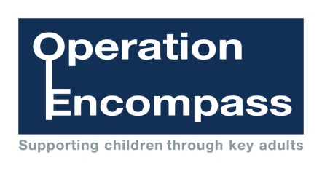

St Just Primary School

Mrs Rogers and Miss Downing are the Key Adults at St Just Primary School.

For further information, please visit the Operation Encompass website at

www.operationencompass.org



In every force, in every school, for every child

Operation Encompass is the early reporting on to schools that a child or young person has been exposed to domestic abuse