|  |  |  |
| --- | --- | --- |
| St Just Primary School  Curriculum Map  Art & Design | | |
| **What does Art & Design look like in EYFS?**  In planning and guiding what children learn, practitioners must reflect on the different rates at which children are developing and adjust their practice appropriately, referring to the Characteristics of Effective Teaching and Learning These are: playing and exploring – children investigate and experience things, and ‘have a go’; active learning – children concentrate and keep on trying if they encounter difficulties, and enjoy their achievements for their own sake; creating and thinking critically – children have and develop their own ideas, make links between ideas, and develop strategies for doing things. In addition, the Prime Areas of Learning (Personal, Social and Emotional Development, Communication and Language and Physical Development) underpin and are an integral part of children’s learning in all areas.  *Please see separate EYFS documents for further information on how our curriculum meets the needs of the children in the Tater Du cohort.* | | |
| St Just Primary School - Home**Expressive Arts and Design – Educational Programme** *(Statutory)*  The development of children’s artistic and cultural awareness supports their imagination and creativity. It is important that children have regular opportunities to engage with the arts, enabling them to explore and play with a wide range of media and materials. The quality and variety of what children see, hear and participate in is crucial for developing their understanding, self-expression, vocabulary and ability to communicate through the arts. The frequency, repetition and depth of their experiences are fundamental to their progress in interpreting and appreciating what they hear, respond to and observe. | | |
| **Opportunties to promote skills.**   * Provide opportunities to work together to develop and realise creative ideas. Reflect with children on how they have achieved their aims.   • Teach children to develop their colour-mixing techniques to enable them to match the colours they see and want to represent, with step-by-step guidance when appropriate.  • Provide a range of materials and tools and teach children to use them with care and precision.  • Promote independence, taking care not to introduce too many new things at once.  • Encourage children to notice features in the natural world and discuss their responses to what they see.  • Help them to define colours, shapes, texture and smells in their own words.  • Visit galleries and museums to generate inspiration and conversation about art and artists | | |
| **Possible vocabulary coverage.**  Mark-make, draw, lines, circles, colour, mix, primary, secondary, texture, form, sculpt, print, art, techniques | | |
| **Development Matters** | | |
| **3-4 years**   * Explore different materials freely, in order to develop their ideas about how to use them and what to make. * Develop their own ideas and then decide which materials to use to express them. * Join different materials and explore different textures. * Create closed shapes with continuous lines, and begin to use these shapes to represent objects. * Draw with increasing complexity and detail, such as representing a face with a circle and including details. * Use drawing to represent ideas like movement or loud noises. * Show different emotions in their drawings and paintings, like happiness, sadness, fear, etc. * Explore colour and colour mixing. | **Reception**   * Explore, use and refine a variety of artistic effects to express   their ideas and feelings.   * Return to and build on their previous learning, refining ideas   and developing their ability to represent them.   * Create collaboratively, sharing ideas, resources and skills. | **ELG – Creating with Materials**  To only be assessed against at the end of the Summer Term, using a ‘Best Fit’ judgement.   * Safely use and explore a variety of materials, tools and techniques, experimenting with colour, design, texture, form and function. * Share their creations, explaining the process they have used. |
| **Physical Development** is a Prime Area which underpins many of the skills needed to ensure progression within Expressive Arts and Design. The progression of Physical Development Skill are outlined below. | | |
| **3-4 Years**   * Use large-muscle movements to wave flags and streamers,   paint and make marks.   * Choose the right resources to carry out their own plan. * Use one-handed tools and equipment, for example, making snips in paper with scissors. * Use a comfortable grip with good control when holding pens and pencils. | **Reception**   * Develop their small motor skills so that they can use a range of   tools competently, safely and confidently.   * Use their core muscle strength to achieve a good posture   when sitting at a table or sitting on the floor.   * Develop overall body-strength, balance, coordination and agility. | **ELG – Fine Motor Skills**  To only be assessed against at the end of the Summer Term, using a ‘Best Fit’ judgement.   * Hold a pencil effectively in preparation for fluent writing - using   the tripod grip in almost all cases.   * Use a range of small tools, including scissors, paintbrushes and cutlery. * Begin to show accuracy and care when drawing. |
| **Core Knowledge** | | |
|  | | |
| **Summary of skills by end of year: developing small and gross motor skills; hold a paintbrush and pencil comfortably; hold a pair of scissors effectively; have explored materials for texture; used junk modelling to explore making something and talking about it; become aware of what is on their face** | | |

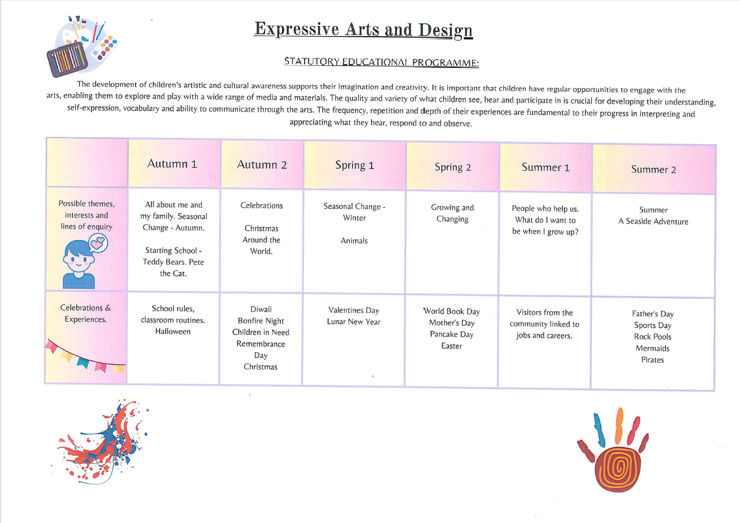

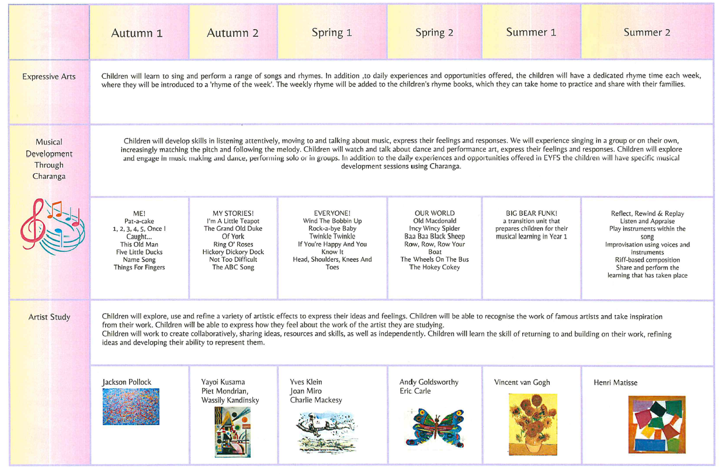

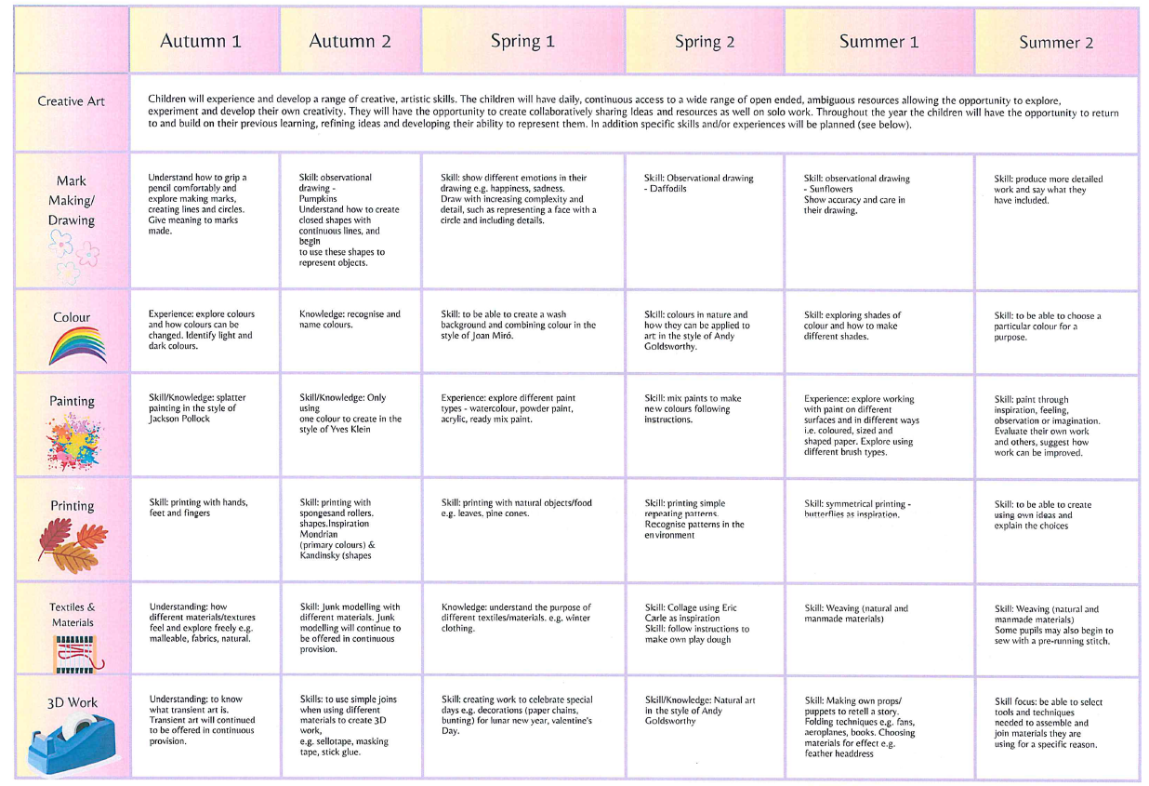

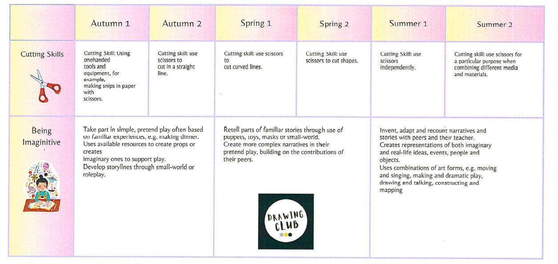

|  |  |
| --- | --- |
| Key Stage 1 National Curriculum Expectations | Key Stage 2 National Curriculum Expectations |
| Pupils should be taught:  -to use a range of materials creatively to design and make products;  -to use drawing, painting and sculpture to develop and share their ideas, experiences and imagination;  -to develop a wide range of art and design techniques in using colour, pattern, texture, line, shape, form and space;  -about the work of a range of artists, craft makers and designers, describing the differences and similarities between different practices and disciplines, and making links to their own work. | Pupils should be taught:  -to develop their techniques, including their control and their use of materials, with creativity, experimentation and an increasing awareness of different kinds of art, craft and design;  -to create sketch books to record their observations and use them to review and revisit ideas;  -to improve their mastery of art and design techniques, including drawing, painting and sculpture with a range of materials [for example, pencil, charcoal, paint, clay];  about great artists, architects and designers in history. |

The national curriculum for art and design aims to ensure that all pupils by the end of year 6:

* produce creative work, exploring their ideas and recording their experiences
* become proficient in drawing, painting, sculpture and other art, craft and design techniques
* evaluate and analyse creative works using the language of art, craft and design
* know about great artists, craft makers and designers and understand the historical and cultural development of their art form

|  |  |  |  |  |  |  |
| --- | --- | --- | --- | --- | --- | --- |
| **Components**: content and skills that will be taught | | | | | | |
| **YEAR 1** | | | | | | |
| Autumn | | | Spring | | Summer | |
| Our School! | Let’s Celebrate! | | Posting and Places | How does your garden grow? | Animal Allsorts | To the rescue |
|  | Chidi Okoye- Jazz time | | Enchanted Owl by Kenojuak Ashevak. | Observational pictures and painting of flowers  Van Gogh sunflowers, irises etc | Clay animal sculptures | Stormy sea pictures using pastels- Gustave Courbet |
| **Outcome** | | | | | | |
|  | To create artwork based on work by an artist. | | To design and make a stamp inspired by the work of Kenojuak Ashevak. | To make observational drawings of flowers. | To use clay to create an animal sculpture. | To create a stormy sea picture using pastels |
| **Sequencing & Skills Progression** | | | | | | |
| **Summary of previous skills : developing small and gross motor skills; hold a paintbrush and pencil comfortably; hold a pair of scissors effectively; have explored materials for texture; used junk modelling to explore making something and talking about it; become aware of what is on their face** | | | | | | |
|  | **1. I can look at and discuss Chidi Okoye’s Jazz time.**  ***What do you like/not like? Why?***  ***What can you see?***  ***What do you think it is about?***  ***How do the colours make you feel? Why do you think the artist chose them?***  **2. I can explore shape by taking my line for a walk around my page using different materials.**  **3. I can develop my use of colour by selecting appropriate colours to convey feelings/experiences.**  **4. I can use my cutting skills to cut shapes from card which relate to our celebration topic.**  **5. I can glue my shapes to my background to create my own version of *Jazz time*.** | **1. I can look at and discuss examples of innuit artwork, focusing on Kenohuak Ashevak.**  ***What do you like/not like? Why?***  ***What is the same/different?***  ***Do you notice anything interesting?***  **2. I can explore shapes and lines to draw an outline of an Arctic animal. I can use dots and lines to demonstrate pattern and provide texture.**  **3. I can explore using patterns and colour similar to those used in the innuit art I have studied.**  **4.I can design a stamp**  **5. I can use a pencil to carve my design into foam.**  **6. I can use my stamp to make block prints using paint and a roller.** | | **1.I can look at and discuss famous artists’ observational art work on flowers.**  ***What do you like/not like?***  ***Do you have a favourite? Why?***  ***What makes them interesting?***  **2. I can use line and shape to make observational drawing of flowers, focusing on their features.**  **3. I can use skills developed in the previous lesson to create an observational painting of a flower.**  **4. I can use what I know about the structure of flowers from my observational drawing and science lessons to explore a range of materials that have been cut, torn or glued to make parts of a flower.** | **1.I can look at and discuss sculptures of animals.**  *What do you like/not like?*  *Why?*  *Do you have a favourite?*  *Why?*  *What materials have been used?*  *How have the artists shown texture?*  **2. I can experiment with manipulating playdough by pinching, squeezing and rolling, to make animal shapes.**  **3. I can explore using tools to give my animal texture.**  **3.I can make an animal sculpture out of clay using the skills I have rehearsed using playdough.**  **4. I can decorate my sculpture considering my choice of colour and technique.** | **1. I can look at and discuss “stormy sea” art work.**  *What do you like/not like?*  *Why?*  *Do you have a favourite?*  *Why?*  *What is the same/different?*  *What are they about?*  *How have the artists used colour to show the mood/feeling in the artwork?*  **2. I can experiment using soft pastels to create lines and shapes, (drawing from my previous experiences in year 1), and explore using them to build and blend colours.**  **3. I can draw on my previous experience of using colour to depict feelings/emotions, to create a stormy sea inspired mood board.**  **4. I can create my own stormy sea picture using soft pastels.** |
| **Core Knowledge** | | | | | | |
|  | **To know how to make different sized lines.**  **To know how to use paintbrush to make different brushstrokes.**  **To know colours can be used to express feelings/emotions.**  **To know that art can be used to express feelings and experiences.**  **To know that colours have different shades.** | **To know that Inuit art, specifically the work of Kenojuak Ashevak, is draws on nature and animals native to the Arctic.**  **To know that a design can be cut into material to create a relief print.**  **To know that an image can be produced by applying paint and pressure to a relief print on paper.** | | **To know how identifying shapes in objects we are drawing can be used to help us when doing observational drawing.**  **To know how to cut, tear and glue materials.**  **To know how to sort and arrange materials to create an image.** | **To know that some materials can be manipulated or carved to form shapes.**  **To know how to pinch, squeeze and roll clay to form different shapes.**  **To know how to use tools to give my sculpture texture.** | **To know colours can be used to express feelings/emotions.**  **To know that art can be used to express feelings and experiences.**  **To know how to use soft pastels to create lines and shapes.**  **To know how to blend soft pastels.** |
|  | Painting/ Drawing | | Printing | Collage | Sculpture | Analysing Artists and Sculptors |
|  | **Chn can experiment with different brushes (including brushstrokes)**  **Chn can add white and black to alter tints and shades** | | **Chn can copy an original print**  **Chn can use a variety of sponges, blocks**  **Chn can demonstrate a growing knowledge techniques, eg rolling, pressing,** | **Chn can use a combination of materials that have been cut, torn and glued**  **Chn can sort and arrange materials** | **Chn can use a variety of techniques, eg rolling, cutting and pinching**  **Chn can use a variety of shapes, including lines and texture** | **Chn can describe the work of famous artists and designers**  **Chn can express an opinion** |
| **Vocabulary** | | | | | | |
|  | Tier 1: Colour, Mixing, Lines  Tier 2: Shades, Tints, Brushstroke, Feelings  Tier 3:Sweep, Dab, Emotions | | Tier 1: Colour, Shape, Print  Tier 2: Nature, Animals, Stamp, Carve, Inuit  Tier 3: Relief, Pressure | Tier 1: Colour, Collage, Squares, Cut  Tier 2: Place, Rip, Tear  Tier 3: Van Gogh, Arrange, Observational | Tier 1: 3d, Shapes, Animals  Tier 2: Sculpture, Model,  Materials, Rolling, Squeezing  Tier 3: Carving, Pinching, Texture, Manipulating | Tier 1: Stormy Sea, artists, lines, shapes, colour  Tier 2: John Wilson,  Gustave Courbet, blend,  Tier 3: Compare, Mood, Emotion, Pressure |

|  |  |  |  |  |  |  |  |
| --- | --- | --- | --- | --- | --- | --- | --- |
| **Art & Design- Year 1**  **Key Stage 1 Objectives** | | 1 | 2 | 3 | 4 | 5 | 6 |
| Our School | Let’s celebrate! | Posting and places | How does your garden grow? | Animal allsorts! | To the recue! |
| 1 | to use a range of materials creatively to design and make products |  |  | **√** | **√** | **√** |  |
| 2 | to use drawing, painting and sculpture to develop and share their ideas, experiences and imagination |  | **√** | **√** | **√** | **√** | **√** |
| 3 | to develop a wide range of art and design techniques in using colour, pattern, texture, line, shape, form and space |  | **√** |  | **√** | **√** |  |
| 4 | about the work of a range of artists, craft makers and designers, describing the differences and similarities between different practices and disciplines, and making |  | **√** | **√** |  |  | **√** |
| **Summary of skills by end of year: holding scissors with more control; following a line with more precision; exploring colour with more understanding; keeping within the lines when painting; exploring materials for texture and stiffness** | | | | | | | |

|  |  |  |  |  |  |  |
| --- | --- | --- | --- | --- | --- | --- |
| **YEAR 2** | | | | | | |
| Autumn | | | Spring | | Summer | |
| How has St Just changed? | Two Kings | | How do I get off the ground? | How does something grow? | Around the world | Is Australia the place for me? |
| Animal prints- foam | Portraits- close observational drawing of the King’s features- Rembrandt/ Leonardo da Vinci/ Christian Furr | | Colour mixing (Primary, Secondary, shades)  Paul Klee- Separation in the Evening | Observational drawings of plants around us- Monet |  | Collage of Australian culture- Dolan Geiman |
| **Outcome** | | | | | | |
| To create an animal print | To draw a portrait of the King | | To understand the difference between Primary and Secondary colours and how it can be used to show mood | To draw a plant from my observations |  | To create a collage of Australian culture |
| **Sequencing of lessons** | | | | | | |
| Prior skills:  **Chn can copy an original print**  **Chn can use a variety of sponges, blocks**  **Chn can demonstrate a growing knowledge techniques, eg rolling, pressing,** | Prior skills:  **Chn can use a sketch pencil with some degree of accuracy**  **Chn can push harder and softer to create an effect**  **Chn can** | Prior skills:  **Chn can experiment with different brushes (including brushstrokes)**  **Chn can add white and black to alter tints and shades** | | Prior skills:  **Chn can describe the work of famous artists and designers**  **Chn can express an opinion** |  | Prior skills:  **Chn can use a combination of materials that have been cut, torn and glued**  **Chn can sort and arrange materials** |
| **1.I can look at other animal prints from other artists and say what I like**  **What do I notice?**  **What patterns can I see?**  **2.I can experiment with mark making using rolling, pressing, stamping and rubbing with different materials**  **3.I can experiment with collage card to recreate some of my own animal markings**  **4. I can explore mark making on foam to create my print**  **5.I can make my own animal print** | **1.I can look at other examples of King portraits from a range of artistic styles (pop art/ contemporary/ classic)**  **2.I can look at mark making with sketch pencils, with a focus on shading and thickness of pencil and creating texture**  **-draw lines of varying thickness**  **-explore materials to draw, for example pastels, chalk and felt tips**  **-use dots and lines to demonstrate pattern and texture**  **3.I can practice the skills used in these examples**  **4.I can draw the key features of a face using youtube videos as support**  **5.I can draw the King using shading and texture and exploring my own style** | **1. I can use a paint brush with more control and explore other tools when mark making**  **2. I can identify the 3 primary colours**  *How do we make colour?*  **3.I can mix 2 primary colours together to make a secondary colour**  **4.I can experiment with black and white paint to alter tints and shades**  **5. I can analyse mood boards that explore primary and secondary colours as well as shades and say how they make me feel.**  **6. I can create my own moodboard inspired by Paul Klee work.** | | **1.I can look at other drawings of plants around us by selecting plants from my local area**  **-what can I see?**  **-what colours/ shades can I see?**  **2.I can analyse and describe other artists who have drawn plants (Monet; Van Gogh etc) and express my personal opinion**  **-what is similar/ different?**  **-what do you think the artist was trying to communicate?**  ***What has been used?***  ***What do you like/ do not like?***  **3.I can try out making different tones with pencils, chalk and charcoal.**  **4.I can create close up studies of Monet images**  **5.I can create my own observational plant drawing using inspiration and compare with their own** |  | **1.I can discuss what I see in other examples of collages and pick out key features**  **-feelings, thoughts, key items in the images**  **2.What colours are popular in Australia?**  *What can you see in the flag?*  *What do the colours represent?*  **3.I can experiment with ripping and tearing to look at patterns created**  **4.I can arrange paper to create patterns and add texture by mixing materials**  **5.I can create my own Australian image** |
| **Core Knowledge** | | | | | | |
| **To know of other artists who have create animal prints**  **To know that animal prints can either be random or have set patterns**  **To know how to use different printing tools**  **To know how to arrange patterns effectively** | **To know the difference between modern, contemporary and classical artists who have painted the Monarchy**  **To know how to create different shades and tones using a sketching pencil**  **To know how to place the features of the face in the correct places** | **To know how primary and secondary colours can affect emotion**  **To know about different artists that have explored primary and secondary colours**  **To know that black paint makes the colour darker and white paint makes the colour lighter** | | **To know what plants are in my local area**  **To know of other modern, contemporary and classical artists who have painted plants**  **To know how to use different mark making tools to create an image** |  | **To know that Australian Indigenous artwork tells the history of that civilization**  **To know that certain symbols represent different meanings**  **To know that layering different materials create different effects** |
| Printing | Drawing | Painting | | Analysing Artists and Sculptors |  | Collage |
| **Chn can copy an original print**  **Chn can use a variety of sponges, blocks**  **Chn can demonstrate a range of techniques, eg rolling, pressing, stamping and rubbing** | **Chn can draw lines of varying thickness**  **Chn can use different materials to draw, for example pastels, chalk and felt tips**  **Use dots and lines to demonstrate pattern and texture** | | **Chn can experiment with different brushes (including brushstrokes) and other painting tools**  **Chn can add white and black to alter tints and shades**  **Name the primary and secondary colours** | **Chn can describe the work of famous artists and designers**  **Chn can express an opinion**  **Chn can use inspiration from famous and notable artists and compare with their own** |  | **Chn can use a combination of materials that have been cut, torn and glued**  **Chn can sort and arrange materials**  **Chn can add texture by mixing materials** |
| **Vocabulary** | | | | | | |
| Tier 1: Colour, Shape,  Printing, Animals  Tier 2: Pressure, Roll, Pattern  Tier 3:Printmaking, Relief printing, Repetitive | Tier 1: Drawings, Line,  Portrait, Shade,  Tier 2: Size, Space, Pressure, Rubbing  Tier 3: Observational | | Tier 1: Colour, Mixing, Brushstroke, Watercolour, Acrylic  Tier 2: Primary, Secondary, White, Black, Tints,  Warm and cold, Shades  Tier 3:Sweep, Dab, Emotions, Moods | Tier 1: Monet, Water Colours  Tier 2: Nature, Plants, Close up study  Tier 3: Inspiration, Observations, Compare,  Contrast |  | Tier 1: Collage, Squares, Cut, Place, Tear, Arrange, Indigenous, Colour  Tier 2: Sort, Sizing, Mixing, Materials  Tier 3: Texture, Layering |

|  |  |  |  |  |  |  |  |
| --- | --- | --- | --- | --- | --- | --- | --- |
| **Art & Design- Year 2**  **Key Stage 1 Objectives** | | 1 | 2 | 3 | 4 | 5 | 6 |
| How has St Just changed? | Two Kings | How do I get off the ground? | How do things grow? |  | Is Australia the place for me? |
| 1 | to use a range of materials creatively to design and make products | **√** | **√** |  |  |  | **√** |
| 2 | to use drawing, painting and sculpture to develop and share their ideas, experiences and imagination | **√** |  | **√** | **√** |  | **√** |
| 3 | to develop a wide range of art and design techniques in using colour, pattern, texture, line, shape, form and space | **√** | **√** | **√** |  |  | **√** |
| 4 | about the work of a range of artists, craft makers and designers, describing the differences and similarities between different practices and disciplines, and making | **√** |  |  | **√** |  |  |
| **Summary of skills by end of year: holding scissors with more control and precision; following a line with varying thickness and manipulating different tools with more precision; exploring colour and shade with more understanding- primary and secondary colours; using black and white paints to create tints; keeping within the lines when painting; exploring materials for texture, appearance and stiffness** | | | | | | | |

|  |  |  |  |  |  |  |  |
| --- | --- | --- | --- | --- | --- | --- | --- |
| **YEAR 3** | | | | | | | |
| Autumn | | | Spring | | | Summer | |
| Stone Age- Set in stone | Magnetism- What’s the Attraction? | | Why are animals human too? | Shake, Rock and Roll | | Romans | Source to Sea |
| A study of sketching animals |  | | Investigation of colour: Fauvism study |  | | Mosaics | Leaf rubbing and printing – Andy Goldsworthy |
| **Outcome** | | | | | | | |
| To know about historical developments of art,  To develop techniques, including control and use of materials (charcoal, sketch pencils) |  | To create a portrait based on Fauvism | | |  | To create a Roman mosaic | To create artwork using resources around me |
| **Sequencing & Skills Progression** | | | | | | | |
| Prior skills:  **Chn can draw lines of varying thickness**  **Chn can use different materials to draw, for example pastels, chalk and felt tips**  **Use dots and lines to demonstrate an awareness of pattern and texture** |  | Prior skills:  **Chn can describe the work of famous artists and designers**  **Chn can express an opinion**  **Chn can use inspiration from famous and notable artists and compare with their own**  **Chn know the difference between primary and secondary colours** | | |  | Prior skills:  **Chn can use a combination of materials that have been cut, torn and glued**  **Chn can sort and arrange materials**  **Chn can add texture by mixing materials** | Prior skills:  **Chn can copy an original print**  **Chn can use a variety of sponges, blocks**  **Chn can demonstrate a range of techniques, eg rolling, pressing, stamping and rubbing** |
| **1. I can apply understanding of prehistoric man made art.**  ***What features do prehistoric paintings have in common?***  ***Why did prehistoric people paint animals?***  ***What basic shapes can we see that they’ve drawn?***  ***(Have a go at sketching British animals using 2D shapes to build up the outline and get the proportions correct)***  **2. I understand scale to enlarge drawings in a different medium (using different hardness of pencils, charcoal)**  ***What does scale up mean? How will the drawing change if we scale up? (showing awareness of space when drawing)***  **3. I can explore how natural products produce pigments to make different colours**  **4. I can select and apply a range of painting techniques,** **such as simple bold black outlines, patterns and dots.**  ***(Encourage the children to experiment with creating different textures by using different parts of the brush and different techniques to vary the effects. Get them to use a small brush for finer details.)*** |  | **1.I can recap knowledge of primary and secondary colours from last year through looking at a colour wheel and using the correct vocabulary.**  ***What are contrasting colours?***  ***Why are they good to use in art?***  **2.I can explore Fauvism and give reasons for my thoughts.**  ***What do you like? Why?***  ***What do you not like? Why?***  ***What does it make you think? Feel?***  ***What shapes can you see?***  **3.I can practice using inspiration from notable artists (Fauvist movement) to create several basic designs**  ***What can we remember about holding a sketch pencil?***  ***What can we use to help draw our designs?***  **4.I can explore contrasting colours that I might use**  **5.I can recap portrait skills taught in previous years.**  **6.I can draw a half portrait of my face**  **7. I can use my knowledge of Fauvism to create a portrait in that style.** | | |  | **1.I can explore and analyse different Roman mosaics**  ***What is a mosaic?***  ***What were they used for?***  ***How were they made?***  ***Which do you like and why?***  **2. I can select colours to create an effect, considering mood and emotion and the artist’s intention. I can show awareness of space and shape.**  **3. I can create multiple designs using my own repeating mosaic patterns, including detailed diagrams**  **4. I can use bits of paper to create repeating patterns, practicing ripping, tearing, layering etc**  **5. I can create my own Roman mosaic, inspired by the examples shown**  **6. I can critically evaluate my creation** | **1.I can analyse different leaf prints and rubbings of leaves**  ***What do you like about them?***  ***What do you not like about it?***  **2. I can select different leaves and materials to create different effects.**  **3. I can use my sketch book to practice multiple designs with blow up designs**  **4.I can select my final design based on given criteria**  **5. I can create my own printing/ rubbing of leaves around me**  **6.I can evaluate my prints based on the criteria I set out at the beginning** |
| **Core Knowledge** | | | | | | | |
| **To know about prehistoric art and evaluate examples**  **To know how to scale up drawing using a charcoal and earth tones of chalk pastels**  **To know how natural products produce pigments to make different colours**  **To know which painting techniques to select and apply** |  | **To know about the artists linked to the Fauvist movement (Henri Matisse, Andre Derain, Vincent Van Gogh, Paul Gaugin)**  **To know different colours that contrast**  **To know how to draw a portrait, thinking about proportion of facial features**  **To know how to critically evaluate their work** | | |  | **To know what mosaics look like and evaluate**  **To know what colours to choose to create era appropriate mosaics**  **To know how to create a repeating pattern**  **To know how to create a Roman moasic**  **To know how to critically evaluate their work** | **To know who Andy Goldsworthy is and what sort of art he creates**  **To know how to use resources around us to create art**  **To know how to print using different resources** |
| Drawing |  | | Analysing Artists and Sculptors |  | | Collage | Printing |
| **Chn can experiment with texture with different hardness of pencils**  **Chn can begin to show an understanding of shading**  **Chn can use different materials to draw (pastels, felt tips, charcoal)**  **Chn can show an awareness of space when drawing** |  | | **Chn can express an opinion on their work**  **Chn can use inspiration from famous and notable artists and compare with their own interpretation**  **Chn can show an awareness of space when drawing**  **Chn can use colours effectively using the correct vocabulary** |  | | **Chn can select specific colours and materials to create effect**  **Chn can begin choosing materials to layer on top of eachother with a growing understanding of texture**  **Chn can learn and practice a variety of techniques for mosaics** | **Chn can use one colour to layer in a print with some accuracy**  **Chn can replicate patterns from observations**  **Chn can make repeated patterns** |
| **Vocabulary** | | | | | | | |
| Tier 1: Shade, Rubbing, Light, Dark  Tier 2: Blend, Texture, Line, Hard, Soft, Pattern  Tier 3: Experiment, Evaluation, Observational |  | | Tier 1: Portrait, Colour, Primary, Secondary, Line  Tier 2: Fauvism, Feeling, Emotion  Tier 3: Proportion, Contrast |  | | Tier 1: Shape, Mosaic, Roman, Colour, Collage  Tier 2: Repeating Pattern, Rotation, Overlapping, Layering  Tier 3: Texture | Tier 1: Printing, Rubbing, Colour, Line, Rolling, Nature  Tier 2: Layer, Andy Goldsworthy, Arrange, Repeating Pattern  Tier 3: Accuracy, Texture |

|  |  |  |  |  |  |  |  |
| --- | --- | --- | --- | --- | --- | --- | --- |
| **Art & Design- Year 3**  **Key Stage 2 Objectives** | | 1 | 2 | 3 | 4 | 5 | 6 |
| Set In Stone | What’s The Attraction | Are Humans animal Too? | Shake Rattle And Roll | What did The Romans Do For Us? | Source to Sea |
| 1 | to create sketch books to record their observations and use them to review and revisit ideas | x |  | x |  | x |  |
| 2 | to improve their mastery of art and design techniques, including drawing, painting and sculpture with a range of materials (for example, pencil, charcoal, paint, clay) | x |  |  |  | x |  |
| 3 | about the greatest artists, architects and designers in history |  |  | x |  | x |  |
| **Summary of skills by end of year: holding and using scissors with control and precision; following a line with varying thickness and manipulating different tools with more precision; exploring pressure using sketch pencils; developing a deeper understanding of colour (and contrasting colours) and shade with more understanding when using a range of tools to create texture; using black and white paints to create a range of tints; using other artists as inspiration; beginning to make choices of materials based on a criteria** | | | | | | | |

|  |  |  |  |  |  |  |
| --- | --- | --- | --- | --- | --- | --- |
| **YEAR 4** | | | | | | |
| Autumn | | | Spring | | Summer | |
| Digestive System- Where does my food go? | Were the Anglo- Saxons good for Britain? | |  |  | Rainforests | Locals- Mining |
| Arcimboldo- fruit faces –art collages | Scenes from the Bayeux Tapestry, | |  |  | Monoprinting by artists Gaugin, Helen Dodsworth & Anna Wilson  Line Drawing | Clay- tin mines  Sketches/ designs – tin mines |
| **Outcome** | | | | | | |
| To create a collage based on an artist’s work | To create part of the Bayeaux Tapestry | |  |  | To create prints based on an artist’s work | To create our own version of a tin mine |
| **Sequencing & Skills Progression** | | | | | | |
| Prior skills:  **Chn can select specific colours and materials to create effect**  **Chn can begin choosing materials to layer on top of each other with a growing understanding of texture** | | Prior skills:  **Chn can use varied brush techniques to create shape and patterns**  **Chn can mix colours effectively using the correct vocabulary** |  |  | Prior skills:  **Chn can express an opinion on their work**  **Chn can use inspiration from famous and notable artists and compare with their own interpretation**  **Chn can use one colour to layer in a print with some accuracy**  **Chn can replicate patterns from observations**  **Chn can make repeated patterns** | Prior skills:  **Chn can experiment with texture with different hardness of pencils**  **Chn can begin to show an understanding of shading**  **Chn can use different materials to draw (pastels, felt tips, charcoal)**  **Chn can show an awareness of space when drawing** |
| **1. Who was Giuseppe Arcimboldo and what was he famous for?**  **2. I can sketch multiple designs of fruit faces – thinking about the lines and colour. I can select colour, textures and materials to create effect.**  **3. I can practice a variety of layering techniques to create different textures.**  **4. I can create my design making adjustments and giving reasons for changes.**  **5. I can evaluate my collage and suggest improvements** | | **1. I can analyse the Bayeaux tapestry as a work of art.**  **2. I can use colour mixing to create a palette of colours similar to the Tapestry**  **3. I can practice painting in the style of embroidering (water colours)**  **4. I can use the techniques learnt to create part of the Bayeaux Tapestry.**  **5.I can create close up detailed designs of my life using the Bayeaux Tapestry as inspiration**  **6. I can create my final design**  **7. I can critically evaluate my final design, explaining how I would improve it next time** |  |  | **1.I can observe rainforest animals carefully and draw animals using only lines**  **2. I can use line drawing to make a monoprint and use carbon paper to print with**  **3. I can create multiple designs using artwork as inspiration, using blow up designs**  **4. I can add colour to the print with oil pastels, considering line, shade, tone, space, shape etc**  **5.I can use line drawing to create a block print and colour mix by printing at least 2 colours**  **6. I can critically evaluate my final design, explaining how I would improve it next time** | **1. I can look at pictures of tin mines, give my opinion and make comparisons with other buildings and other artists.** *What emotion is the artist trying to get across? How have they used light and shadow to create effects?*  **2. I can experiment and explore line, tone and texture (pencil / charcoal grades)**  **3. I can sketch key features from the mines exploring a range of tools including pastels, charcoal, pastels, etc.. (brick work; shading)**  **4. I can create multiple images of mines using different techniques showing an awareness of space and detail.**  **5. I can create my final drawing of a mine using the techniques I have practiced.**  **6. I can evaluate my work and suggest future improvements.** |
| **Core Knowledge** | | | | | | |
| **To know who Arcimboldo was?**  **To know how to use a range of tools to create different lines and effects.**  **To know how to layer a collage using different materials.**  **To know how to improve my design.** | | **To know the purpose of the Bayeux tapestry.**  **To know how to mix Primary and Secondary colours effectively and with reasoning (colour wheel).**  **To know how to use a paintbrush to create specific techniques.** |  |  | **To know how to create drawings that replicate a selected image.**  **To know how to select imagery and colours to create a mood board with a defined theme and colour palette.**  **To know about the work of William Morris, using subject vocabulary to describe his work and style.**  **To know how to create a pattern using drawing, taking inspiration from mood boards and initial research to develop it.**  **To know how printed fabric was created in creative industries.**  **To know how designer developed products.** | **To know where the mines are in St Just.**  **To know which artists are famous for drawing mines.**  **To know how to create emotion using a range of tools.**  **To know how pencils can create different tones.** |
| Collage | Painting | |  |  | Printing/ Analysing Artists and Sculptors | Drawing/ Sculpture |
| **Chn can select colours, texture and materials to create effect**  **Chn can learn and practice a variety of techniques for layering different materials to create texture and effect.**  **Chn can make adjustments- giving reasons for changes** | **Chn can use varied brush techniques to create shape, textures, lines and patterns**  **Chn can mix colours effectively using the correct vocabulary**  **Chn can create different textures and effects with paint** | |  |  | **Chn can use inspiration from famous artists to replicate a piece of work**  **Chn can reflect upon their work**  **Chn can express an opinion on their work**  **Chn can make repeated patterns with precision**  **Chn can make printing blocks** | **Chn can cut, make and combine shapes to create a realistic sculpture**  **Chn can practice developed joining techniques using clay**  **Chn can add materials to create some detail using a range of tools**  **Chn can experiment with showing line, tone and texture with different hardness of pencils**  **Chn can use shading to show light and shadow effects**  **Chn can use different materials to draw (pastels, felt tips, charcoal)**  **Chn can show an awareness of space and detail when drawing** |
| **Vocabulary** | | | | | | |
| Tier 1: Collage, Arrange, Sort, Colour, Shape  Tier 2: Overlapping, Tessellation, Texture, Arcimboldo  Tier 3: Adjustments, Effect, Techniques | Tier 1: Primary, Secondary, Mixing, Warm, Cold,  Tier 2: Foreground, Background, Textures, Effects, Tone  Tier 3: Inspiration, Embroidery, Evaluation | |  |  | Tier 1: Colour, Printing Blocks, Shape, Rolling, Rainforest, Line  Tier 2: Colour Palette, Inspiration, Monoprint  Tier 3: Refine, Precision, Reflect, Product | Tier 1: Shade, Line, Tone, Hard, Soft, Mining, Space, Proportion  Tier 2: Light, Shadows, Texture, Emotion  Tier 3: Detail, Inspiration, Evaluation |

|  |  |  |  |  |  |  |  |
| --- | --- | --- | --- | --- | --- | --- | --- |
| **Art & Design- Year 4**  **Key Stage 2 Objectives** | | 1 | 2 | 3 | 4 | 5 | 6 |
| Where does our food go? | Were the Anglo- Saxons good for Britain? |  |  | Could you survive in a rainforest? | Local- Mining |
| 1 | to create sketch books to record their observations and use them to review and revisit ideas | **√** | **√** |  |  | **√** | **√** |
| 2 | to improve their mastery of art and design techniques, including drawing, painting and  sculpture with a range of materials (for example, pencil, charcoal, paint, clay) |  | **√** |  |  | **√** | **√** |
| 3 | about the greatest artists, architects and designers in history | **√** |  |  |  |  | **√** |
| **Summary of skills by end of year: shading of varying thickness and manipulating different tools with growing precision; exploring pressure using sketch pencils and other mark making tools; developing skill when mixing a range of colour and shade with more understanding when using a range of tools to create texture and tone; using other artists as inspiration and commenting on their final piece; choosing materials based on a criteria and exploring layering effects and texture** | | | | | | | |

|  |  |  |  |  |  |  |  |
| --- | --- | --- | --- | --- | --- | --- | --- |
| **YEAR 5** | | | | | | | |
| Autumn | | | | Spring | | Summer | |
| To the stars- Cosmic | | Poles Apart | | Ancient Greeks |  | Indus Valley |  |
| Starry, starry night- Van Gogh | | Water colour animals- Helen Bishop (modern) | | Making Greek pots- clay |  | Printing- Indus Valley |  |
| **Outcome** | | | | | | | |
| To recreate Van Gogh’s ‘Starry Starry Night’ | | To use water colours to create animal pictures | | To make a clay Greek pot |  | To recreate an Indus Valley style print design |  |
| **Sequencing & Skills progression** | | | | | | | |
| Prior skills:  **Chn can experiment with showing line, tone and texture with different hardness of pencils**  **Chn can use shading to show light and shadow effects with guidance.**  **Chn can use different materials to draw (pastels, felt tips, charcoal)**  **Chn can show an awareness of space and detail when drawing**  **Chn can use inspiration from famous artists to replicate a piece of work**  **Chn can reflect upon their work**  **Chn can express an opinion on their work** | Prior skills:  **Chn can experiment with showing line, tone and texture with different hardness of pencils**  **Chn can use shading to show light and shadow effects with guidance.**  **Chn can use different materials to draw (pastels, felt tips, charcoal)**  **Chn can show an awareness of space and detail when drawing**  **Chn can use varied brush techniques to create shape, textures, lines and patterns**  **Chn can mix colours effectively using the correct vocabulary**  **Chn can create different textures and effects with paint** | | Prior skills:  **Chn can cut, make and combine shapes to create recognizable forms in clay**  **Chn can practice joining techniques using clay**  **Chn can add materials to create some detail** | |  | Prior skills:  **Chn can explore different tools for mark making**  **Chn can show an understanding of layering paints for printed effects**  **Chn can make repeated patterns with some skill**  **Chn can make printing blocks** |  |
| **1.I can observe and describe some of the techniques used by Van Gogh in his ‘Starry Night’ painting.**  ***What does it make you feel?***  ***What do you like? Why?***  ***What skills can you see?***  **2. I can use tools to create movement.**  **3.I can sketch key areas from the original picture and use these to create some of my own**  **4.I can explore different materials to recreate some of the patterns in the Van Gogh image**  **5.I can create my own version of ‘Starry Night’ using techniques used by Van Gogh.**  **6. I can evaluate mine and others artwork and make suggestions on areas for improvement, as well as identifying areas we like.** | **1.I can analyse water colour animal drawings**  ***What do you like? Why?***  ***What do they make you feel?***  **2. I know how to experiment with water colours using different sized brushes, thickness of paint, brush strokes**  **3.I can practice using the water colours effectively to recreate shapes/ lines/ patterns**  **4.I can create close up studies of parts of the animal**  **5.I can create my own animal water colour picture**  **6. I can evaluate mine and others artwork and make suggestions on areas for improvement, as well as identifying areas we like.** | | **1.I can research the shapes and styles of Grecian pots**  **2.I can design an image for a pot based on popular designs found on Grecian pots.**  **3.I can practice joining and etching techniques**  **4.I can create a pot using the shapes and styles of Grecian pots**  **5.I can paint a design on a Grecian pot.**  **6. I can evaluate mine and others artwork and make suggestions on areas for improvement, as well as identifying areas we like.** | |  | **1.I can analyse different Indus Valley designs**  ***What stories are being told?***  ***How have the prints been made?***  ***What do you/ do you not like and why?***  **2.I can develop techniques in block and relief printing**  **3. I can practice using different types of print patterns using different tools**  **4.I can design my final print**  **5.I can use my print to create my Indus Valley design**  **6. I can evaluate mine and others artwork and make suggestions on areas for improvement, as well as identifying areas we like.** |  |
| **Core Knowledge** | | | | | | | |
| **To know that different tools create different effects.**  **To know that there are different shapes in artwork.**  **To know that different grades of pencil, create a different effect.**  **To know how to use different materials to create different effects and emotions.**  **To know how to draw on a range of techniques to create a final piece.**  **To know how to evaluate a finished piece, making suggestions and comparisons.** | **To know how to create different pigments, exploring with different colours and amount of water.**  **To know that different sized brushes affects the delicacy in the painting.**  **To know that different shapes, lines and patterns create different textures, thickness, effects.**  **To know how to evaluate a finished piece, making suggestions and comparisons.** | | **To know that the different shapes and sizes of pots are used for different purposes.**  **To know that different patterns on pots can demonstrate a scene from history.**  **To know how to use pinching, scoring and blending techniques to join and smooth clay surfaces.**  **To know how to evaluate a finished piece, making suggestions and comparisons.** | |  | **To know that different materials are easier to manipulate, etch and engrave shapes into for printing.**  **To know that different materials provide more definition of a shape in comparison to others**  **To know that layering paint makes it easier to add surface texture and subtle colour shifts.**  **To know how to evaluate a finished piece, making suggestions and comparisons.** |  |
| Drawing / Analysing Artists and Sculptors | | Painting/ Drawing | | Sculpture |  | Printing |  |
| **Chn can use a variety of techniques to add effects, eg, shadows, reflection**  **Chn can use a variety of tools and independently select the most appropriate**  **Chn can begin to master their knowledge of space and detail when drawing**  **Chn can give observations about notable artists and designers and use this as inspiration for their own work**  **Chn can offer researched facts about artists and designer** | | **Chn can demonstrate effective mixing techniques with some independence and accuracy**  **Chn can use a range of paints to create visually interesting pieces**  **Chn can create different textures and effects with paint with growing independence and accuracy** | | **Chn can improve their skill of arts and design techniques**  **Chn can plan and design a sculpture**  **Chn can use tools to carve, add shape and pattern with growing independence and accuracy**  **Chn can develop cutting and joining skills with growing independence and accuracy** |  | **Chn can design and create printing blocks/ tiles**  **Chn can develop techniques in block and relief printing**  **Chn can create accurate patterns**  **Chn can use more than one colour to layer in a print**  **Chn can replicate patterns from observations** |  |
| **Vocabulary** | | | | | | | |
| Tier 1: Van Gogh, Line, Effects, Colour, Blend, Hard, Soft, Contrast, Pattern  Tier 2: Sketch, Shadow, Shade, Texture, Proportion, Emotion  Tier 3: Historical, Inspiration | | Tier 1: Water Colour, Blend, Mix, Lighter, Darker, Dab, Animals, Warm, Cold  Tier 2: Detail, Abstract, Texture, Pattern  Tier 3: Reflect, Evaluate, Refine, Inspiration | | Tier 1: Sculpture, Greek, Pot, Carve, Smooth, Join, 3D, Mark Making  Tier 2: Repeating Patterns, Form, Strength, Mastering  Tier 3: Form, Reflect, Evaluate, Refine, Inspiration, Comparisons |  | Tier 1: Printing, Layering, Arrange, Rolling, Shape, Colour, Contrasting  Tier 2: Relief Printing, Pattern, Design  Tier 3: Reflect, Evaluate, Refine, Inspiration |  |

|  |  |  |  |  |  |  |  |
| --- | --- | --- | --- | --- | --- | --- | --- |
| **Art & Design- Year 5**  **Key Stage 2 Objectives** | | 1 | 2 | 3 | 4 | 5 | 6 |
| To the stars | Poles apart | Ancient Greeks |  | Indus Valley |  |
| 1 | to create sketch books to record their observations and use them to review and revisit ideas | **√** | **√** | **√** |  | **√** |  |
| 2 | to improve their mastery of art and design techniques, including drawing, painting and  sculpture with a range of materials (for example, pencil, charcoal, paint, clay) | **√** | **√** | **√** |  |  |  |
| 3 | about the greatest artists, architects and designers in history | **√** |  | **√** |  | **√** |  |
| **Summary of skills by end of year: shading of varying thickness and manipulating different tools with growing precision and mastery; using shade and shadow for effect and atmosphere; developing skill when mixing a range of colour and shade with more mastery when using a range of tools with a purpose; using other artists as inspiration to help them compare their own work; choosing materials based on a criteria and exploring layering effects and texture; mastering joining skills with growing independence** | | | | | | | |

|  |  |  |  |  |  |  |
| --- | --- | --- | --- | --- | --- | --- |
| **YEAR 6** | | | | | | |
| Autumn | | | Spring | | Summer | |
| Who’s in control? | Evolution and Inheritance | | Mayans |  |  | Beyond 1066- World War 2 & Battle of Britain |
| A study of Barbara Hepworth | Mono printing | | Clay modelling |  |  | LS Lowry  Observational drawings  1 point perspective |
| **Outcome** | | | | | | |
| To recreate a Barbara Hepworth style sculpture | To create a bird mono print | | To use clay to make Mayan pottery |  |  | To draw using perspective (LS Lowry) |
| **Sequencing & Skills progression** | | | | | | |
| Prior skills:  **Chn can give observations about notable artists and designers and use this as inspiration for their own work**  **Chn can offer researched facts about artists and designer** | Prior skills:  **Chn can demonstrate effective mixing techniques with some independence and accuracy**  **Chn can use a range of paints to create visually interesting pieces**  **Chn can create different textures and effects with paint with growing independence and accuracy** | Prior skills:  **Chn can improve their skill of arts and design techniques**  **Chn can plan and design a sculpture**  **Chn can use tools to carve, add shape and pattern with growing independence and accuracy**  **Chn can develop cutting and joining skills with growing independence and accuracy** | |  |  | Prior skills:  **Chn can use a variety of techniques to add effects, eg, shadows, reflection**  **Chn can use a variety of tools and independently select the most appropriate**  **Chn can begin to master their knowledge of space and detail when drawing**  **Chn can give observations about notable artists and designers and use this as inspiration for their own work**  **Chn can offer researched facts about artists and designer** |
| **1. I can analyse work by the sculptor Barbara Hepworth and give detailed observations and make comparisons with other notable artists and designers.**  **2. I can offer well researched facts about artists and designer**  **3.I can explore different materials to create structures and different shapes developing cutting and joining skills using wire**  **4. I can plan and design a sculpture (sketchbook)**  **5. I can use other materials other than clay to create a 3d sculpture by taking inspiration from drawings to create my own piece**  **6. I can compare and reflect on their own creations** | **1. I can analyse the work of various artists around the theme of ‘*birds*’**  **2. I can practice using water colour paints and create a colour palette**  **3. I can sketch birds from various viewpoints using a variety of sketching techniques to add effects and close up studies of features**  **4. I can use a variety of tools and select the most appropriate for mark making on foam and can design and create printing blocks/ tiles**  **5. I can develop techniques in mono, block and relief printing and demonstrate effective and mastered mixing techniques**  **6. I can create my own water colour bird** | **1. I can analyse Mayan pottery**  **2. I can use materials other than clay to plan, design and create a 3d sculpture such as play dough to practice etching and**  **coiling.**  **3. I can make a slip to join clay using mastered skills with cutting and joining skills using wire.**  **4. I can improve my mastery of arts and design techniques**  **learned from previous years**  **5. I can use tools to carve, add shape and pattern with mastered skill**  **6. I can recreate and decorate a piece of Mayan pottery to show mastered skill with cutting and joining skills using wire** | |  |  | **1.I can develop an understanding of LS Lowry’s work. (VE Day Celebrations)**  What are the pictures about? (the themes)  What colours does he generally use?  What sort of mood do the pictures express?  How would you describe his art style?  **2. I can give detailed observations about a notable artist (LS Lowry) to** **take inspiration from drawings to create my own piece**  **3. I can create a colour palette using mixing techniques** (Lowry’s use of only 5 colours.)  **4. I can use a variety of tools effectively and select the most appropriate to show a mastery understanding**  **5. I can use a variety of mastered techniques to add effects, eg, shadows, reflection**  **6. To learn how to become proficient in drawing techniques using one-point perspective and depict movement in drawings;** |
| **Core Knowledge** | | | | | | |
| **To know the history of Barbara Hepworth and other notable artists.**  To know how different materials, affect the creation of a structure.  **To know how to manipulate different materials through mastery.** | **To know how to create a colour palette**  To know how to use a variety of tools to create a mono print  **To know techniques to mix paint and print in mono, block and relief.** | **To know how to plan and design a 3D sculpture using different materials.**  To know how to use tools to cut, join, carve and add shape. | |  |  | **To know the history of LS Lowry.**  To know how to use a variety of tools effectively and select the most appropriate to show a mastery understanding.  **To know how to use a variety of mastered techniques including perspective.** |
| Analysing Artists and Sculptors | Painting/ Printing | | Sculpture |  |  | Analysing Artists and Sculptors / Drawing |
| **Chn can give detailed observations about notable artists and designers**  **Chn can offer well researched facts about artists and designer**  **Chn can compare and reflect on their own creations** | **Chn can create a colour palette**  **Chn can demonstrate effective and mastered mixing techniques**  **Chn can use a range of paints to effectively create visually interesting pieces (acrylic, oil paints, water colours)**  **Chn can design and create printing blocks/ tiles**  **Chn can develop techniques in mono, block and relief printing**  **Chn can create accurate patterns** | | **Chn can improve their mastery of arts and design techniques**  **Chn can plan and design a sculpture**  **Chn can use tools to carve, add shape and pattern with mastered skill**  **Chn can show mastered skill with cutting and joining skills using wire**  **Chn can use materials other than clay to create a 3d sculpture** |  |  | **Chn can become proficient in drawing techniques**  **Chn can use a variety of mastered techniques to add effects, eg, shadows, reflection**  **Chn can use a variety of tools effectively and select the most appropriate to show a mastery understanding**  **Chn can take inspiration from drawings to create their own piece** |
| **Vocabulary** | | | | | | |
| Tier 1: Sculptor, Barbara Hepworth, Strength, 3D, Shape, Mark Making, Repeating Patterns, Join  Tier 2: Compare, Contrast, Form  Tier 3: Mastery, Evaluation, Refine, Reflection | Tier 1: Mono Printing, Relief Printing, Design, Colour, Tile, Rolling, Pattern, Abstract  Tier 2: Viewpoint, Impressionism, Effect  Tier 3: Mastery, Evaluation, Refine, Reflection | | Tier 1: Sculpture, Mayan, Pot, Carve, Smooth, Join, 3D, Mark Making  Tier 2: Repeating Patterns, Form, Strength, Mastery, Texture  Tier 3: Form, Reflect, Evaluate, Refine, Inspiration, Comparisons |  |  | Tier 1: Line, Shade, Blend, Hard, Soft, Light, Dark, LS Lowry  Tier 2: One Point Perspective, Proportional  Tier 3: Form, Reflect, Evaluate, Refine, Inspiration, Comparisons |

|  |  |  |  |  |  |  |  |
| --- | --- | --- | --- | --- | --- | --- | --- |
| **Art & Design- Year 6**  **Key Stage 2 Objectives** | | 1 | 2 | 3 | 4 | 5 | 6 |
| Who is in control? | Evolution/ Inheritance | Mayans |  |  | Beyond 1066 |
| 1 | to create sketch books to record their observations and use them to review and revisit ideas | **√** | **√** | **√** |  |  | **√** |
| 2 | to improve their mastery of art and design techniques, including drawing, painting and  sculpture with a range of materials (for example, pencil, charcoal, paint, clay) | **√** | **√** | **√** |  |  | **√** |
| 3 | about the greatest artists, architects and designers in history | **√** |  | **√** |  |  | **√** |
| **Summary of skills by end of year: shading of varying thickness and manipulating different tools with precision and mastery; using shade and shadow for effect; developing skill when mixing a range of colour and shade with mastery when using a range of tools; using other artists as inspiration to help them compare their own work and suggest next steps; choosing a range of materials based on a criteria and exploring layering effects and texture; mastering joining skills with independence and precision** | | | | | | | |

**SEND STATEMENT:**

**At St Just Primary School, we value each child’s unique qualities and strengths. We have high aspirations and expectations for all children with Special Educational Needs and Disabilities (SEND) and strive to ensure that all SEND pupils make rapid and sustained progress from their starting point. We will strive to remove barriers to learning to ensure that all SEND pupils access, participate and engage with their learning therefore enabling them to fulfil their potential. These steps include more adult support; pencil grips; wider brushes; support scissors etc**