KEY INSTANT RECALL FACTS
Year 5 – Autumn Term 1

Year 1 – Autumn Term 2

Key Vocabulary
What is double 31?
What is half of 78?
What is double 34?
What is half of 98?

TARGET:
- I know doubles and halves of all two-digit numbers
By the end of this term children should be able to:
- Recall instantly the double and halves of all two-digit numbers
Top Tips…the secret to success is practising little and often. Use time wisely.
- Practise Key Facts while walking to school or during a car journey.
- Have a fact of the day – half of 38 is 19.
- Use what you already know – Encourage your child to find the connection between the 2 times table and double facts
- Play games – to support your child in maths. Your child has access to Purple Mash and Times Tables Rock Stars are brilliant for building number confidence and fluency.
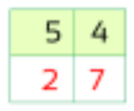
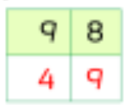
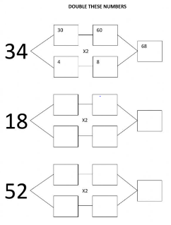

Remember – by the end of the term they should be able to recall these confidently and quickly.

