KEY INSTANT RECALL FACTS
Year 2 – Spring Term 2

Year 1 – Autumn Term 2

Key Vocabulary
What is 5 multiplied by 3?
What is 5 times 9?
What is 45 divided by 5?
What is 10 multiplied by 7?
What is 10 times 12?
What is 80 divided by 10?

TARGET:
- I know the multiplication and division facts for the 5 and 10 times tables.
By the end of this term children should be able to:
- Recall multiplication and division facts for the 5 and 10 times tables.
Top Tips…the secret to success is practising little and often. Use time wisely.
- Practise Key Facts while walking to school or during a car journey.
- Have a fact of the day.
- Pronunciation: Make sure that your child is pronouncing the numbers correctly and not getting confused between thirteen and thirty; nineteen and ninety.
- Songs and Chants: multiplication songs/chants/dances online. Check out … (https://www.bbc.co.uk/teach/supermovers)
- If your child creates their own song, this can make the times tables even more memorable.
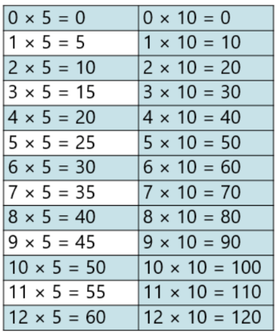
- Play games – to support your child in maths. Your child has access to Times Tables Rock Stars, Purple Mash and the White Rose 1 minute App (https://whiterosemaths.com/resources/1-minute-maths#download) is brilliant for building number confidence and fluency.
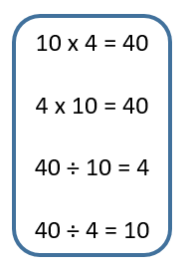
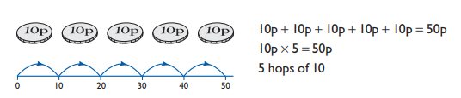
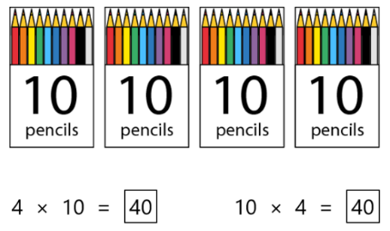

Remember – by the end of the term they should be able to recall these confidently and quickly.

