

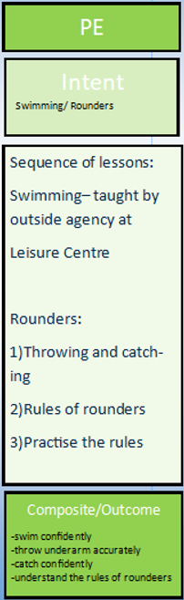
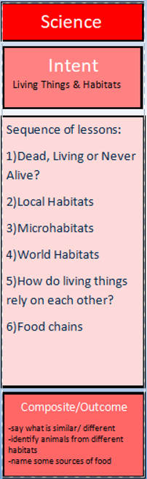
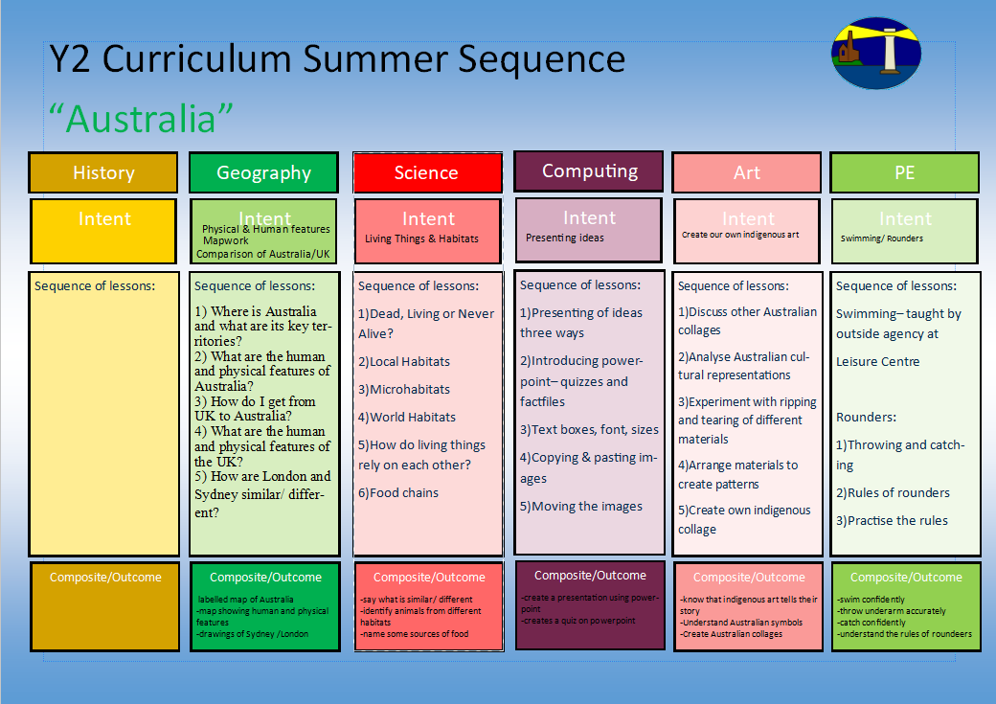
1.What do you think inventors look like? How might they look in the future?
2.How has flight changed throughout the years? Why might it have changed? Why did people want to fly? What were the key changes? What were the consequences?
3.Who were the Wright brothers? How has their hard work changed your life?
4.What do we think flight will look like in the future?
5. Who were famous pilots?
Dance

Making presentations

1)What do plants need to grow healthily?
2)What is inside a seed?
3)What is the difference between a seed and a bulb?
4)What is the lifecycle of a plant?
5)How are seeds dispersed so they can germinate again into new plants?
6)How do plants grow in a dry, hot or cold climate?

-understanding balance and travelling
-using climbing frames
1)Using the equipment safely
2)Balancing effectively solo and with partner
3)Travelling from one balance to another
4)Exploring equipment in different ways
5)Creating sequences
Dance

-log on and off
-confident with Purple Mash
-moving objects using coding
1)Typing skills on powerpoint
2)Opening existing documents and saving
3)Copying and pasting images
4) Animating powerpoint
5)Putting together a slideshow

Understanding what can affect a plant’s growth
Difference between a seed and a bulb
Lifecyles with correct vocabulary

How do plants grow?

-analysis of how news is spread
-timeline
-research gathering

Round the World
Y2 Curriculum Summer Term 1 Sequence

Australia/ Round the World
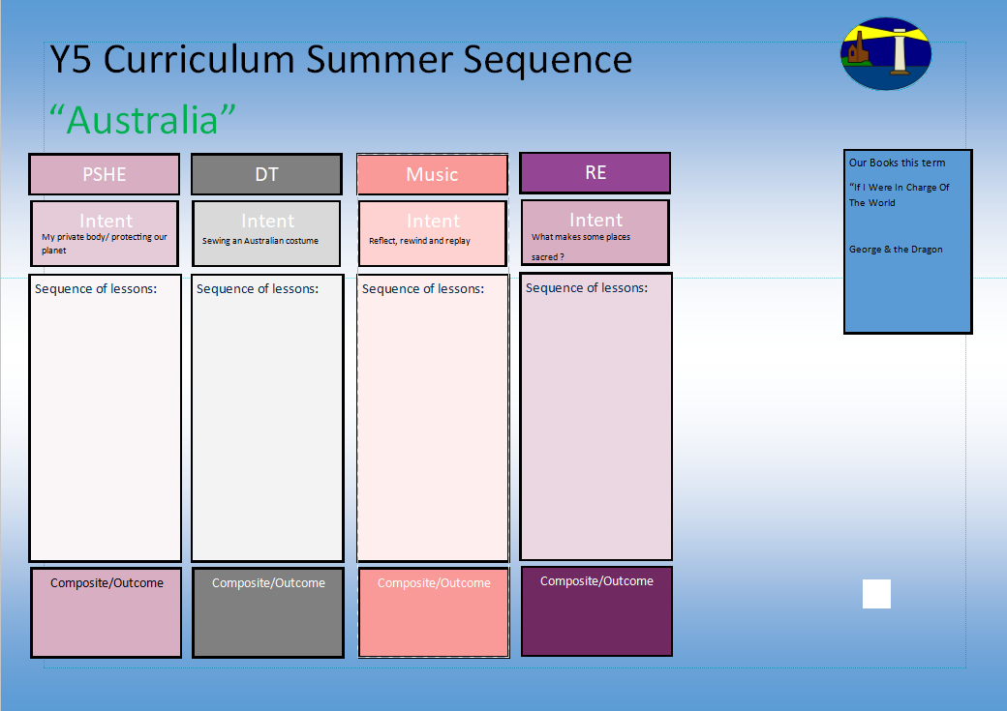
Understanding the world around us
1.I can look at moving toys
2.I can design my own moving toy for a particular age group
3.I can practice joining different materials
4.I can explore different materials depending on strength, flexibility etc
5.I can make my own moving toy
6.I can decorate my moving toy
7.I can evaluate my moving toy
Y2 Curriculum Summer Term 1 Sequence

Australia
Our books this term for English:

The Boy Who Grew Dragons
Persuasive Letter

The Magic Paint Brush
Traditional Tale

1.I know who Jesus was and who his disciples were.
2.I know the importance of forgiveness in the Bible.
3.I know how Jesus spread the word of peace around the world.
4.I know the importance and power of prayer in Christianity.
5.I know why Jesus is ‘Good News’.
Our books this term for reading comprehension:

-The Boy who Grew Dragons
What is the good news that Christians say Jesus brings?
Friendship song
Joining materials
Understanding the structure of a car
Strengthening materials
Moving Toy
Respecting All Families
Understanding Peer Pressure
Fight or Flight
Positive Friendships
Understanding Autism
Y2 Curriculum Spring Term 2 Sequence

Sowing and Growing

I know the stories that Jesus would tell and why they were important
Share and perform the learning that has taken place

1.Listen and Appraise Classical music
2.Understand about pulse and rhythm
3.Singing along to the pulse
4.Play instruments within the song and to create our own pulse
5.Improvisation using voices and instruments
6.Composition

Understanding the environment and our impact of the earth
Navigating cyber safety

-How to say no
-What can you remember?
-Private parts rap

-Why is the planet getting warmer?
-What can we do to help?

-Personal Goal Setting
-Adapting to Change

