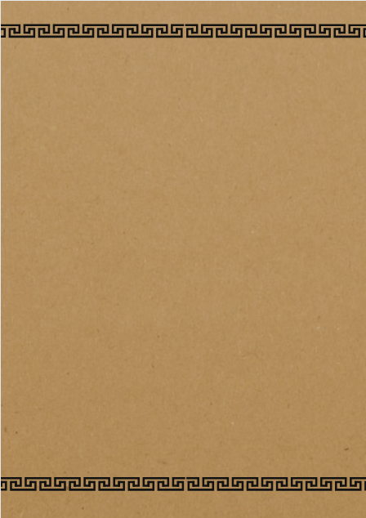

**Ancient Greeks**

As well as reading daily at home, practicing times tables (TTRock Stars) and spellings, we are continuing with our **homework menu** which has once again proved to be extremely popular.

The children will be able to choose a minimum of **two** activities from the selection of tasks below to complete by the end of the topic. At least one activity must be an English (*) based task.

* **Please can all homework be completed and brought into school or uploaded to Seesaw by Friday 9th February.**

**Godrevy Class Homework Menu**

Choose and research a mythical creature from Greek mythology. Draw a picture to accompany your description.

Design your own Greek theatre mask. Draw and label it’s different features and explain what genre of play it would be used for.

Find out about the Greek alphabet and present your findings in an exciting way.

Make a Spartan helmet or design a shield to present to the class.

Make a collage using pictures from holiday brochures or the internet showing ancient buildings and interesting place to visit in Greece.

Create a fact file for a Greek god and answer the following questions: Who was the god? What was their special ability? Did they have any famous stories or myths associated with them? (*)

Imagine you are an athlete in the Ancient Olympic Games. Write a diary entry describing your experience during one of the events, (*)

Choose one famous philosopher from Ancient Greece (e.g Socrates, Plato, Aristotle). Find a quote by that philosopher and explain what you think it means. (*)