Artists covered at St Just
At St Just Primary School, we aim to expose the children to a wide range of artists- from contemporary to modern day.
Year Group | Autumn 1 | Autumn 2 | Spring 1 | Spring 2 | Summer 1 | Summer 2
EYFS | 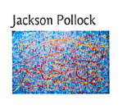 | 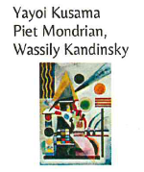 | 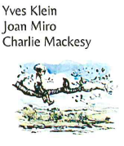 | 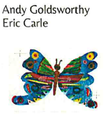 | 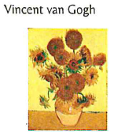 | 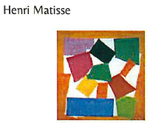
1 |  | Chidi Okoye- Jazz time  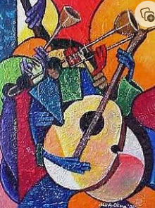 | Enchanted Owl by Kenojuak Ashevak.  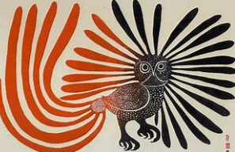 | Van Gogh sunflowers, irises etc  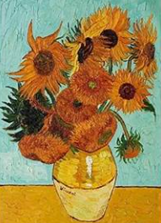 |  | Stormy sea pictures -Gustave Courbet  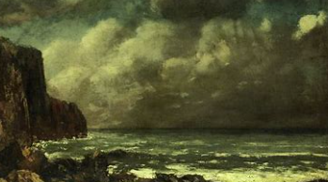
2 |  | Paul Klee- Separation in the Evening  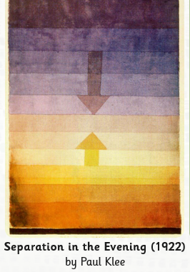 | Rembrandt/ Leonardo da Vinci/ Christian Furr 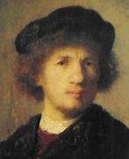 | Monet  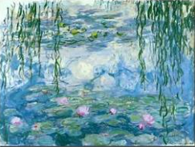 |  | Dolan Geiman  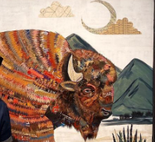
3 | Fauvism study  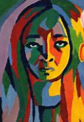 |  | Animal shapes  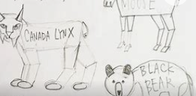 |  | Roman Mosaics  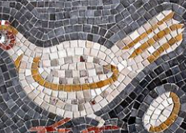 | Andy Goldsworthy  
4 | Archimboldo  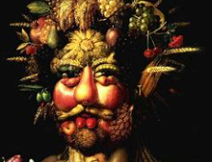 | Bayeux Tapestry  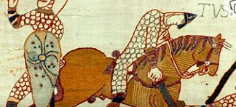 |  |  | 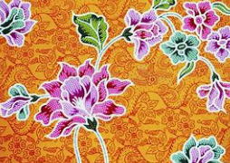  Printing- Batik | John Humphrey Spender  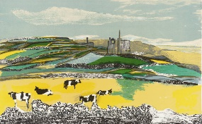
5 | Starry, starry night- Van Gogh  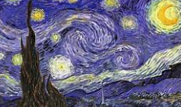 | Water colour artists- Helen Bishop (modern)  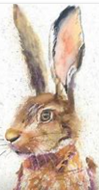 | Making Greek pots- clay  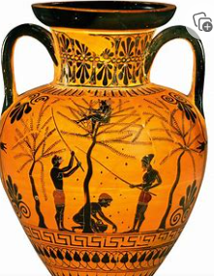 |  | Indus Valley printing  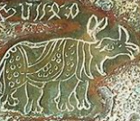
6 | Barbara Hepworth  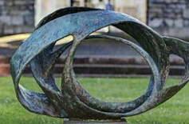 | 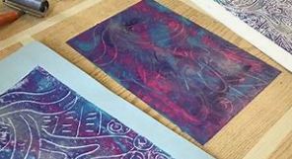  Mono Printing | Mayan pottery  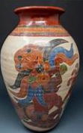 |  |  | LS Lowry  