KEY INSTANT RECALL FACTS
Year 1 – Autumn Term 2

Year 1 – Autumn Term 2

Key Vocabulary
What is double 5?
What is double 6?
What is double 4?
What is double 10?

TARGET:
- I know my doubles of numbers to 10
By the end of the Autumn term children should be able to:
- Recall instantly doubles of numbers to 10.

Top Tips…the secret to success is practising little and often. Use time wisely.
- Practise Key Facts while walking to school or during a car journey.
- Have a fact of the day.
- Play games – to support your child in maths your child has access to Purple Mash, Numbots/Times Tables Rock Stars, and the White Rose 1 minute App is brilliant for building number confidence and fluency.
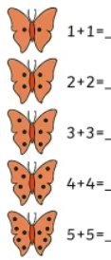
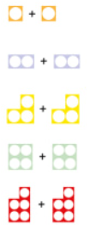
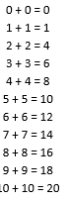

Remember – by the end of the term they should be able to recall these confidently and quickly without counting on their fingers.

